Milestone 3
Document Library & Member Directory
Project: | Communauté de Pratique — Évaluation des Politiques Publiques
Client: | Ministère
Developer: | LVZ Analytics Corp
Platform URL: | https://cop-forum.onrender.com
Date: | March 2026

What Was Delivered
Two major capabilities were added to the platform in this milestone: a Documentation Repository for storing, organizing, and searching evaluation resources, and a Member Directory that lets professionals find and connect with one another. Together, these features transform the platform from a discussion space into a comprehensive knowledge-sharing and networking hub for the evaluation community.

Documentation Repository
A full-featured document management system has been built into the platform, allowing members to upload, organize, and search evaluation resources. This system was designed to handle the specific needs of evaluation professionals — from methodological guides and policy reports to training materials and case studies.
Key capabilities delivered:
- File uploads — Members can upload documents in common formats (PDF, Word, Excel, PowerPoint, images), with a configurable size limit currently set to 20 MB.
- Structured metadata — Every document requires a title, author, date, description (minimum 50 characters), category, and tags. Optional fields include region, sector, source organization, publication date, and language.
- Five document categories — Reports, Tools, Policy Documents, Case Studies, and Training Materials — each available in French and English.
- Search and filtering — Documents can be searched by title, description, or tags, and filtered by category, region, and sector.
- Access control — Each document can be marked as public (visible to all visitors) or members-only (requiring login).
- Moderation workflow — Uploaded documents enter a review queue where moderators can approve or reject them before they become visible. Certain categories can be configured for automatic approval.
- Version control — When a document is updated, the original version is preserved. Administrators can view the full version history of any document.
- Download tracking — The system records how many times each document has been downloaded, supporting usage analytics.
- Cloud storage ready — The system supports Cloudflare R2 cloud storage for scalable file hosting, with automatic fallback to local storage if cloud credentials are not configured.
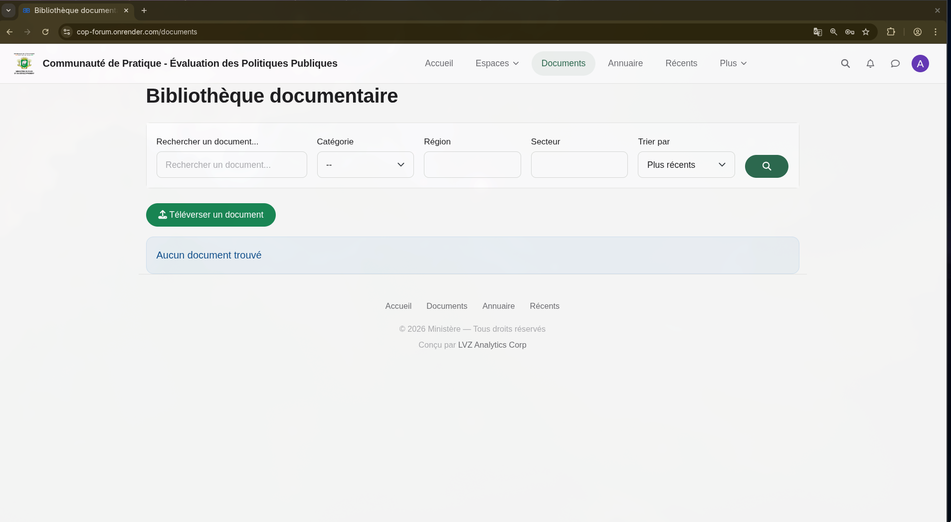
The document library with search and filter capabilities
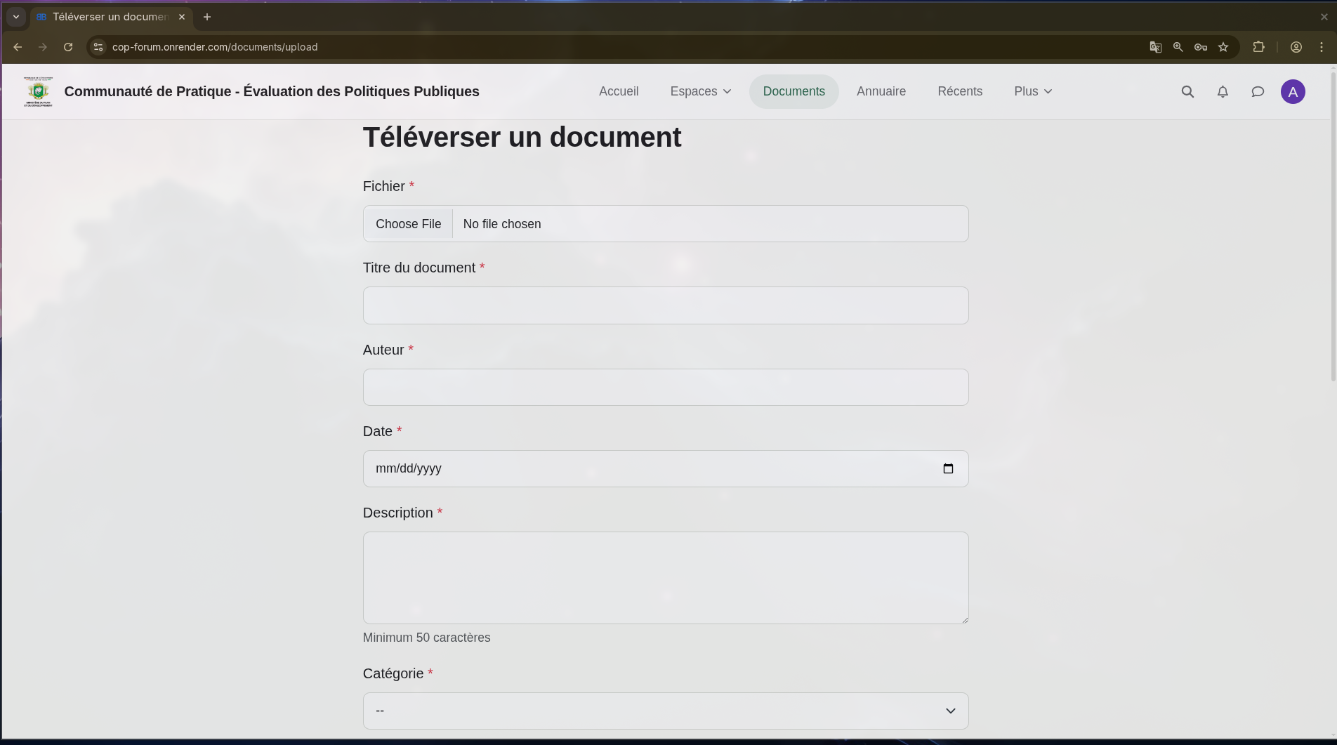
The document upload form with structured metadata fields
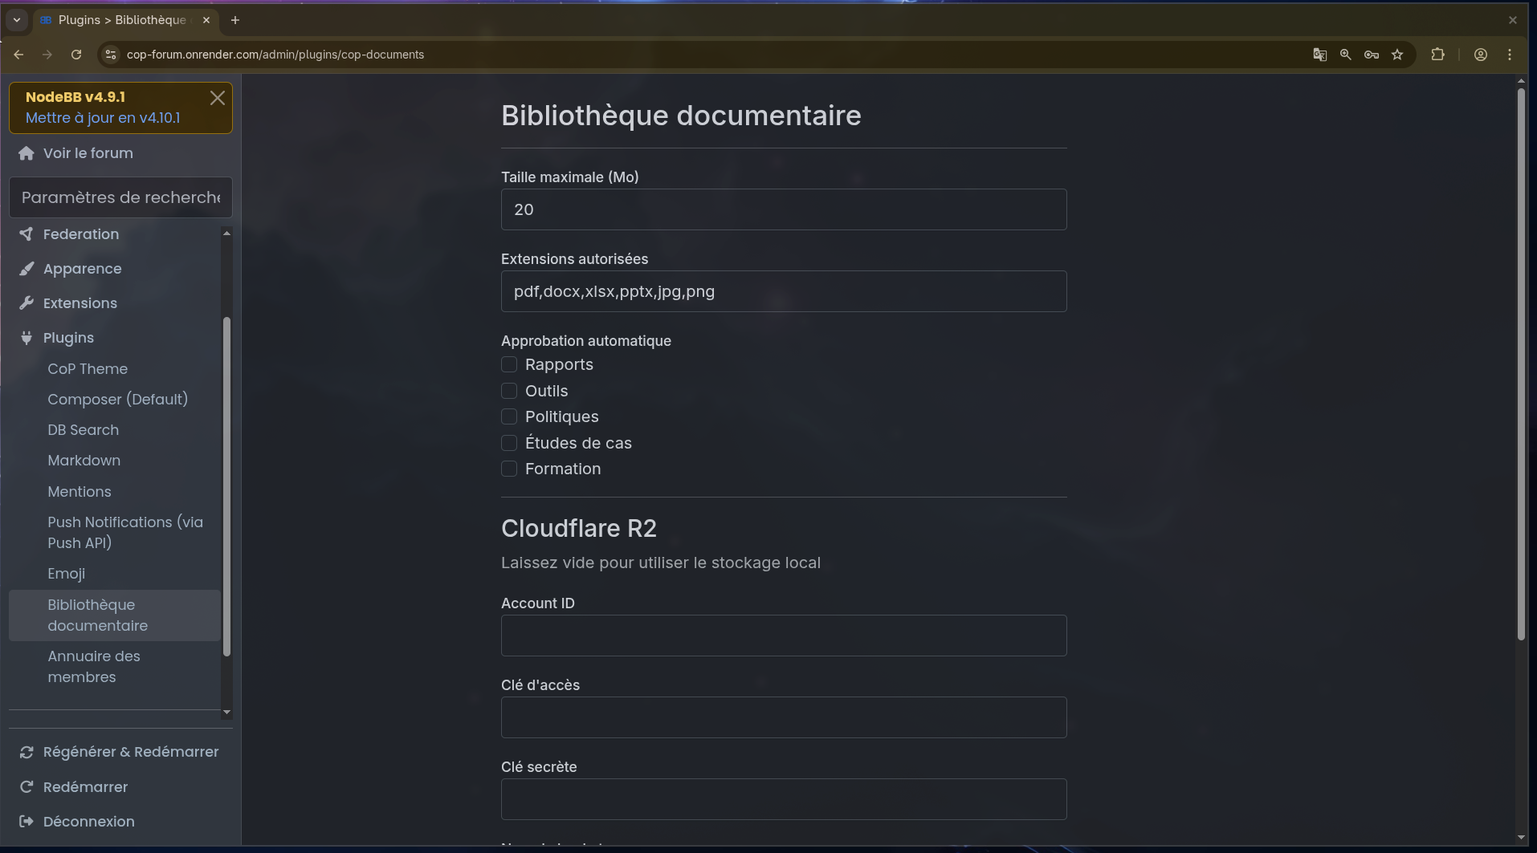
Administrative settings for the document library, including cloud storage configuration

Member Directory
A searchable directory has been added to the platform, making it easy for evaluation professionals to find colleagues by expertise, region, sector, or organization type. This feature is essential for building professional connections within the community and facilitating collaboration across institutions.
Key capabilities delivered:
- Member cards — Each member appears as a card showing their name, organization, role, region, sector, and areas of expertise.
- Search — Free-text search across names, organizations, roles, and biographies.
- Filters — Dropdown filters for expertise area, region, sector of focus, and organization type — all drawn from the same fields members fill in on their profiles.
- Privacy controls — Members can opt out of appearing in the directory entirely, using a toggle directly on the directory page.
- Direct messaging — Each member card links to a messaging function, allowing members to connect privately through the platform.
- Admin-configurable — The expertise tags, sectors, regions, and organization types that appear in filters are managed by administrators, ensuring the directory stays current as the community evolves.
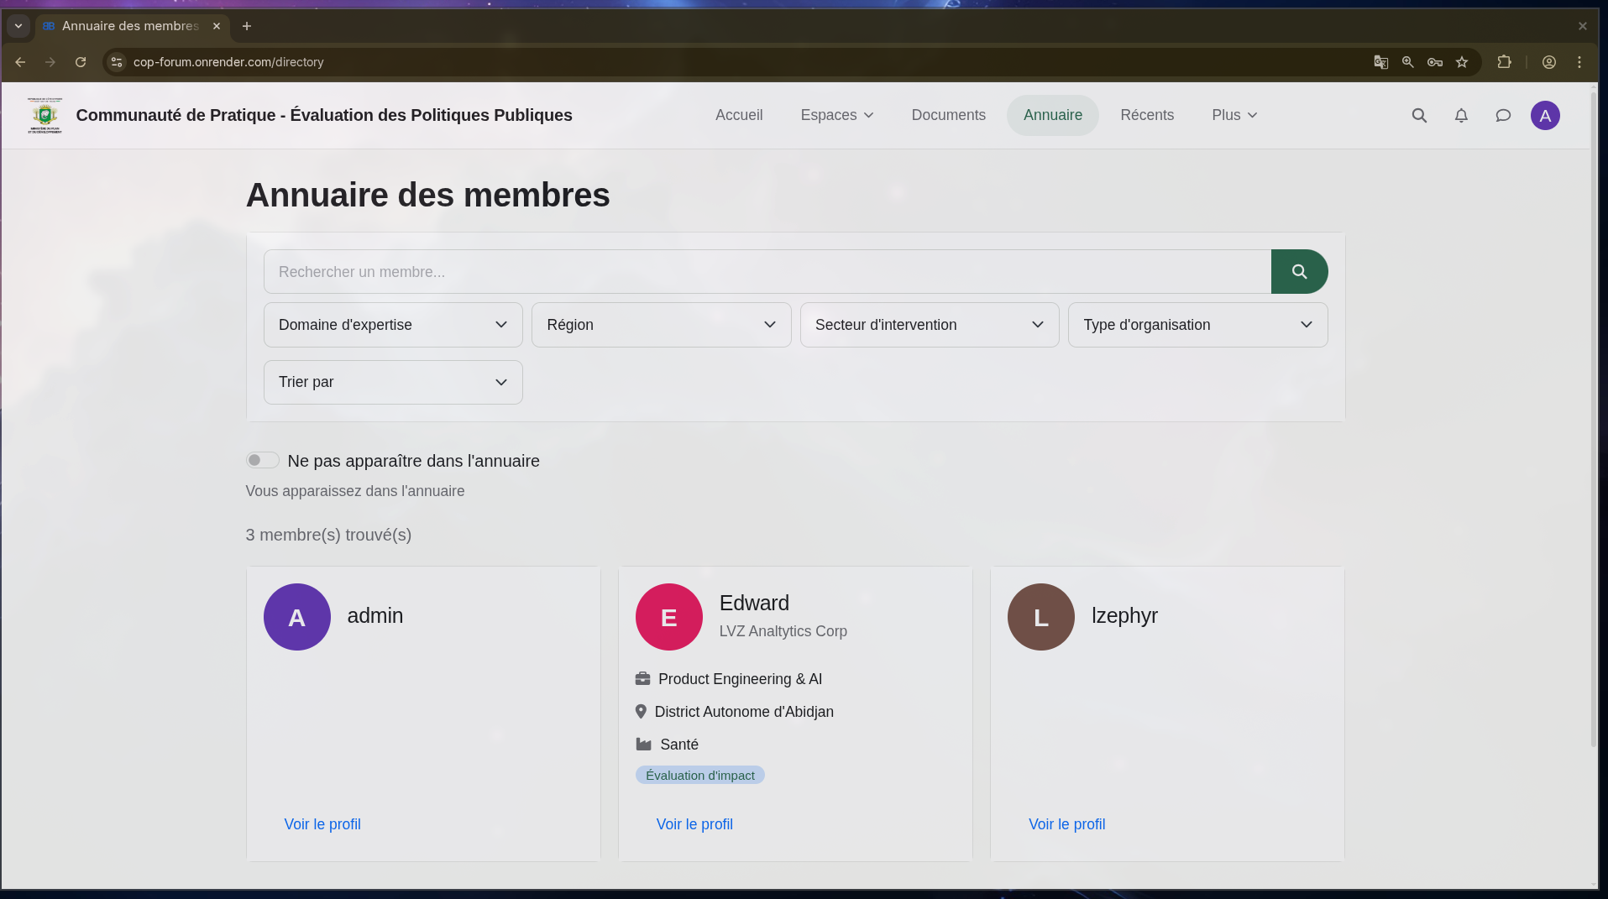
The member directory with search, filters, and member cards
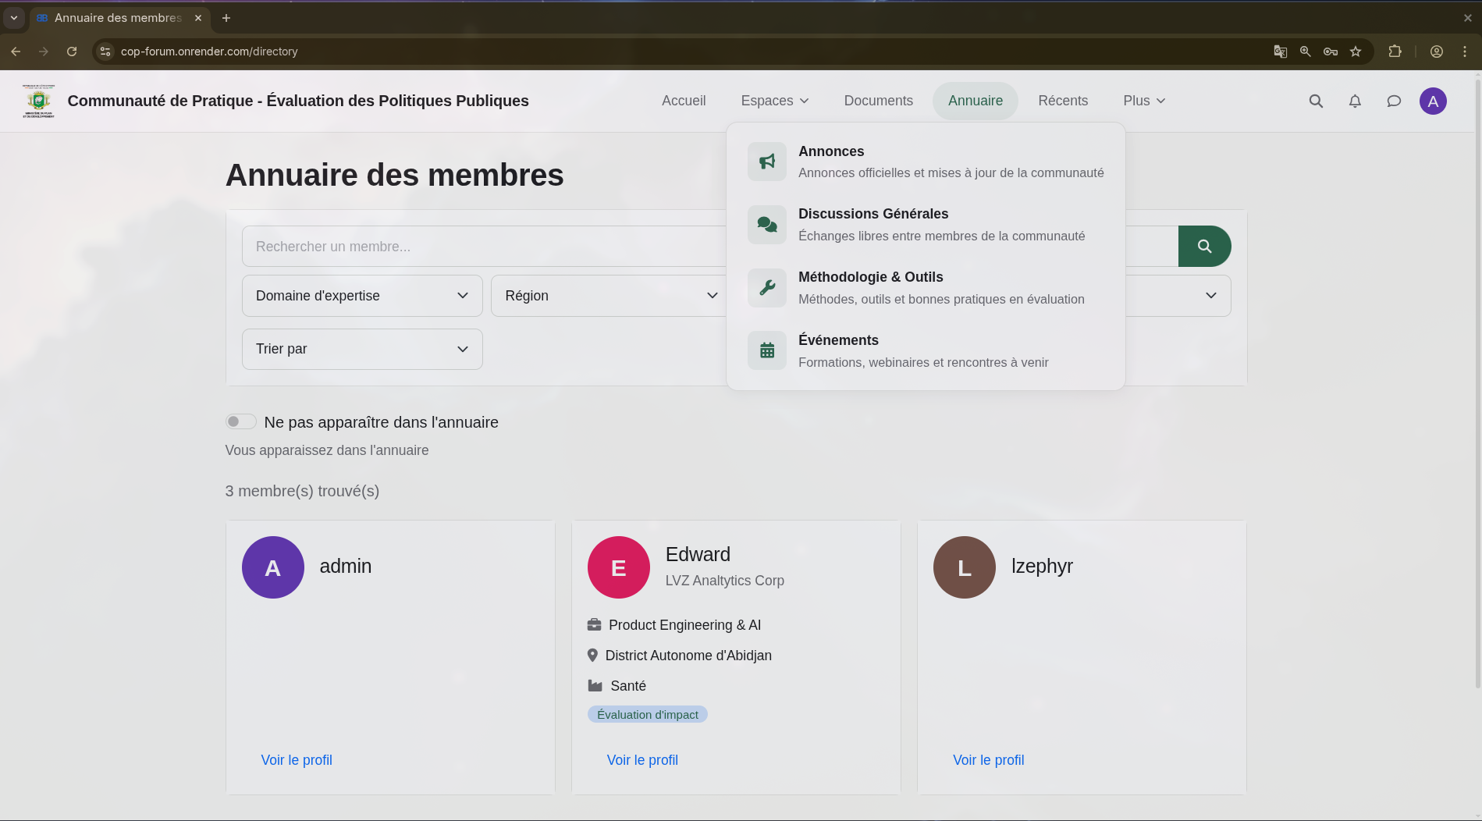
Platform navigation showing integrated access to all community sections

Enhanced Member Profiles
To support the directory, member profiles have been enriched with professional fields tailored to the evaluation community. These fields ensure that the directory is populated with meaningful, searchable information about each member’s professional background.
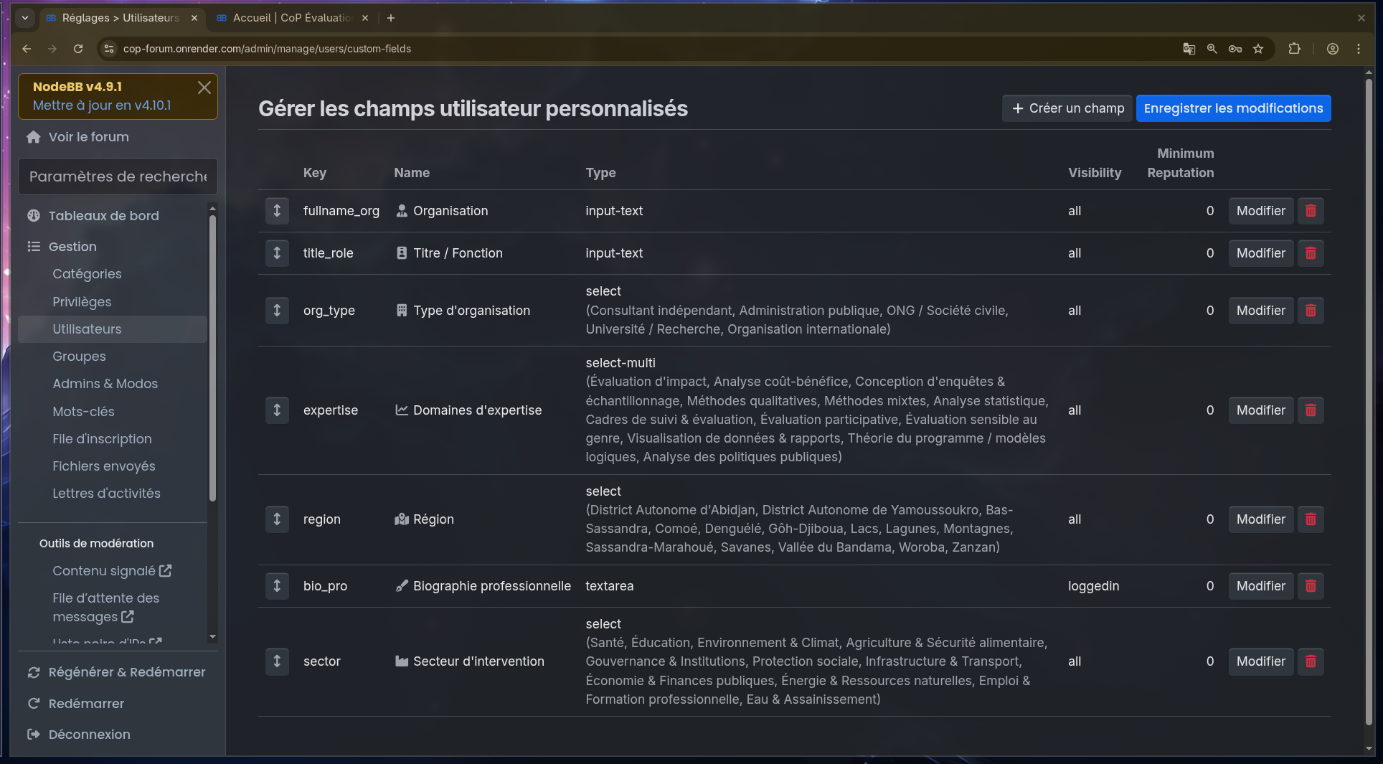
Custom profile fields configured for evaluation professionals
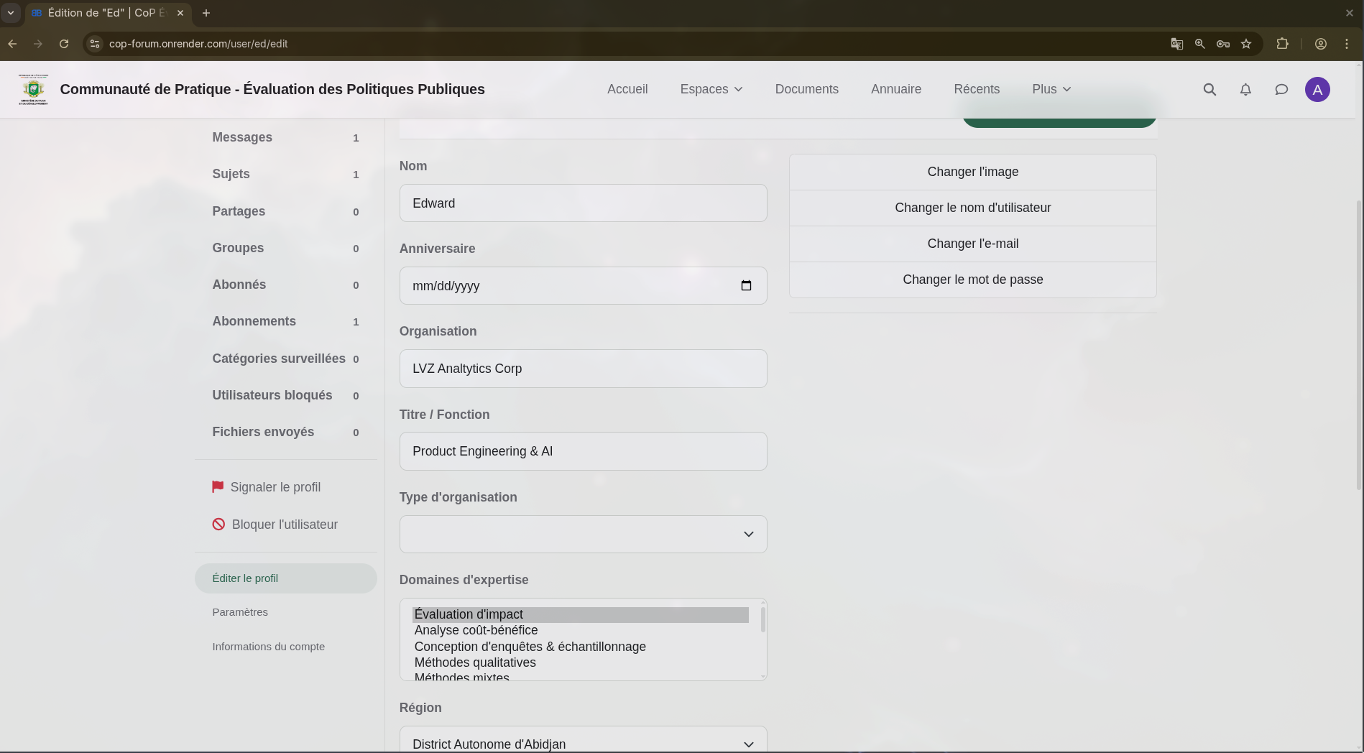
A member’s profile with professional information and expertise areas
The following fields are available on every member profile:
Field | Description
Organisation | The member’s affiliated organization
Titre / Fonction | Professional title or role
Type d’organisation | Category of organization (consultant, government, NGO, academic, international)
Domaines d’expertise | Areas of evaluation expertise (14 domains, multiple selections allowed)
Région | District within Côte d’Ivoire (14 regions)
Biographie professionnelle | Professional biography (visible to members only)
Secteur d’intervention | Sector of focus (11 sectors including health, education, environment, and more)

How to Verify
Please visit https://cop-forum.onrender.com and confirm the following:

Document Library
- Navigate to Documents in the top menu
- The document library page loads with search bar, filters (category, region, sector), and a sort option
- Click Téléverser un document — the upload form appears with all required fields
- Upload a test document (PDF or Word) with all required metadata
- The document enters the moderation queue (unless auto-approval is enabled for that category)
- As an administrator, navigate to the pending documents page and approve the test document
- The approved document appears in the library and can be found via search
- Download the document and confirm the download counter increments

Member Directory
- Navigate to Annuaire in the top menu
- The directory displays member cards with professional information
- Use the search bar to find a member by name or organization
- Use the filter dropdowns to narrow results by expertise, region, sector, or organization type
- Click “Voir le profil” on a member card to view their full profile
- Toggle “Ne pas apparaître dans l’annuaire” to opt out, then verify your card disappears

Member Profiles
- Log in and navigate to your profile settings
- All professional fields are visible and editable (organization, title, expertise, region, sector, bio)
- The expertise field allows selecting multiple domains
- Privacy controls are respected — biography is visible only to logged-in members

What Comes Next — Milestone 4
Milestone 4 focuses on integration and administration tools to prepare the platform for day-to-day operations:
- Event management — Ability to post events in the Événements space with date, time, and meeting links (Zoom/Teams), making it easy for members to join virtual sessions.
- Email notifications — Configuration of the email delivery system so members receive notifications for replies, mentions, and document approvals.
- Social media sharing — Share buttons on discussions and documents for Facebook, LinkedIn, and Twitter.
- Moderation workflows — Final configuration of content review processes and administrator tools.

Prepared by the development team — LVZ Analytics Corp

