Milestone 4
Integration & Admin Tools
Project: | Communauté de Pratique — Évaluation des Politiques Publiques
Client: | Ministère
Developer: | LVZ Analytics Corp
Platform URL: | https://cop-forum.onrender.com
Date: | April 2026

What Was Delivered
Milestone 4 adds event management, social sharing, email notifications, and moderation tools to the platform. These features prepare the Community of Practice for day-to-day operations — administrators can now organize meetings, members receive timely notifications, and moderators have full control over content quality.

Event Management
A complete event management system has been built as a dedicated plugin (nodebb-plugin-cop-events), allowing administrators and global moderators to create, edit, and manage meetings, webinars, and workshops. Each event automatically generates a discussion topic in the Événements category, connecting the event to the community’s conversation space.
Key capabilities delivered:
- Event creation — Administrators can create events with a title, date/time, sector, region, location, meeting platform (Zoom/Teams/other), meeting link, registration link, banner image, and a Markdown description.
- Calendar view — A month-view calendar displays all events, allowing members to browse by date and plan their participation.
- List view with filters — Events can be browsed in list format, searched by keyword, and filtered by region or sector. Tabs separate upcoming and past events.
- Event detail page — Each event has a dedicated page with a hero banner, prominent “Rejoindre la réunion” button, full event details, and a sidebar with RSVP, timezone information, social sharing, and calendar download.
- RSVP system — Logged-in members can indicate their participation with a single click. A live participant count is displayed on the event page.
- Auto-created discussion topic — When an event is created, a discussion topic is automatically posted in the Événements category with the event’s date, time, location, and meeting link. Editing or deleting an event updates or removes the associated topic.
- Banner image uploads — Event banners are stored on Cloudflare R2, with automatic fallback to local storage.
- Add to calendar — Members can download a .ics file to add the event to their personal calendar (Outlook, Google Calendar, Apple Calendar).
- Admin panel — A settings page at /admin/plugins/cop-events allows configuring the default discussion category and backfilling topics for existing events.
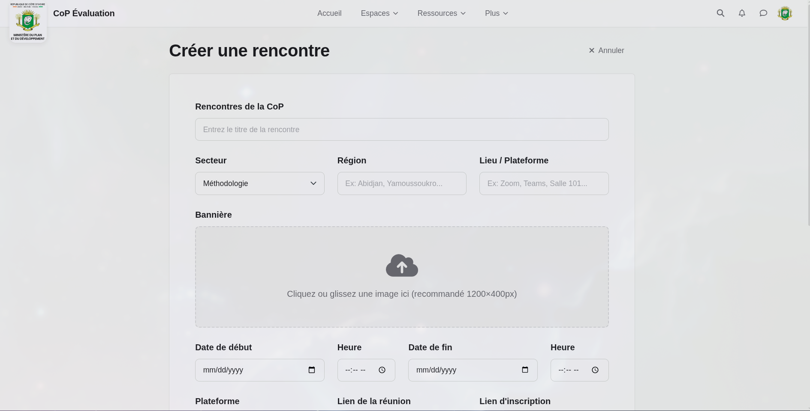
The event creation form with all fields: title, sector, region, banner upload, dates, and meeting details
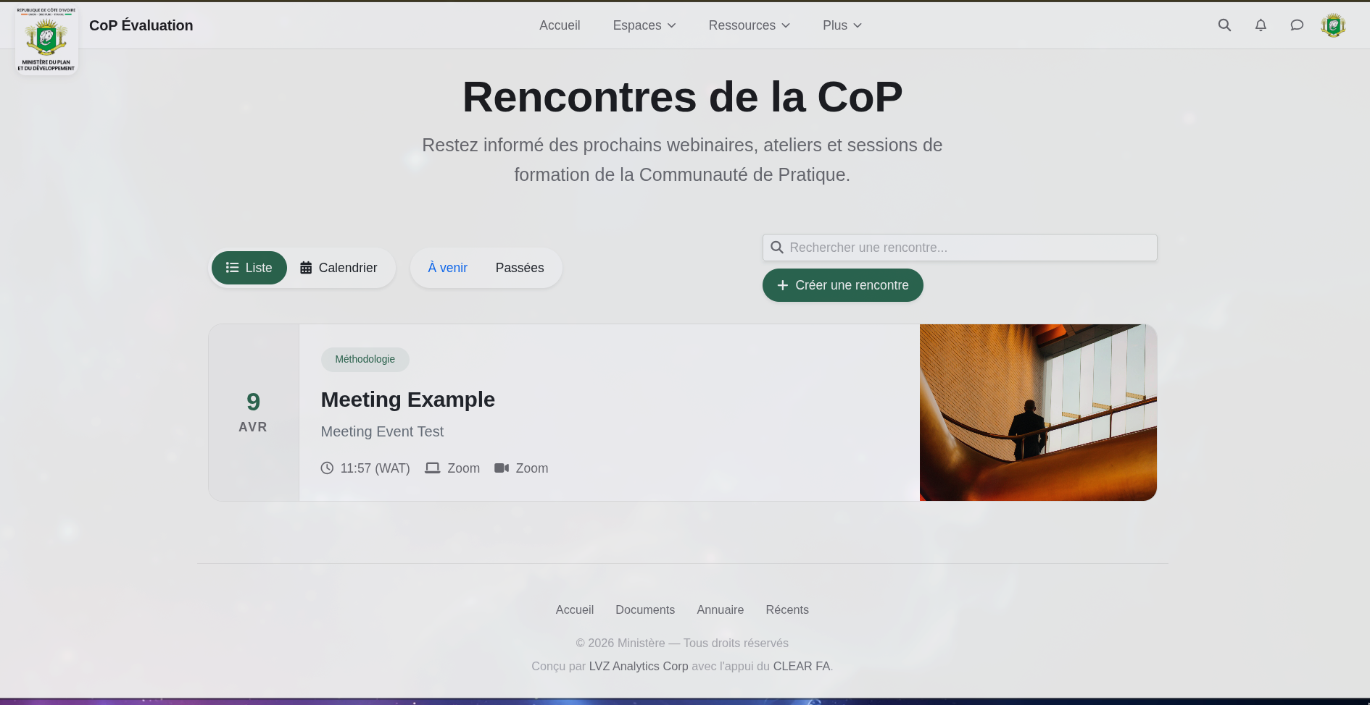
The events list page with search, filters, and meeting cards
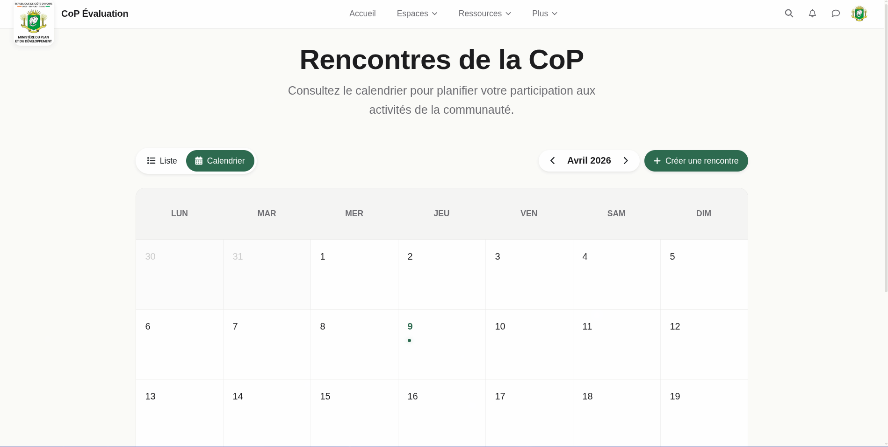
The calendar view showing events for the month

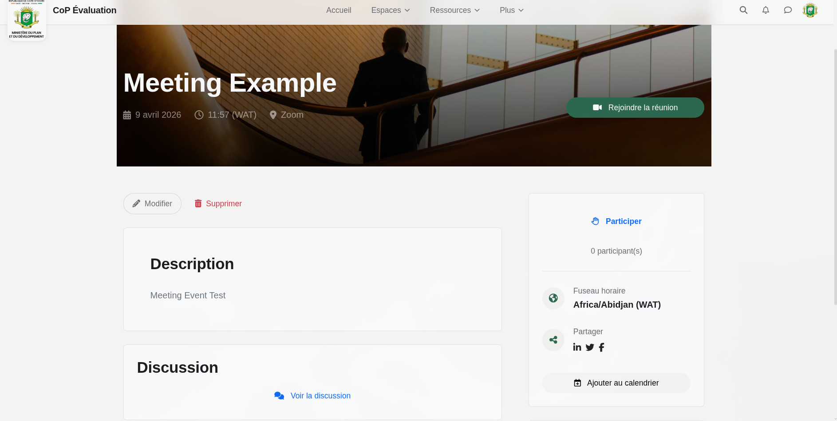
Event detail page with hero banner, meeting link, RSVP, social sharing, and calendar download
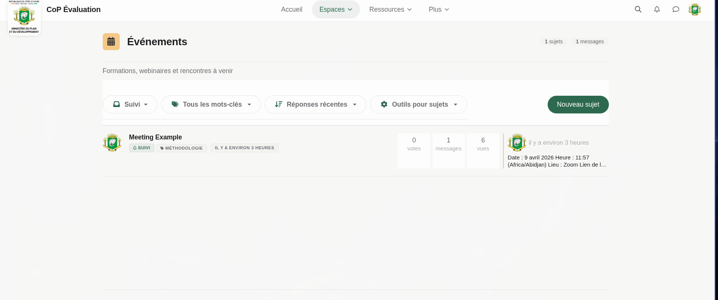
The Événements category showing the auto-created discussion topic
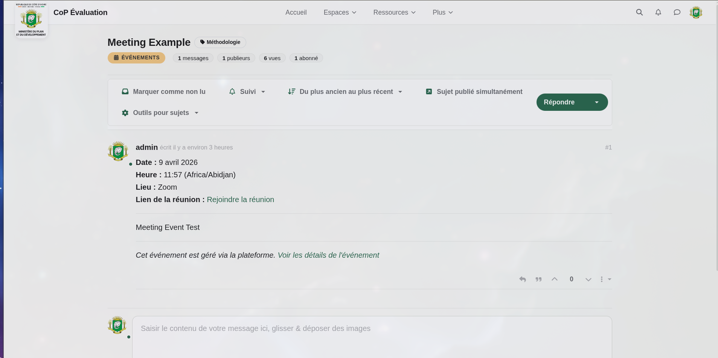
The auto-created discussion thread with event details and meeting link

Social Media Sharing
Social sharing buttons have been integrated into event detail pages, enabling members to share events on LinkedIn, Twitter/X, and Facebook. Open Graph metadata is generated automatically by NodeBB for all topics and pages, ensuring that shared links display rich previews with the correct title, description, and image.
- Share buttons — LinkedIn, Twitter/X, and Facebook sharing links are displayed on every event detail page.
- Open Graph metadata — Titles, descriptions, and images are embedded in page headers for rich link previews across social platforms.
- Access-gated content — Members-only content remains protected even when shared — visitors are prompted to log in before accessing restricted pages.

Email Notification System
The platform’s email notification system is fully operational. NodeBB’s built-in email capabilities handle verification, password resets, and notification delivery. SMTP delivery is configured through the admin panel — no code changes required.
Notifications supported:
- Email verification — New users must verify their email address before accessing the platform.
- Password reset — Secure password reset emails with a 2-hour expiry token.
- Topic reply notifications — Members are notified when someone replies to a topic they follow.
- @mention notifications — Members are notified when they are mentioned in a post.
- Reaction notifications — Members are notified when someone reacts to their post.
- Document approval notifications — Administrators and global moderators are notified when a new document is uploaded and awaiting approval.
- Preference controls — Each member can configure notification delivery per type: immediate, daily digest, weekly digest, or disabled.

Moderation & Administration
All moderation and administration capabilities are provided by NodeBB’s built-in tools, which have been verified and configured for the platform:
- Content moderation — Moderators can edit, move, lock, pin (with optional expiry), and delete posts and topics. Deleted content can be restored.
- Flag queue — Members can flag inappropriate content for moderator review via a centralized queue.
- Audit logging — All moderator and administrator actions are logged (40+ event types) for accountability.
- User management — Administrators can manage user accounts, roles, bans, and group memberships.
- Category management — Administrators can create, edit, reorder, and configure categories and their permissions.

How to Verify
Please visit https://cop-forum.onrender.com and confirm the following:

Event Management
- Navigate to Rencontres in the top menu — the events list page loads with search bar, region/sector filters, and list/calendar tabs
- Switch to the Calendrier tab — the month calendar view displays with event indicators
- Click “Créer une rencontre” — the event creation form appears with all fields (title, sector, region, location, banner, dates, meeting link, description)
- Create a test event with a Zoom or Teams meeting link
- The event appears in the list and calendar views
- Navigate to the event detail page — the hero banner, “Rejoindre la réunion” button, and all event details are displayed
- Click “Participer” — the RSVP is recorded and the participant count updates
- Click “Ajouter au calendrier” — a .ics file downloads
- Navigate to Événements in the Espaces menu — a discussion topic was automatically created for the event
- Open the discussion topic — the event details (date, time, location, meeting link) appear in the first post

Social Media Sharing
- On an event detail page, the social sharing icons (LinkedIn, Twitter/X, Facebook) are visible
- Click a share button — the corresponding platform opens with the event URL pre-filled
- Share an event link on any social platform — the link preview shows the correct title and description

Email Notifications
- Navigate to /admin/settings/email — SMTP settings are visible and configurable
- Configure SMTP credentials and send a test email from the admin panel
- Register a new account — a verification email is received
- Request a password reset — a reset email is received
- Reply to a followed topic — the topic author receives an email notification
- Check notification preferences in user settings — per-type controls (immediate/daily/weekly/disabled) are available

Moderation & Administration
- As a moderator, edit a post and verify the changes are saved
- Move a topic to a different category
- Lock and then unlock a topic
- Pin a topic with an expiry date
- Flag a post and verify it appears in the moderator flag queue
- Navigate to /admin/manage/users — user management tools are accessible
- Check /admin/advanced/events — moderator actions are logged

What Comes Next — Milestone 5
The final milestone focuses on AI-powered features and platform finalization:
- AI discussion summaries — A “Summarise this discussion” button on long threads, generating concise French-language summaries powered by a configurable AI provider (Gemini, OpenAI, or Anthropic).
- AI document summaries — Automatic 3–5 sentence summaries generated when documents are uploaded or approved, with caching and admin-configurable visibility.
- Catch-up digest — A “Catch me up” feature for members returning after an absence, summarizing recent activity across categories.
- Security & performance — Security audit, accessibility review, load testing, backup automation, and preparation of administrator handover documentation.

Prepared by the development team — LVZ Analytics Corp

