1. Simple Test

cd /path/to/emac/sim

./runsim

1. Choose different test cases for testing.

cd /path/to/emac/sim/script

wish runcase.tcl

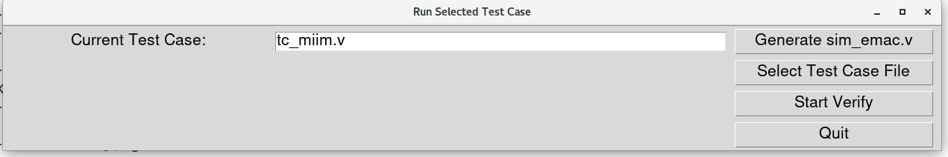

Click the “Select Test Case File” button.

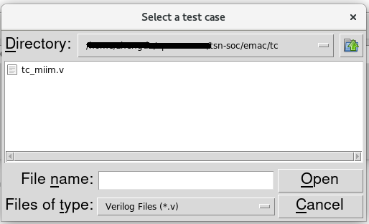

Choose the desired test case such as “tc_miim.v”, then close the pop - up dialog box.

Click the “Start Verify” button to execute the simulation.

