外 文 翻 译

毕业设计题目：兴趣班开团小程序

原文1：An e-Learning System Based on GWT and Spring MVC
译文1：一个基于Spring MVC 和 GAT的智能学习系统

原文2：About Microservices, Containers and their Underestimated Impact on Network Performance I
译文2：关于微服务，容器及其对网络性能的被低估的影响

An e-Learning System Based on GWT and Spring MVC
Abstract
A solution is presented which integrate the GWT and Spring MVC in the e-Learning system in this paper. The client-side is provided with widget support based on Ajax by using GWT, and the Spring MVC layer the project, make the project easy to maintain. Hibernate using the database configuration information to provide persistent services to application, and the persistent object. Google Web Toolkit (GWT) and Spring MVC are two frameworks that used in the web application. GWT is one of the sharp spike for Web UI development. Spring MVC and Hibernate as one mature rapid business application development architecture free US from the complicated business issues. Finally, the practice shows that the method presented by this paper enable the architecture to effectively improve the real-time requirements and human-computer interaction experience of e-Learning system.
Keywords: Web 2.0,GWT,Spring MVC,hibernate,framework

- INTRODUCTION
For e-Learning system, the main benefit of Ajax is a greatly improved user experience. Although JavaScript and DHTML — the technical foundations of Ajax — have been available for years, most programmers ignored them because they were difficult to master . Although most of the Ajax frameworks available today simplify development work, you still need a good grasp of the technology stack. So, if you’re planning to use Ajax to improve only your application's user experience — So, if you're planning to use Ajax to improve only your application’s user experience — if you’re not also using it as a strategic advantage for your business — it may be unwise to spend a lot of money and time on the technology.
Existing systems focus on the business data processing. It is difficult to adapt to variable business rules, business rules are difficult to express it. More is a simple test and data storage, display, cannot assist business logic to handle. Due to the system level is not clear, there are some disadvantages, poor reuse of software components, development, maintenance process is complicated; Operator switching between different systems and the operating interface is not friendly . Aiming at the abovemotioned problems, a solution of e-Learning system is proposed in this paper. Using the foreground and background interactive mode called by Remote Procedure Call (RPC) that is offered by GWT, the new solution carries on the decoupling between rich client and serverside, thus forming a kind of hierarchical and extensible eLearning system framework. On this basis according to the integration of GWT and Spring MVC, not only are the cost and complexity of e-Learning system reduced significantly but the human-computer interaction experience and realtime requirements are improved effectively.

- GWT AND SPRING MVC
Google offers another way to help Java developers create Ajax applications more productively. This new framework, called GWT. It uses Java as a single programming language for both the client and server sides. The GWT eliminates the complexity of hand coding HTML, JavaScript, and other elements that bind the JavaScript actions triggered in an HTML page (client-side code run within the user's browser) to the controlling layer executing within the Java EE application server (serverside, where the database resides). When developed within a good IDE, the GWT can provide an immeasurable advantage over other frameworks and considerably lower the cost and complexity of the project. And the relative simplicity of the language helps traditional developers become accustomed to the latest technologies .
Spring’s Web MVC framework is designed around a DispatcherServlet that dispatches requests to handlers, with configurable handler mappings, view resolution, locale and theme resolution as well as support for upload files. The default handler is a very simple Controller interface, just offering a ModelAndViewhandleRequest (request, response) method. This can already be used for application controllers, but you will prefer the included implementation hierarchy, consisting of, for example AbstractController, AbstractCommandCon-troller and SimpleFormController. Application controllers will typically be subclasses of those. Note that you can choose an appropriate base class: if you don't have a form, you don’t need a form controller. This is a major difference to Struts.
Spring MVC integration in Spring Web Flow. The Spring framework provides a full-featured MVC module to build Web applications. Using the Spring MVC architecture which can be inserted .Through policy interface, the Spring framework is highly configurable, and contains a variety of view technologies, Spring MVC separates the controller, the model object, dispatcher and the role of handler object. This separation makes them easier to customize. MVC is the core part of the WEB project development, as the decomposition of the three words, C (Controller) separate V (View, Client) and M (model, business) constitute MVC. The Spring annotations will make our work easier, by using the reflection mechanism of annotation is to solve the problem of a large number of configuration. In the configuration file with simple statement, can easily deal with all the request control project work. When using Spring MVC to do Java Web project, using the Spring framework's built-in filter CharacterEncodingFilter, to solve the problem of the garbled .
Dispatcher servlet binds Spring MVC together. This XML configuration file will be the one that register as our servlet in web.xml, and it’s the one that will receive all the HTTP requests to the site. Its responsibilities are as follows. Firstly, read the incoming request and delegate it to the appropriate Controller. Secondly, the controller resolve the view, means turning a request for the index view. Finally, the controller will then tell the resolved view to render the output by passing the model to the view.

- IMPLEMENTATION OF THE E-LEARNING SYSTEM
As Fig .1 showed, a kind of hierarchical and extensible e-Learning system is proposed in this paper. In this Fig .1, the rich client is deployed and run in the user's browser, and the layers of server-side is deployed and run in the Java EE application server, and the communication mode is Ajax between the two. The rich client is provided with widget by GWT based on Ajax. The framework proposed by this paper makes full use of the characteristic of GWT technology and obtains further depuration and encapsulation, which enable the framework more suitable for the design and development of specific eLearning system.
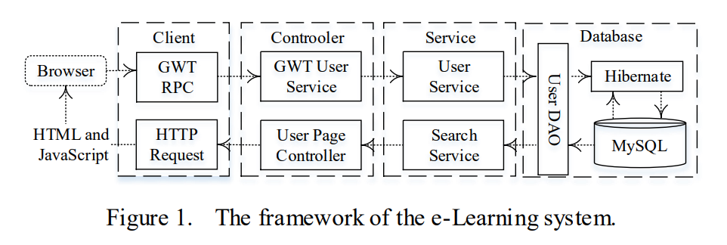
In Fig .1, it's the framework of e-learning application. The GWT services straddle the line between controllers and services, since they basically provide the HTTP processing capability of a controller and perform some GWT serialization work on the results from the service layer. The DAO layer contain the code make the results of our business processes persistent and query the database.
All business logic should be kept in the service layer because this is the place where it will be most reusable. Service objects are simple POJOs. The HTTPRequestobject used in a controller. Similarly, to keep the object relationship mapping (ORM) code in a DAO layer. This serves two purposes. First, it improves the testability of service layer. Accessing the database directly from within the business methods, we need to access the database when we unit test these services, which will complicate our unit tests considerably. With an injected DAO layer, to inject mock DAO objects instead, which will make unit tests far easier to do. Additionally, if we ever need to switch database or decide to use a different ORM tool, we’ll have an excellent buffer to isolate the effect of these changes.
- Rich UI Client-side
The client presentation layer is in charge of downstage interface display of e-Learning system, the implementation of which includes two parts: one is HTML, CSS, photograph and etc. that do not need GWT compiling; the others are Java interface codes that need be translated into JavaScript. The former is similar to the development of B/S mode, and the latter is mainly responsible for the management and use of GWT UI widget.
In order to embody the technical features of rich clientside, the functions of data cache and logic calculation should be provided in the client logic layer of client-side. Making full use of the computing capability of client-side can improve the response time of e-Learning system and reduce the load of server-side. The reusability and maintainability of client-side application can be improved significantly by designing the tool class of e-Learning system to implement the above functions.
Service calling layer is responsible for calling service offered by the service layer of server-side and returning the result to client logic layer and client presentation layer. In other words, the service calling layer decouple between foreground logic and background logic. According to each YourService in this layer, a YourServiceCaller class is designed. Both the construction of the service object and the access of operating the service object are encapsulating, which enable client-side to call the service by YourServiceCaller class. In doing so, it is implemented to centralized control of background service access in order to maintain the code.
- Service Layer
The class diagram of the GWT RPC service extended framework about e-Learning system is shown in Fig .2. By extending the RPC framework of GWT, e-Learning system not only implements the communications between the service calling layer and the server-side, but accomplishes the uniform control of the whole system service. According to the GWT RPC extended framework, as shown in Fig .2, the sequence diagram (Fig .3) below presents a typical flow of calls between the GWT RPC mechanism and MySQL Database.

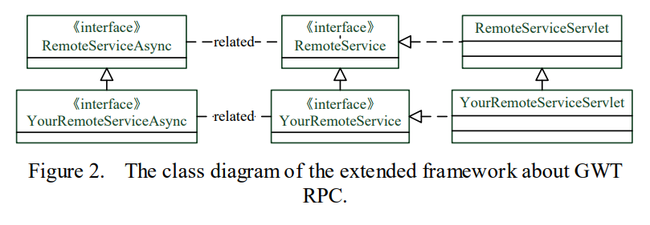

- The interaction in the system logic framework component
In the design of the architecture, the business developer only needs to develop five types of code: UIController, UIWidgct, Action, DAO and Entity. UI using the GWT framework, provides the UI development "UI management components" and "UI Widget components". The UI 657 management components have cache management. The object that mainly manage is: the current user information, system constants and the dynamic parameters that system commonly used and so on, to avoid the frequent transfer data in the foreground and the background. "UI Widget components" has tree components, dialog operation, paging box components and drawer components, etc. Developer’s use these components can quickly develops business module, not only improves the speed of development, also is beneficial to the accumulation of component in the future, reuse and maintain. "UI Widget component" is mainly responsible for rendering and input control interface, it does not call the background service. "UI Controller components" is mainly responsible for interactions with the data of the background services, management and scheduling Widget component.
"Action components" provide the business logic implementation, such as: the saving of announcement information, save announcement information first, and then submit for review. Action must use the interface to implements the separate design patterns, and to follow the AJAX of GWT calls specification, provide an asynchronous interface. Need to register in the Spring configuration file.
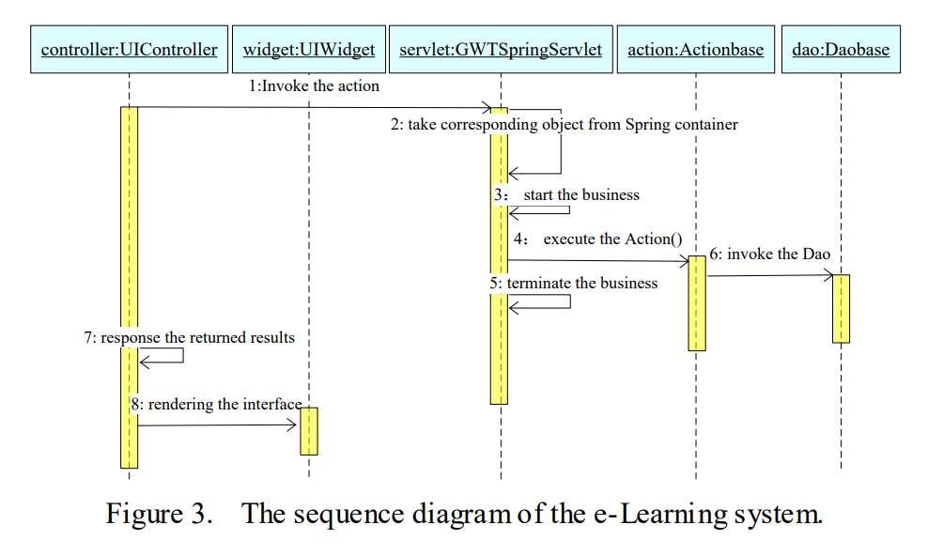
"GWTSpring integration components" implemented will GWT integration with Spring framework. In the Fig .3, GWTSpringServlet is "GWTSpring integration components", it as a WEB application service unified listening Servlet, UIController calls to back-end services are made by GWTSpringServlet route by and forward.GWTSpringServlet contains calls to the Spring container packaging, in a WEB application server startup, read the Spring configuration file, to initialize the Spring container.
"GWTSpring integration components" implements the integration between the GWT and Spring framework. GWTSpringServlet is "GWTSpringintegration components", it is a unified listening Servlet in WEB application service, UIController calls to back-end services are made by GWTSpringServlet route and transmit. GWTSpringServlet contains call and encapsulation to the Spring container, when the WEB application server startup, read the Spring configuration file, to initialize the Spring container. When UIController send the asynchronous AJAX request GWTSpringServlet inform the Spring container and instantiate the relevant Action .When the spring initialize a Bean instance, according to the Spring configuration file structure an instance, inject the dependent objects, such as: DAO or other Action. Before the call Action method, the Spring container will determine to start a transaction according to the configuration.
After the call method of Action terminate, Spring container will determine to submit an effective transaction or rollback transaction according to the configuration and code execution. Therefore, it is not necessary to write any sentences about transaction in the business development code. After UIController send the Action call request, the user can operate other interface, browser receives the results returns from Action, automatically send to the UIController. UIController getting the results, rendering the UIWidget component interface.
- Hibernate and GWT Serialization
Hibernate is an open source object-relational mapping framework, It has a very lightweight object encapsulation for JDBC, Java programmer can manipulate the database with object programming thinking. Hibernate can be used in any situation which use the JDBC .It can be not only used in Java client program, but also in the Servlet/JSP Web application. The most revolutionary is that Hibernate can replace the CMP in the J2EE application architecture which apply EJB, to complete data persistence.
Using XML mapping document for each Java class. Within that document, specify the name of the database table to map to and the columns that our object properties will be saved in. Hibernate use these mapping to automatically convert our Java objects into SQL select, insert, and update commands. For basic object properties, this is simple. Things get a little more complicated (but also more valuable) when we start letting Hibernate take care of persisting more complicated relationships, such as those for Map and Set. The GWT class named ServerSerializationStreamWriter class has an enumeration that matches incoming objects to the appropriate serialize. Listing 3-1 shows the first bit of this from the basic GWT class.
CLASS_TO_VALUE_WRITER.put(long.class, new ValueWriter() {
Public void write(ServerSerializationStream Writerstream, Objectinstance) throwsSerializationException {
stream.writeLong(((Long)instance).longValue()); }});

This Map collection is responsible for writing out the serialized value of incoming objects to the stream. So we can’t extend it. Being reduced to reworking the class is unfortunate but it works. Adding a method such as the one in Listing 3-2.

public void setValueWriter(Class clazz, ValueWriter writer) { CLASS_TO_VALUE_WRITER.put(clazz,writer); }

This method change ValueWriter into one of our own that executes our HibernateFilter. GWTController code in Listing 3-3.

private ServerSerializationStreamWriter1941 getWriter(Serialization PolicyserializationPolicy) { ServerSerializationStreamWriter1941writer=new ServerSeria lizationStream Writer1941(serializationPolicy); writer.setValueWriter(Object.class, new ValueWriter() { publicvoidwrite(ServerSerializationStreamWriter1941 stream, Objectinstance)throwsSerializationException { stream.writeObject(HibernateFilter.filter(instance)); } }); return writer;

When GWT Controller is asked for ServerSerializationStreamWriter, create one of our own design, and set the Objectstream writer to one that enacts HibernateFilter before the objects are serialized. That’s all need to do to prevent GWT deserialization from exploding when it deals with Hibernate objects.
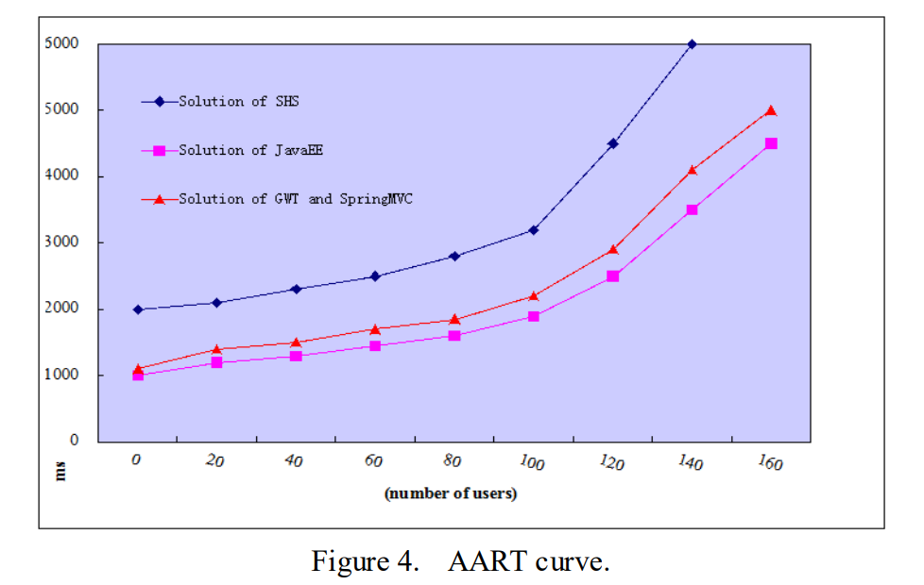
- FOOTNOTES
It is simulated that the client-side submits static and dynamic request to JavaEE application Server by browsers in real environment through the Grinder, in this paper. The testing scenario is information query in the first page of system, which can relate to view switching, curriculum screening, sorting, and pagination etc. The performance testing highlights the Java class in the lasting unit. The aggregate average response time (AART) of the system is shown as Fig .4.
When analyzing the AART curve in Fig .4, compared with the e-Learning system solutions of and, we can find that the system response time of the solution proposed by this paper may increase according to the curve until it reaches 100 users. After that time, the increase of the curve changes more acutely. Through analyzing the changing tendency of curves, in the performance test, the application's maximum limit on the number of users is 100, so it meets the needs of the application service. The solution of GWT and Spring MVC is close to the Solution of JavaEE AART. This solution is a very effective solution.It has high development efficiency, and it's easy to manage and maintain the E-learning system at the same time. Finally, in this paper how to improve e-Learning system construction is also discussed which has some guiding significance for the application and development of the e-Learning system construction in the network teaching field. ACKNOWLEDGMENT This work was supported by the Science and Technology Project of Education Department of Liaoning Province (Research of e-Learning System of Small and Medium-Size Enterprises Based on SaaS, No. L2013417).

作者：Bo Song, Yejun Zhang
国籍：中国
出处：International Conference on Mechatronics, Control and Electronic Engineering (MCE 2014)

一个基于Spring MVC 和 GAT的智能学习系统
摘要
本文提出了一个将GWT和Spring MVC集成到电子学习系统中的解决方案。 客户端通过使用GWT提供基于Ajax的widget支持，Spring MVC层为项目，使项目易于维护。 Hibernate使用数据库配置信息为应用程序和持久对象提供持久服务。 Google Web Toolkit（GWT）和Spring MVC是Web应用程序中使用的两个框架。 GWT是Web UI开发的尖峰之一。 Spring MVC和Hibernate作为一个成熟的快速商业应用程序开发架构，免费从复杂的业务问题中解脱出来。 最后通过实践证明，本文提出的方法使得架构能够有效地提高电子学习系统的实时性要求和人机交互体验。
关键词：Web 2.0,GWT,Spring MVC,hibernate,framework
1.介绍
对于电子学习系统，Ajax的主要好处是大大改善了用户体验。尽管JavaScript和DHTML（Ajax的技术基础）已经可用多年，但大多数程序员忽视了它们，因为它们很难掌握。尽管今天大部分Ajax框架可以简化开发工作，但您仍然需要掌握好技术堆栈。因此，如果您计划使用Ajax来改善应用程序的用户体验，那么，如果您计划使用Ajax来改善应用程序的用户体验 - 如果您还没有将其用作您的应用程序的战略优势企业 - 花费大量金钱和时间在技术上可能是不明智的。 现有系统专注于业务数据处理。很难适应变化的业务规则，业务规则很难表达出来。更多的是简单的测试和数据存储，显示，不能协助业务逻辑处理。由于系统层面不清晰，存在一些缺点，软件组件的重用性差，开发，维护过程复杂;不同系统和操作界面之间的操作员切换不友好。针对上述问题，本文提出了一个电子学习系统的解决方案。利用GWT提供的远程过程调用（Remote Procedure Call，RPC）调用的前后台交互模式，新方案将富客户端与服务器端进行解耦，形成一种层次化，可扩展的电子学习系统框架。在此基础上，根据GWT和Spring MVC的整合，不仅使e-Learning系统的成本和复杂度显着降低，而且有效地改善了人机交互体验和实时性要求。

- GWT 和SPRING MVC
Google提供了另一种方法来帮助Java开发人员更高效地创建Ajax应用程序。这个新的框架，称为GWT。它使用Java作为客户端和服务器端的单一编程语言。 GWT消除了将HTML页面（在用户浏览器中运行的客户端代码）中触发的JavaScript操作绑定到在Java EE应用程序服务器内执行的控制层的手动编码HTML，JavaScript和其他元素的复杂性（服务器端，数据库驻留在哪里）。
当在一个好的IDE中开发时，GWT可以提供超越其他框架的不可估量的优势，大大降低项目的成本和复杂性。语言相对简单，有助于传统开发人员习惯于最新的技术。
Spring的Web MVC框架是围绕DispatcherServlet设计的，它将请求分派给处理程序，具有可配置的处理程序映射，视图分辨率，区域设置和主题解析以及对上载文件的支持。默认处理程序是一个非常简单的Controller接口，只是提供一个ModelAndViewhandleRequest（request，response）方法。这已经可以用于应用程序控制器，但是您更喜欢包含的实现层次结构，例如AbstractController，AbstractCommandCon-troller和SimpleFormController。应用程序控制器通常是这些的子类。请注意，您可以选择适当的基类：如果您没有表单，则不需要表单控制器。这是Struts的主要区别。
Spring Web Flow中的Spring MVC集成。 Spring框架提供了一个全功能的MVC模块来构建Web应用程序。使用可插入的Spring MVC体系结构。通过策略接口，Spring框架是高度可配置的，并且包含了各种视图技术，Spring MVC将控制器，模型对象，调度器和处理程序对象的角色分开。这种分离使得他们更容易定制。 MVC是WEB项目开发的核心部分，由于分解了三个词，C（Controller）分离出V（View，Client）和M（Model，Business）构成MVC。 Spring注释将使我们的工作更容易，通过使用注释的反射机制来解决大量配置的问题。在简单语句的配置文件中，可以轻松处理所有请求控制项目的工作。当使用Spring MVC做Java Web项目时，使用Spring框架的内置过滤器CharacterEncodingFilter，来解决乱码的问题。
Dispatcher servlet将Spring MVC绑定在一起。这个XML配置文件将在web.xml中注册为我们的servlet，它将接收所有到站点的HTTP请求。其职责如下。首先，读取传入的请求并将其委托给适当的Controller。其次，控制器解析视图，意味着转向索引视图的请求。最后，控制器会通过将模型传递给视图来告诉解析的视图来渲染输出。
3.智能学习系统的实施
如图1所示，本文提出了一种分层和可扩展的在线学习系统。 在图1中，胖客户端部署在用户浏览器中运行，服务器端部署在Java EE应用服务器中运行，通信模式为Ajax。 GWT基于Ajax提供了丰富的客户端。 本文提出的框架充分利用GWT技术的特点，进一步净化和封装，使框架更适合于具体的电子学习系统的设计和开发。3.1.表示层框架Struts
在图1中，这是电子学习应用程序的框架。 GWT服务跨越了控制器和服务之间的界限，因为它们基本上提供了控制器的HTTP处理能力，并对服务层的结果进行了一些GWT序列化工作。 DAO层包含代码，使业务流程的结果持久化并查询数据库。
所有的业务逻辑应该保留在服务层，因为这是最可重用的地方。服务对象是简单的POJO。控制器中使用的HTTPRequest对象。同样，要将对象关系映射（ORM）代码保留在DAO层中。这有两个目的。首先，它提高了服务层的可测试性。直接从业务方法中访问数据库，当我们单元测试这些服务时，我们需要访问数据库，这将使我们的单元测试变得相当复杂。使用注入的DAO层，注入模拟DAO对象，这将使得单元测试更容易完成。此外，如果我们需要切换数据库或决定使用不同的ORM工具，我们将有一个很好的缓冲区来隔离这些变化的影响。

- 丰富的UI客户端
客户端表示层负责电子学习系统的前台界面显示，其实现包括HTML，CSS，照片等两部分，不需要GWT编译;其他的是需要翻译成JavaScript的Java接口代码。前者类似于B / S模式的开发，后者主要负责GWT UI小部件的管理和使用。
为了体现富客户端的技术特点，需要在客户端的客户端逻辑层提供数据缓存和逻辑计算等功能。充分利用客户端的计算能力，可以缩短电子学习系统的响应时间，减轻服务器端的负担。通过设计电子学习系统的工具类来实现上述功能，可以大大提高客户端应用的可重用性和可维护性。
服务调用层负责调用服务器端服务层提供的服务，并将结果返回给客户端逻辑层和客户端表示层。换句话说，服务调用层在前台逻辑和后台逻辑之间分离。根据此层中的每个YourService，设计一个YourServiceCaller类。服务对象的构造和操作服务对象的访问都是封装的，使得客户端可以通过YourServiceCaller类来调用服务。这样做是为了维护代码而实现对后台服务访问的集中控制。

- 服务层
图2显示了GWT RPC服务扩展框架关于e-Learning系统的类图。 通过扩展GWT的RPC框架，e-Learning系统不仅实现了服务调用层与服务器端之间的通信，而且实现了整个系统服务的统一控制。 根据GWT RPC扩展框架，如图2所示，下面的序列图（图3）给出了GWT RPC机制和MySQL数据库之间的典型的调用流程。

- 系统逻辑框架组件中的交互
在架构设计中，业务开发人员只需要开发五种类型的代码：UIController，UIWidgct，Action，DAO和Entity。使用GWT框架的UI，提供了UI开发“UI管理组件”和“UI Widget组件”。 UI 657管理组件具有缓存管理。主要管理的对象是：当前的用户信息，系统常用的和系统常用的动态参数等，以避免在前台和后台频繁传输数据。 “UI Widget组件”包括树组件，对话框操作，分页框组件和抽屉组件等。
开发者使用这些组件可以快速开发业务模块，不仅提高了开发速度，而且有利于组件的未来积累，重用和维护。 “UI Widget组件”主要负责渲染和输入控制界面，不调用后台服务。 “UI Controller组件”主要负责与后台服务，管理和调度Widget组件的数据交互。
“动作组件”提供了业务逻辑的实现，如：公告信息的保存，首先保存公告信息，然后提交审查。 Action必须使用接口来实现独立的设计模式，并遵循GWT调用规范的AJAX，提供一个异步接口。需要在Spring配置文件中注册。
“GWTSpring集成组件”实现了GWT与Spring框架的集成。在图3中，GWTSpringServlet是“GWTSpring集成组件”，它作为一个WEB应用服务统一监听Servlet，UIController对后端服务的调用都是由GWTSpringServlet进行路由和转发.GTSTSpringServlet包含了对Spring容器打包的调用，在一个WEB应用服务器启动，读取Spring配置文件，初始化Spring容器。
“GWTSpring集成组件”实现了GWT和Spring框架之间的集成。 GWTSpringServlet是“GWTSpringintegration组件”，它是在WEB应用服务中统一监听Servlet，UIController对后端服务的调用是由GWTSpringServlet路由和传输制作的。 GWTSpringServlet包含对Spring容器的调用和封装，当WEB应用服务器启动时，读取Spring配置文件，初始化Spring容器。
当UIController发送异步的AJAX请求时，GWTSpringServlet通知Spring容器并实例化相关的Action。当Spring初始化一个Bean实例时，根据Spring配置文件结构实例注入依赖对象，如：DAO或其他Action。在调用Action方法之前，Spring容器将根据配置决定启动一个事务。
在Action的调用方法终止后，Spring容器将根据配置和代码的执行情况决定是否提交一个有效的事务或回滚事务。因此，没有必要在业务开发代码中编写任何有关交易的句子。
UIController发送Action调用请求后，用户可以操作其他接口，浏览器接收到Action返回的结果，自动发送给UIController。 UIController获取结果，呈现UIWidget组件接口。

- Hibernate和GWT序列化
Hibernate是一个开源的对象关系映射框架，它有一个非常轻量级的JDBC对象封装，Java程序员可以用对象编程思想操纵数据库。 Hibernate可以在任何使用JDBC的情况下使用，不仅可以用于Java客户端程序，也可以用于Servlet / JSP Web应用程序。最具革命性的是Hibernate可以取代应用EJB的J2EE应用程序架构中的CMP来完成数据持久化。
为每个Java类使用XML映射文档。在该文档中，指定要映射到的数据库表的名称以及对象属性将保存的列.Hibernate使用这些映射来自动将我们的Java对象转换为SQL选择，插入和更新命令。对于基本的对象属性，这很简单。当我们开始让Hibernate处理更复杂的关系（比如Map和Set）时，事情会变得更复杂一些（但也更有价值）。名为ServerSerializationStreamWriter类的GWT类具有一个枚举，将传入对象与适当的序列化相匹配。清单3-1显示了基本GWT类中的第一位。
CLASS_TO_VALUE_WRITER.put(long.class, new ValueWriter() {
Public void write(ServerSerializationStream Writerstream, Objectinstance) throwsSerializationException {
stream.writeLong(((Long)instance).longValue()); }});
该Map集合负责将传入对象的序列化值写入流中。 所以我们不能扩展它。 减少到重新班级是不幸的，但它的工作。 添加一个如清单3-2所示的方法。
public void setValueWriter(Class clazz, ValueWriter writer) { CLASS_TO_VALUE_WRITER.put(clazz,writer); }
这个方法改变了ValueWriter到我们自己的执行我们的HibernateFilter。 清单3-3中的GWTController代码。
private ServerSerializationStreamWriter1941 getWriter(Serialization PolicyserializationPolicy) { ServerSerializationStreamWriter1941writer=new ServerSeria lizationStream Writer1941(serializationPolicy); writer.setValueWriter(Object.class, new ValueWriter() { publicvoidwrite(ServerSerializationStreamWriter1941 stream, Objectinstance)throwsSerializationException { stream.writeObject(HibernateFilter.filter(instance)); } }); return writer;
当GWT控制器被请求ServerSerializationStreamWriter时，创建一个我们自己的设计，并将Objectstream编写器设置为在对象序列化之前执行HibernateFilter的编写器。 这是所有需要做的，以防止处理Hibernate对象的GWT反序列化过载。

4.FOOTNOTES
本文通过Grinder模拟客户端通过浏览器在真实环境中向JavaEE应用服务器提交静态和动态请求。测试场景是系统首页的信息查询，涉及到视图切换，课程筛选，排序，分页等。性能测试突出了持久化单元中的Java类。系统的总体平均响应时间（AART）如图4所示。
在分析图4中的AART曲线时，与本文提出的e-Learning系统解决方案相比，本文提出的解决方案的系统响应时间可以按曲线增加，直到达到100个用户。此后，曲线的增长变化更为剧烈。通过分析曲线的变化趋势，在性能测试中，应用程序对用户数量的最大限制是100，因此它满足了应用程序服务的需求。 GWT和Spring MVC的解决方案接近JavaEE AART的解决方案。这个解决方案是一个非常有效的解决方案，它具有很高的开发效率，同时对E-learning系统的管理和维护也很方便。最后，本文还讨论了如何改进网络教学系统的构建，对网络教学系统在网络教学系统建设中的应用和发展具有一定的指导意义。致谢本文得到辽宁省教育厅科技计划项目（基于SaaS的中小企业电子学习系统研究，L2013417）的支持。

About Microservices, Containers
and their Underestimated Impact on Network Performance
Abstract
Microservices are used to build complex applications composed of small, independent and highly decoupled processes. Recently, microservices are often mentioned in one breath with container technologies like Docker. That is why operating system virtualization experiences a renaissance in cloud computing. These approaches shall provide horizontally scalable, easily deployable systems and a high-performance alternative to hypervisors. Nevertheless, performance impacts of containers on top of hypervisors are hardly investigated. Furthermore, microservice frameworks often come along with software defined networks. This contribution presents benchmark results to quantify the impacts of container, software defined networking and encryption on network performance. Even containers, although postulated to be lightweight, show a noteworthy impact to network performance. These impacts can be minimized on several system layers. Some design recommendations for cloud deployed systems following the microservice architecture pattern are derived.
Keywords–Microservice; Container; Docker; Software Defined Network; Performance

- INTRODUCTION
Microservices are applied by companies like Amazon, Net- flix, or SoundCloud. This architecture pattern is used to build big, complex and horizontally scalable applications composed of small, independent and highly decoupled processes communicating with each other using language-agnostic application programming interfaces (API). Microservice approaches and container-based operating system virtualization experience a renaissance in cloud computing. Especially container-based virtualization approaches are often mentioned to be a highperformance alternative to hypervisors. Docker is such a container solution, and it is based on operating system virtualization using Linux containers. Recent performance studies show only little performance impacts to processing, memory, network or I/O . That is why Docker proclaims itself a ”lightweight virtualization platform” providing a standard runtime, image format, and build system for Linux containers deployable to any Infrastructure as a Service (IaaS) environment.
This study investigated the performance impact of Linux containers on top of hypervisor based virtual machines logically connected by an (encrypted) overlay network. This is a common use case in IaaS Cloud Computing being applied by popular microservice platforms like Mesos, CoreOS or Kubernetes (the reader may want to study a detailed analysis of such kind of platforms ). Nevertheless, corresponding performance impacts have been hardly investigated so far. Distributed cloud based microservice systems of typical complexity often use hypertext transfer protocol (HTTP) based and representational state transfer (REST) styled protocols to enable horizontally scalable system designs. If these systems are deployed in public clouds, additional requirements for encrypted data transfer arise. There exist several open source projects providing such a microservice approach on top of IaaS provider specific infrastructures using this approach (e.g. Mesos, Kubernetes, CoreOS and more). These approaches are intended to be deployable to public or private IaaS infrastructures. So in fact, these approaches apply operating system virtualization (containers) on top of hypervisors (IaaS infrastructures). Although almost all of these microservice frameworks rely heavily on the combination of containerization on top of hypervisors, and some of these approaches introduce additional overlay networking and data encryption layers, corresponding performance impacts have been hardly analyzed so far. Most performance studies compare container performance with virtual machine performance but not container performance on top of virtual machines (see Felter at al. for a typical performance study).
Because overlay networks are often reduced to distributed hashtable (DHT) or peer-to-peer approaches, this paper uses the term software defined virtual networks (SDVN). SDVNs, in the understanding of this paper, are used to provide a logical internet protocol (IP) network for containers on top of IaaS infrastructures.
Section II presents related work about state-of-the-art container approaches and SDVN solutions. Section III explains the experiment design to identify performance impacts of containers, SDVNs and encryption. The benchmark tooling and the performance data collected is provided online . Resulting performance impacts are discussed in Section IV. Derived design recommendations to minimize performance impacts on application, overlay network and IaaS infrastructure layer are presented in concluding Section V

- RELATED WORK
Although container based operating system virtualization is postulated to be a scalable and high-performance alternative to hypervisors, hypervisors are the standard approach for IaaS cloud computing . Felter et al. provided a very detailed analysis on CPU, memory, storage and networking resources to explore the performance of traditional virtual machine deployments, and contrast them with the use of Linux containers provided via Docker. Their results indicate that benchmarks that have been run in a Docker container
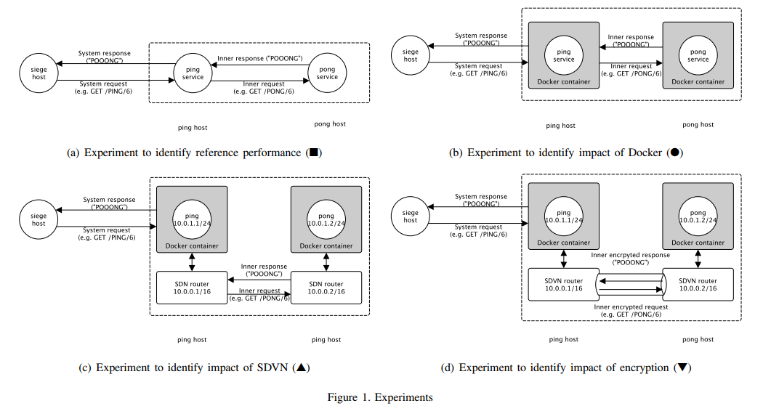
show almost the same performance (floating point processing, memory transfers, network bandwidth and latencies, block I/O and database performances) like benchmarks run on ”bare metal” systems. Nevertheless, Felter et al. did not analyze the impact of containers on top of hypervisors. Although there exist several SDVN solutions for Docker, only one open source based SDVN has been identified, which is able to encrypt underlying data transfers: Weave. That is why other SDVN approaches for Docker like flannel or docknet are not covered by this study. Pure virtual local area network (VLAN) solutions like Open vSwitch (OVS) are not considered, because OVS is not to be designed for operating system virtualization. So, weave remained as the only appropriate SDVN candidate for this study. But the author is confident that this will change in the future and more encryptable SDVN solutions will arise. Weave creates a network bridge on Docker hosts to enable SDVN for Docker containers. Each container on a host is connected to that bridge. A weave router captures Ethernet packets from its bridge-connected interface in promiscuous mode. Captured packets are forwarded over the user datagram protocol (UDP) to weave router peers running on other hosts. These UDP ”connections” are duplex, can traverse firewalls and can be encrypted. To analyze the performance impact of containers, software defined networks and encryption, this paper considered several contributions on cloud related network performance analysis. But none of these contributions focused explicitly on horizontally scalable systems with HTTP-based and REST-like protocols. To address this common use case for microservice architectures, this paper proposes the following experiment design.

- EXPERIMENT DESIGN
This study analyzed the network performance impact of container, SDVN and encryption layers on the performance impact of distributed cloud based systems using HTTP-based REST-based protocols. Therefore, five experiments have been designed (see Figure 1). The analyzed ping-pong system relied on a REST-like and HTTP-based protocol to exchange data. Apachebench was used to collect performance data of the ping-pong system. Siege, ping and pong servers have been deployed to the Amazon Web Services (AWS) IaaS infrastructure on a m3.medium instance type. Experiments have been run in eu-west-1c availability zone (Ireland). The siege server run the apachebench benchmark. The ping and pong application were developed using Googles Dart programming language. To understand the performance impact of containers, SDVN and encryption to network performance, the study analyzed the data transfer rate trans(m) of m byte long messages.
■ The reference experiment shown in Figure 1(a), was used to collect reference performance data of the ping-pong system deployed to different virtual machines interacting with a REST-like and HTTP based protocol. No containers, SDVN or encryption were used in this experiment. Further experiments added a container, a SDVN and an encryption layer to measure their impact on network performance. A ping host interacts with a pong host to provide its service. Whenever the ping host is requested by siege host, the ping host relays the original request to the pong host. The pong host answers the request with a response message. The siege host can define the inner message and system response message length by query. All requests are performed using the HTTP protocol. The siege host is used to run several apachebench benchmark runs with increasing requested message sizes to measure the system performance of the ping-pong system. This paper refers to measured transfer rates for a message size of m (bytes) of this experiment as trans(m).
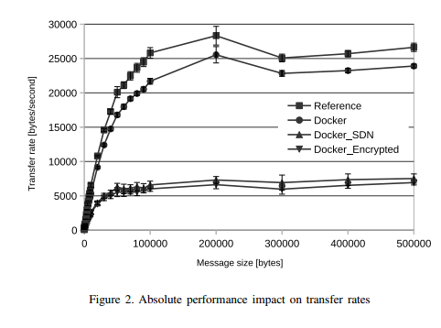
These absolute values are presented in Figure 2. ● The intent of the Docker experiment was to figure out the impact of an additional container layer to network performance (Figure 1(b)). So, the ping and pong services are provided as containers to add an additional container layer to the reference experiment. Every performance impact must be due to this container layer. The measured transfer rates are denominated as trans (m). The impact of containers on transfer rates is calculated as follows and presented in Figure 3(a):
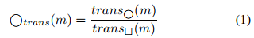

▲ The intent of the SDVN experiment shown in Figure 1(c) was to figure out the impact of an additional SDVN layer to network performance. This experiment connects ping and pong containers by a SDVN. So, every data transfer must pass the SDVN solution between ping and pong. This paper refers to measured transfer rates for a message size of m (bytes) of this experiment as trans∆(m). The impact of SDVN on transfer rates for a message size m is calculated as follows and presented in Figure 3(a):
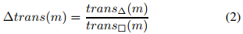
▼ The encryption experiment (see Figure 1(d)) figured out the impact of an additional data encryption layer on top of a SDVN layer. Additionally, this experiment encrypts the SDVN network. Corresponding measured transfer rates are denominated as trans∇(m). The impact of SDVN on transfer rates for a message size m is calculated as follows and is presented in Figure 3(a):
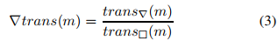
◮◭ The intent of cross-regional experiment was to figure out the impact of an cross-regional deployment to network performance. Although this was not the main focus of the study, this use case has been taken into consideration to generate a more graspable performance impact understanding for the reader. The setting has been the same as in Figure 1(a), except that the ping and pong hosts were deployed to different regions of the AWS infrastructure. ping (and the siege host) were deployed to the AWS region eu-west-1c (EU, Ireland) and the pong host was deployed to AWS region apnortheast-1c (Japan, Tokyo). Data from this experiment is only used to compare container, SDVN and encrypted SDVN performance with a cross-regional performance impact in a qualitative manner. A cross-regional impact might be more intuitively graspable for the reader. The cross-regional impact on transfer rates is presented in Figure 3(a) as a lightgrey line.
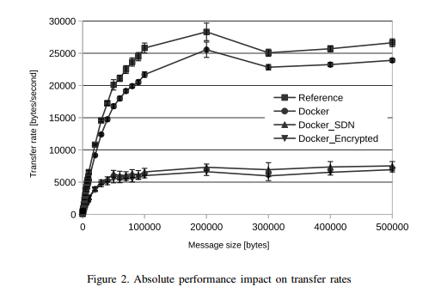

- DISCUSSION OF RESULTS
The results presented are based on more than 12 hours of benchmark runs, which resulted in a transfer of over 316GB of data requested by more than 6 million HTTP requests (see Table I). Reference and Docker experiments show only minor standard deviations. The maximum deviations were measured for very small message sizes (10 and 20 byte). Standard deviations increased with the introduction of SDVN. So, the collected deviation data indicates that the experiment setting produces reliable data (increasing deviations of SDVN experiment have to do with the technical impacts of SDVNs, they are not due to experiment design and will be discussed by this paper).
Containers are stated to be lightweight and to have only negligible performance impacts. The Docker experiment shows a somewhat different picture. A non negligible performance loss can be identified for data transfer rates (see Figure 2). An additional container layer on top of a bare virtual machine reduces the performance to 80% (for message sizes smaller than 100 kBytes) to 90% (for message sizes greater than 100kBytes). The study also included a cross-zone deployment (similar to the cross-region deployment but in two different availability zones of the same AWS region). It turned out that a cross-zone deployment shows almost the same performance like an one-zone deployment. Containers show a significant higher performance impact than cross-zone deployments in IaaS clouds. So, compared with cross-zone deployments (nonmeasurable effects), we have to say that containers have measurable (non-negligible) impacts to network performance.
▲ SDVN impact: The impact of analyzed SDVN solution weave reduces data transfer rates from 25 kB/s to about 7,5kB/s (see Figure 2). Figure 3a shows the relative performance of the SDVN experiment. SDVN experiments show only 60% performance of the reference experiment for small message sizes going down to about 25% performance for message sizes greater than 100kB. The SDVN experiment shows a comparable performance impact like a cross-regional deployment (for big message sizes, Ireland ↔ Japan). Weave SDVN routers are provided as Docker containers. The SDVN experiment measures the performance impact of containerization and SDVN. To identify the pure SDVN effect, the reader has to compare SDVN data (∆) relative to the performance data of containers ( ) to exclude the container effects (see Figure 3b).
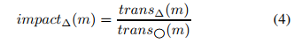
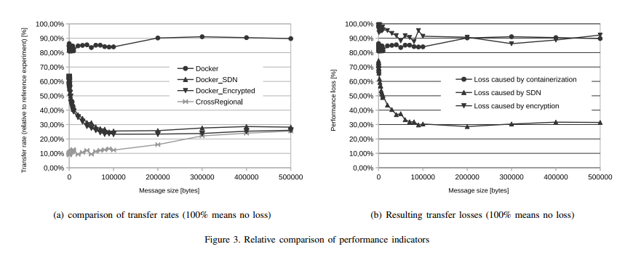
To avoid container losses, SDVN solutions should be provided directly on the host and not in a containerized form. This should reduce the performance loss about 10% to 20%. Furthermore, it is noted that tests were running on a singlecore virtual machine (m3.medium type). In saturated network load situations, the weave router contends for CPU with the application processes, so it will saturate faster compared with Reference or Docker experiment where the network is handled by the hypervisor and physical network, outside of such contention. This effect explains the severe performance impacts shown in Figure 3. That lead us to the design conclusion that SDVN solutions should always run on multi-core systems to avoid severe performance impacts due to contention. ▼ Encryption impact: Additional encryption shows only minor impacts to transfer rates compared with SDVN without encryption (see Figure 2). So, most of the performance losses are due to SDVN and not because of encryption. To identify the pure encryption effect, encrypted SDVN data (∇) has to be compared relative to the performance data of SDVN experiment (∆).
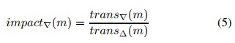
Encryption reduces the transfer performance down to about 90% compared with the transfer rates of non encrypted data transfers. For smaller message sizes this negative effect of encryption gets even more and more negligible. In other words, especially for small message sizes encryption is not a substantial performance killer compared to SDVN impact (see Figure 3b). For bigger message sizes the data transfer performance impact of encryption is comparable to containerization.
- CONCLUSION
This study analyzed performance impact of containers, overlay networks and encryption to overall network performance of HTTP-based and REST-like services deployed to IaaS cloud infrastructures. Obviously, our conclusions should be cross checked with other SDVN solutions for containers. The provided data and benchmarking tools to apply the presented methodologycan be used as benchmark for that purpose. Nevertheless, some of the study results can be used to derive some design recommendations for cloud deployed HTTP-based and REST-like systems of general applicability.
Although containers are stated to be lightweight , this study shows that container impact on network performance is not negligible. Containers show a performance impact of about 10% to 20%. The impact of overlay networks can be even worse. The analyzed SDVN solution showed a performance impact of about 30% to 70%, which is comparable to a cross regional deployment of a service between Ireland and Japan. Encryption performance loss is minor, especially for small message sizes.
The results show that performance impacts of overlay networks can be minimized on several layers. On application layer message sizes between system components should be minimized whenever possible. Network performance impact gets worse with increasing message sizes. On overlay network layer performance could be optimized by 10% to 20% by providing SDVN router applications directly on the host (in a not containerized form, because 10% to 20% are due to general container losses). On infrastructure layer, the SDVN routers should be deployed to multi core virtual machines to avoid situations, where SDVN routers contend for CPU with application processes.
So containers, which are often mentioned to be lightweight, are not lightweight under all circumstances. Nevertheless, the reader should not conclude to avoid container and SDVN technologies in general. Container and SDVN technologies provide more flexibility and manageability in designing complex horizontally scalable distributed cloud systems. And there is nothing wrong about flexibility and manageability of complex systems. That is why container solutions like Docker and microservice approaches regain so much attention recently. But container and SDVN technologies should be always used with above mentioned performance implications in mind.
ACKNOWLEDGMENT
This study was funded by German Federal Ministry of Education and Research (Project Cloud TRANSIT, 03FH021PX4). The author thanks L ¨ubeck University (Institute of Telematics) and fat IT solution GmbH (Kiel) for their support of Cloud TRANSIT. The author also thanks Bryan Boreham of zett.io for checking our data of zett.io’s weave solution (which might show now better results than the analyzed first version of weave).

作者：Nane Kratzke
国籍：德国
出处：Lubeck University of Applied Sciences, Center of Excellence CoSA Lubeck, Germany

关于微服务，容器
及其对网络性能的被低估的影响
摘要
微服务用于构建由小型，独立和高度分离的进程组成的复杂应用程序。最近，像Docker这样的容器技术常常提到微服务。这就是操作系统虚拟化在云计算中经历复兴的原因。这些方法将提供可横向扩展的，易于部署的系统，以及管理程序的高性能替代品。尽管如此，容器在虚拟机管理程序之上的性能影响很难被调查。而且，微服务框架通常与软件定义的网络一起出现。这一贡献提供了基准结果，以量化容器，软件定义的网络和加密对网络性能的影响。即使容器被认为是轻量级的，也会对网络性能产生显着的影响。这些影响可以在几个系统层面上最小化。派生出一些遵循微服务架构模式的云部署系统的设计建议。
关键词：Microservice; Container; Docker; Software Defined Network; Performance

1.介绍
微服务由Amazon，Netflix或SoundCloud等公司应用。这种体系结构模式用于构建大型，复杂和水平可伸缩的应用程序，这些应用程序使用语言无关的应用程序编程接口（API）与小型，独立和高度解耦的进程进行通信。微服务方法和基于容器的操作系统虚拟化经历了云计算的复兴。特别是基于容器的虚拟化方法通常被认为是管理程序的高性能替代方案。 Docker就是这样一个容器解决方案，它基于使用Linux容器的操作系统虚拟化。最近的性能研究表明，对处理，内存，网络或I / O只有很小的性能影响。这就是为什么Docker宣称自己是一个“轻量级虚拟化平台”，为可部署到任何基础架构即服务（IaaS）环境的Linux容器提供标准运行时，映像格式和构建系统。
本研究调查了Linux容器在基于虚拟机管理程序的虚拟机之上的性能影响，该虚拟机通过（加密）覆盖网络进行逻辑连接。这是IaaS云计算中常见的应用案例，由Mesos，CoreOS或Kubernetes等流行的微服务平台应用（读者可能希望研究这类平台的详细分析）。尽管如此，相应的绩效影响至今尚未被调查。典型复杂度的基于分布式云的微服务系统通常使用基于超文本传输​​协议（HTTP）和代表性状态传输（REST）样式的协议来实现水平可扩展的系统设计。如果这些系统部署在公共云中，则会出现对加密数据传输的额外要求。现在有几个开源项目在使用这种方法（例如Mesos，Kubernetes，CoreOS等）的基础设施提供商特定基础设施之上提供这种微服务方法。这些方法旨在可以部署到公共或私人IaaS基础设施。所以实际上，这些方法在虚拟机管理程序（IaaS基础架构）之上应用了操作系统虚拟化（容器）。尽管几乎所有这些微服务框架都严重依赖于管理程序之上的集装箱化组合，而其中一些方法引入了额外的覆盖网络和数据加密层，但迄今为止相应的性能影响还很难分析。大多数性能研究都将容器性能与虚拟机性能进行了比较，而不是在虚拟机之上的容器性能（请参阅Felter等人的典型性能研究）。
由于覆盖网络通常被简化为分布式哈希表（DHT）或点对点方法，本文使用术语软件定义的虚拟网络（SDVN）。在理解本文时，SDVN用于为IaaS基础设施之上的容器提供逻辑网络协议（IP）网络。
第二部分介绍了有关最先进的集装箱方法和SDVN解决方案的相关工作。第三部分解释了实验设计，以确定容器，SDVN和加密的性能影响。在线提供基准工具和收集的性能数据。第四部分讨论了最终的绩效影响。第五部分介绍了派生设计建议，以尽量减少对应用，覆盖网络和IaaS基础设施层的性能影响。

2.相关工作
尽管基于容器的操作系统虚拟化被认为是管理程序的可扩展性和高性能替代，但管理程序是IaaS云计算的标准方法。 Felter等人 对CPU，内存，存储和网络资源进行了非常详细的分析，以探索传统虚拟机部署的性能，并将其与使用通过Docker提供的Linux容器进行对比。 他们的结果表明已经在Docker容器中运行的基准测试
与“裸机”系统上运行的基准一样，性能（浮点处理，内存传输，网络带宽和延迟，块I / O和数据库性能）几乎相同。尽管如此，Felter等人没有分析虚拟机管理程序之上的容器的影响。尽管存在多个用于Docker的SDVN解决方案，但只有一个基于开放源码的SDVN已被识别，其能够加密底层数据传输：编织。这就是为什么其他的SDVN方法，像法兰绒或码头的Docker不包括在这项研究。纯虚拟局域网（VLAN）解决方案（如Open vSwitch（OVS））不予考虑，因为OVS不适用于操作系统虚拟化。所以，编织仍然是本研究唯一合适的SDVN候选者。但笔者有信心今后会发生变化，将会出现更多可加密的SDVN解决方案。 Weave在Docker主机上创建一个网桥，为Docker容器启用SDVN。主机上的每个容器都连接到该桥。编织路由器以混杂模式从其桥接接口捕获以太网数据包。捕获的数据包通过用户数据报协议（UDP）转发，以编织在其他主机上运行的路由器对等体。这些UDP“连接”是双工的，可以穿越防火墙并且可以被加密。为了分析容器的性能影响，软件定义的网络和加密，本文考虑了在云相关网络性能分析方面的一些贡献。但是这些贡献都没有明确地集中在基于HTTP和REST的协议的水平可伸缩系统上。为了解决这个微服务架构的常见用例，本文提出了以下实验设计。
3.实验设计
本研究分析了容器，SDVN和加密层对使用基于HTTP的基于REST协议的分布式云系统的性能影响的网络性能影响。因此，设计了五个实验（见图1）。所分析的乒乓系统依赖于类似REST的协议和基于HTTP的协议来交换数据。 Apachebench被用来收集乒乓系统的性能数据。 Siege，ping和pong服务器已经部署到m3.medium实例类型的Amazon Web Services（AWS）IaaS基础架构上。实验已在欧洲西部1c可用区（爱尔兰）进行。攻城服务器运行apachebench基准。 Ping和pong应用程序是使用Google的Dart编程语言开发的。为了解容器，SDVN和加密对网络性能的性能影响，本研究分析了m字节长消息的数据传输速率（m）。
图1（a）中所示的参考实验用于收集部署到不同虚拟机的乒乓系统的参考性能数据，这些虚拟机与基于REST的协议和基于HTTP的协议进行交互。在这个实验中没有使用容器，SDVN或加密。进一步的实验增加了一个容器，一个SDVN和一个加密层来衡量它们对网络性能的影响。 ping主机与pong主机进行交互以提供其服务。每当ping主机被攻击主机请求时，ping主机将原始请求中继到pong主机。乒乓主机通过响应消息来回答请求。攻城主机可以通过查询来定义内部消息和系统响应消息的长度。所有请求都使用HTTP协议执行。攻城主机用来运行多个apachebench基准测试，以增加请求的消息大小来测量乒乓系统的系统性能。本文将本实验的消息大小为m（字节）的传输速率称为trans（m）。
这些绝对值如图2所示。●Docker实验的目的是找出额外容器层对网络性能的影响（图1（b））。 所以，ping和pong服务是作为容器提供的，以便为参考实验添加一个额外的容器层。 每个性能影响都必须归因于这个容器层。 测量的传输速率被称为trans（m）。 容器对传输率的影响计算如下，如图3（a）所示：
▲图1（c）所示的SDVN实验的目的是想出额外的SDVN层对网络性能的影响。 本实验通过SDVN连接ping和pong容器。 所以，每次数据传输都必须通过ping和pong之间的SDVN解决方案。 本文将本实验的消息大小为m（字节）的传输速率称为transΔ（m）。 SDVN对消息大小m的传输速率的影响如下计算，如图3（a）所示：
▼加密实验（参见图1（d））计算出SDVN层上的附加数据加密层的影响。 另外，这个实验加密了SDVN网络。 相应的测量传输速率被命名为trans∇（m）。 SDVN对消息大小m的传输速率的影响如下计算，如图3（a）所示：
跨区域实验的目的是弄清跨区域部署对网络性能的影响。 虽然这不是本研究的主要重点，但是这个用例已经被考虑到了，以便为读者产生一个更加可理解的对性能影响的理解。 除了将ping和pong主机部署到AWS基础结构的不同区域之外，该设置与图1（a）中的设置相同。 （和围城东道主）被部署到AWS地区eu-west-1c（欧盟，爱尔兰），pong主机被部署到AWS地区apnortheast-1c（日本，东京）。 本实验的数据仅用于比较容器，SDVN和加密的SDVN性能，并以质量方式对跨区域性能影响进行比较。 读者可以更直观地理解跨区域的影响。 图3（a）表示了跨区域对传输速率的影响。
4.结果讨论
所提交的结果是基于超过12小时的基准测试运行结果，超过600万个HTTP请求所请求的数据超过316GB（见表I）。参考和Docker实验只显示较小的标准偏差。对于非常小的消息大小（10和20字节）测量最大偏差。标准偏差随着SDVN的引入而增加。因此，收集的偏差数据表明，实验设置产生了可靠的数据（SDVN实验的增加偏差与SDVNs的技术影响有关，这不是由于实验设计而将在本文中讨论）。
容器被认为是轻量级的，只有微不足道的性能影响。 Docker实验显示了一个不同的图片。数据传输速率可以确定一个不可忽略的性能损失（见图2）。裸虚拟机顶部的附加容器层将性能降至80％（对于小于100 KB的消息大小）至90％（对于大于100kBytes的消息大小）。该研究还包括跨区域部署（类似于跨区域部署，但在相同AWS区域的两个不同可用区域中）。事实证明，跨区域部署表现出与单区部署几乎相同的性能。容器比IaaS云中的跨区域部署具有更高的性能影响。因此，与跨区域部署（不可测量的影响）相比，我们不得不说容器对网络性能有着可衡量的（不可忽略的）影响。
▲SDVN影响：分析的SDVN解决方案组织的影响将数据传输速率从25 kB / s降低到7.5 kB / s（见图2）。图3a显示了SDVN实验的相对性能。 SDVN实验显示，对于消息大小超过100kB的小型消息大小，参考实验只有60％的性能下降到大约25％的性能。 SDVN实验显示出类似于跨区域部署的性能影响（对于大消息大小，爱尔兰？日本）。编织SDVN路由器作为Docker容器提供。 SDVN实验测量集装箱化和SDVN的性能影响。为了识别纯SDVN效应，读者必须比较SDVN数据（Δ）和容器（）的性能数据，以排除容器效应（见图3b）。
为避免容器损失，SDVN解决方案应直接提供给主机，而不是以集装箱形式提供。这应该将性能损失降低10％到20％左右。此外，值得注意的是，测试运行在singlecore虚拟机（m3.medium类型）上。在饱和的网络负载情况下，编织路由器与应用程序进程争夺CPU，所以与参考或Docker实验相比，网络由虚拟机管理程序和物理网络处理的速度要快于饱和。这种影响解释了图3所示的严重的性能影响。这使我们得出了设计结论，即SDVN解决方案应始终在多核系统上运行，以避免由于争用而导致严重的性能影响。 ▼加密影响：与没有加密的SDVN相比，附加加密对传输速率的影响不大（参见图2）。所以，大部分的性能损失都是由SDVN造成的，而不是由于加密。为了确定纯粹的加密效果，必须将加密的SDVN数据（∇）相对于SDVN实验（Δ）的性能数据进行比较。
与非加密数据传输的传输速率相比，加密将传输性能降低至约90％。 对于较小的消息大小，加密的负面影响变得越来越可以忽略不计。 换句话说，与SDVN影响相比（特别是对于较小的消息大小），加密并不是一个实质的性能杀手（见图3b）。 对于更大的消息大小，加密的数据传输性能影响与容器化相当。

5.结论
本研究分析了容器，覆盖网络和加密对部署到IaaS云基础架构的基于HTTP和REST的服务的整体网络性能的影响。显然，我们的结论应该与其他SDVN容器解决方案进行交叉检查。所提供的数据和基准工具来应用所提出的方法论可以用作基准。尽管如此，一些研究结果可以用来为一般适用性的云部署的基于HTTP和REST的系统推导出一些设计建议。
虽然容器被认为是轻量级的，但这项研究表明，容器对网络性能的影响是不容忽视的。集装箱的性能影响约为10％至20％。覆盖网络的影响可能会更糟。分析的SDVN解决方案表现出约30％至70％的性能影响，这与爱尔兰和日本之间的跨地区服务相当。加密性能损失很小，特别是对于小消息大小。
结果表明，覆盖网络的性能影响可以在几个层面上最小化。在应用层上尽可能使系统组件之间的消息大小最小化。随着邮件大小的增加，网络性能的影响变差通过直接在主机上提供SDVN路由器应用（非集装箱形式，因为10％到20％是由于一般容器损失），覆盖网络层性能可以优化10％到20％。在基础设施层面，SDVN路由器应该部署到多核虚拟机上，以避免SDVN路由器与应用进程竞争CPU。
因此，容器通常被认为是轻量级的，在任何情况下都不是轻量级的。尽管如此，读者不应该总结为避免容器和SDVN技术。容器和SDVN技术在设计复杂的可水平扩展的分布式云系统时提供了更大的灵活性和可管理性。复杂系统的灵活性和可管理性没有错。这就是为什么像Docker和微服务这样的容器解决方案最近重新受到关注。但是容器和SDVN技术应该始终与上面提到的性能影响一起使用。

致谢
这项研究由德国联邦教育和研究部（Project Cloud TRANSIT，03FH021PX4）资助。 作者感谢Lüebeck大学（Telematics公司）和IT解决方案有限公司（Kiel）对Cloud TRANSIT的支持。 作者还感谢zett.io的Bryan Boreham检查zett.io的编织解决方案的数据（这可能显示比分析的第一个编织版本更好的结果）。

