|  |
| --- |
| Logbook for ISD  21007619 |
| **Lukasz Wilk 21007619** |

Lukasz Wilk 21007619

Introduction

Week 1

1.What is a code repository (often also called version control system) used for?

2. Why is it advantageous to use a code repository?

3. Describe the different “layers” of Software that exist on a typical

computer and explain why there are different layers of software.s …

4. Describe what an algorithm is and explain why it is a useful “tool” to

translate from a human level problem (we can think of) to a computer program.

Week 2

1. Scrambled eggs algorithm

2. Is Idle (the Python language shell) an Interpreter or and Compiler or both? Explain your answer.

3. Write a command in the Idle shell that says “Hello world”

4. Programming task 1

5. Programming task 2

# Introduction

# Week 1 – 26/09/2016

First lecture started with general information about module’s content, aims , goals, assessments, attendance. Main topics of lecture covered programming tools such as code editors and code repository, python programming language, various computer uses , hardware , software layers.

## Exercise 1. What is a code repository (often also called version control system) used for?

Code repository is storage place for programmer’s source code files. It is used as a tool to record history of software development.

## Exercise 2. Why is it advantageous to use a code repository?

Code repository provides number of benefits such as collaboration, history recording, opportunity to revert to earlier versions in case any difficulties during development or other problems.

## Exercise 3. Describe the different “layers” of Software that exist on a typical computer and explain why there are different layers of software.

Computer consist of hardware, physical components such as motherboard, processor, random access memory, storage solution, various input-output devices. Then there are several software layers: System software include BIOS (basic input output system) operating system (OS), drivers, controllers. Next there is whole universe of application software: programs to perform specific tasks for instance: productivity software (open office suite), video editing software (adobe). , numerous utilities, etc.

Each layer depends of previous. Application software for example, cannot function directly on hardware layer. System software is required to control hardware to make it operational., system software cannot function without hardware. Whole computer system is structured. Higher layer depends on and is served by lower layer.

## Exercise 4. Describe what an algorithm is and explain why it is a useful “tool” to translate from a human level problem (we can think of) to a computer program.

Algorithm is a sequence of steps to solve given problem that can be handled by computer. Algorithms are fundamental to computer science. It can be compared to recipe or procedure. Algorithms are useful because can be designed independently of specific programming language. It is possible to create better and more efficient algorithms by breaking down problem to easier portions to manage.Having good algorithm helps to write better code once problem has been understood and broken down into smaller easier to manage blocks.

# Week 2 - 03/10/2016

Second lecture encompassed general information about python programming language, its history main features followed by demonstration how traditional “Hello World” syntax is written in python plus further differences about statements and expressions.

## Exercise 1 Write an algorithm that describes how to make scrambled eggs, try to use control words, like IF, WHEN, UNTIL, WHILE, WAIT, AND, OR.

1. begin to prepare all required tools and ingredients.

1.get the frying pan (FP) on heat source.

2.heat the FP FOR 90 seconds

3.break egg-#01 directly into fFP.

Then break egg-#02

Then break egg-#03

Then break egg-n

4.While waiting for eggs to scramble

stir clockwise 10 times AND add further ingredients.

5 IF eggs are scrambled to satisfactory consistency

Then Power down heat source

6.transfer content of FP to plate

7.stop

## Exercise 2. Is Idle (the Python language shell) an Interpreter or and Compiler or both? Explain your answer

Python language shell is both interpreter and compiler. Compiling is done directly and does not require to be compiled by programmer before running. In contrast languages such as Java, C, C++ require extra step first compiling.

## Exercise 3. Write a command in the Idle shell that says “Hello World”

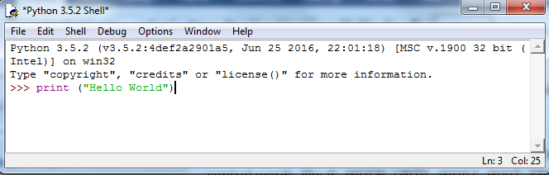

I used print () command as per instruction with encompassing parentheses

Here is outcome:

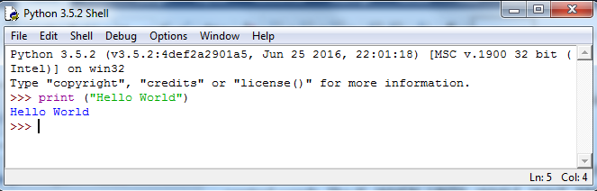

As expected output was satisfactory. Printed in blue – Hello World. Command in purple (print),

command’s argument in green colour: Hello World. Output in blue: Hello World.

## Exercise 4. Write a program that produces the following output:

Hello World

I am in my ISD class right now

My code:

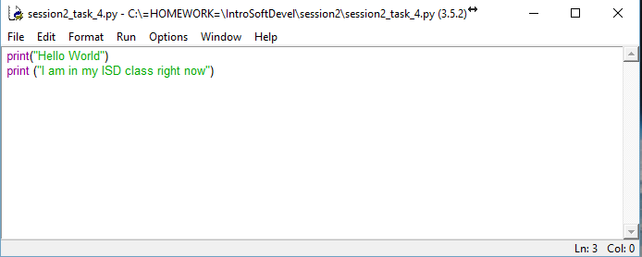

Test:

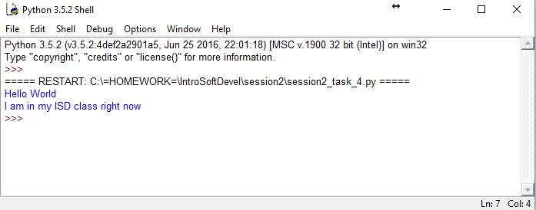

Program output satisfactory.

## Exercise5. Write a program that asks the user for his/her name and produces an output like:

Hi there, what is your name?

Hello

“User name”

How are you?

I wrote the following lines:

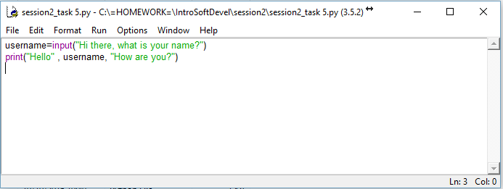

Here is output:

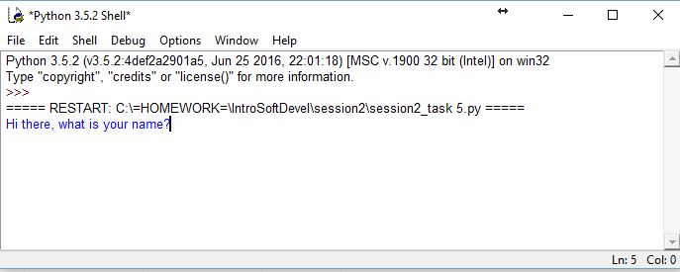

I have entered my name:

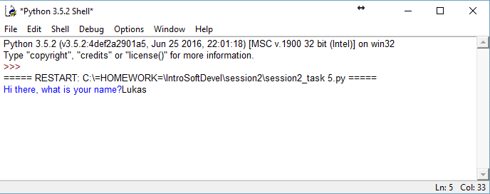

Here is outcome:

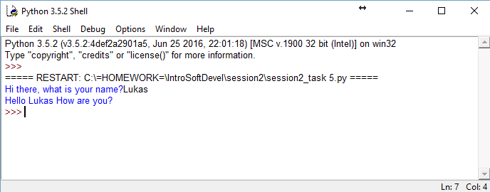

Nearly there but I am not happy that program produces - Hello Lukas How are you - in one line.

I added \n to break lines

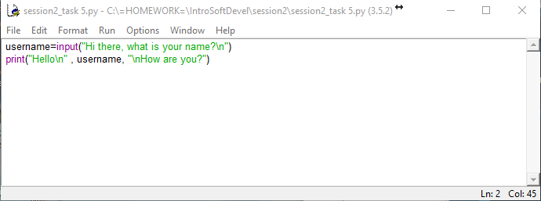

Output looks better. Output produces program adequate to the task requirements.

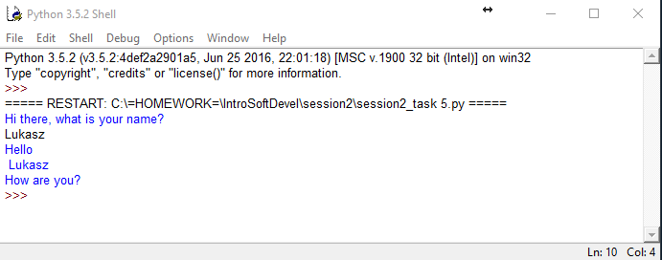

*Week 3 - 10/10/2016*

Third lecture was in two main parts .

First part included overview of Github software repository. Its definition and purpose.

Second part was continuation from previous lecture about building blocks of python : statements and expressions, commenting, reserved keywords and variables.

1) Write a program that asks for two numbers (Python has all the basic mathematical functions in place, like +,- etc.), adds them up and displays the result.

Code:

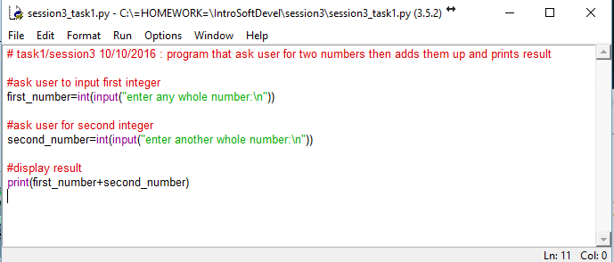

Result:

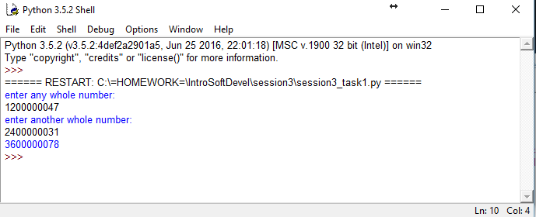

2) Answer the questions by implementing the code and run it.

a) What will the output be from the following code?  
  
num = 4  
  
num*=2  
  
num1=num+2  
  
num1+=3  
  
print(num1)  
  
 Code:

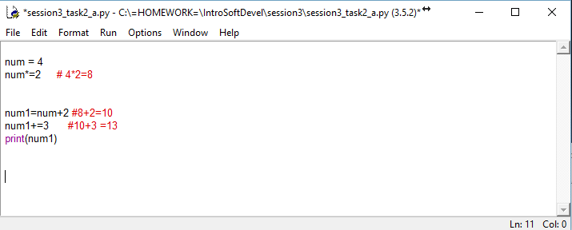

Result:

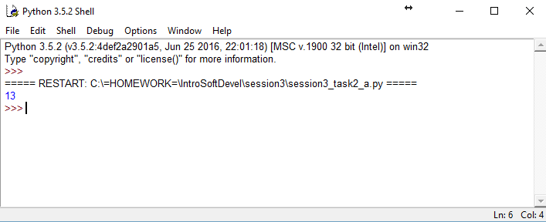

b) What do the following lines of code output? Why do they give a different answer?  
  
print(2 / 3)  
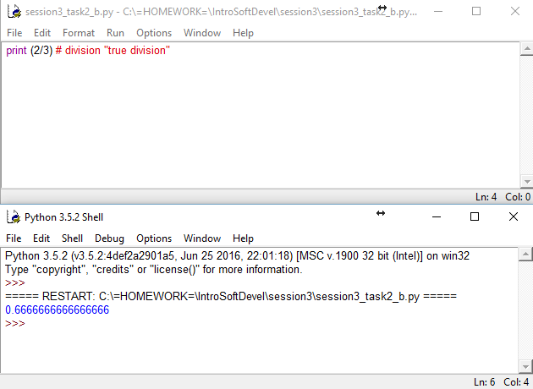

print(2 // 3)  
  
 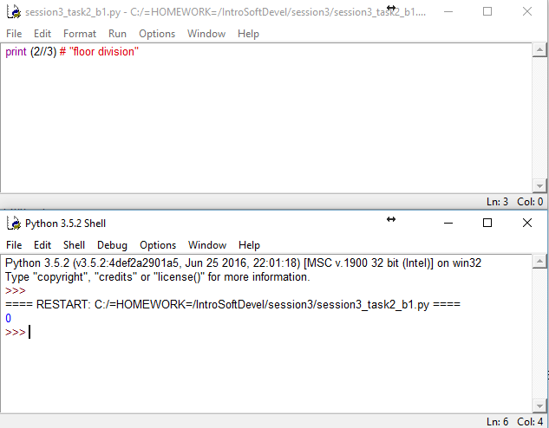

3) All of the variable names below can be used. But which of these is the better variable name to use?

A, a - capital A not very descriptive, lower case a same problem.

Area, AREA, area - better than single letter but still too general.

areaOfRectangle - best so far but inconsistent capitalizing.area = lower case, Rectangle = upper case . let's chose one and stick to it.

AreaOfRectangle - the best name in my opinion: descriptive and readable. easy to understand easy to read .consistent capitalizing.

In conclusion, writing clean , easy to read code make life easier both for developer and others who may collaborate on the project.

4) Which of these variables names are not allowed in Python? (More than one might be wrong.)

1. apple
2. APPLE
3. Apple2
4. 1Apple
5. account number
6. account_number
7. account.number
8. accountNumber
9. fred
10. Fred
11. Return
12. return_value
13. 5Return
14. GreatBigVariable
15. greatBigVariable
16. great_big_variable
17. great.big.variable

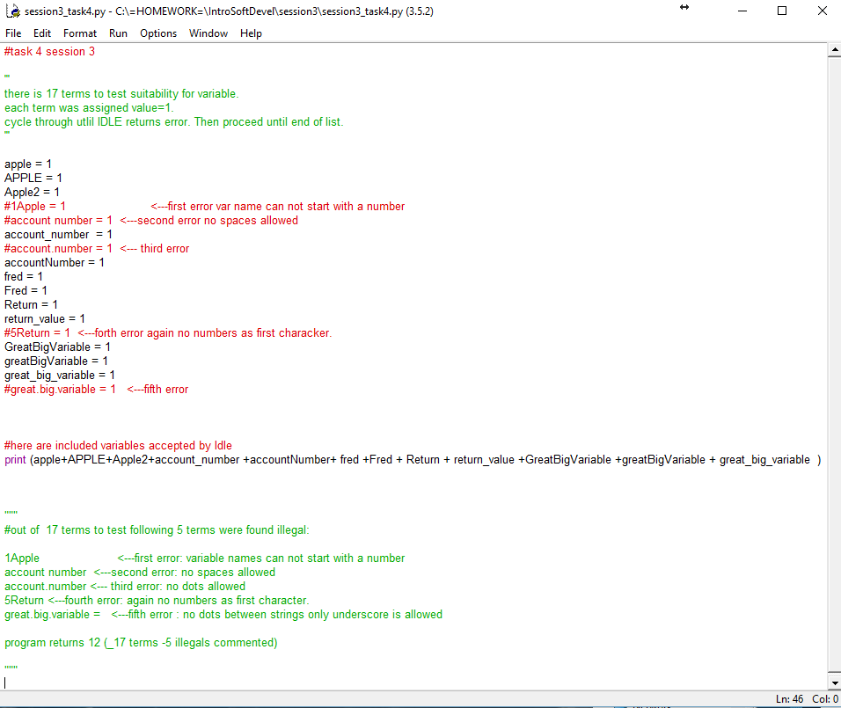

Result:

