**Personal Workout Management System (PWMS-CRM) System**

**System Design Document**

**1. INTRODUCTION**

**1.1 Overview**

This document has been developed for the PWMS-CRM project.  This document was developed from the PWMS-CRM Software Requirements Specification and is intended to detail the

* Technical Architecture
* Class Diagram
* Database Design

**1.2 Scope**

Servers: Internet Information Services (IIS) 10

Database: SQL Server 2014

Languages & Frameworks: ASP.NET 4.5, C# 5.0

**1.3 Reference Material**

Other system documentation for this system should include:

* System Requirement Specification
* System Configuration Document

**1.4 Document Conventions**

All diagrams, charts and tables are generated using standard UML guidelines.

**2. SYSTEM OVERVIEW**

This enterprise project consists of three major layers. The front-end layer is the portal that users will log into and make requests from. These requests are handled in the business layer, in which lie the various Personal Training Management Portal (PTMP) services. These services retrieve and manipulate data through the data access layer. The service returns the necessary data to the front-end, which then updates a view or renders a new view for the user.

**3. SYSTEM ARCHITECTURE**

**3.1 Architectural Design**

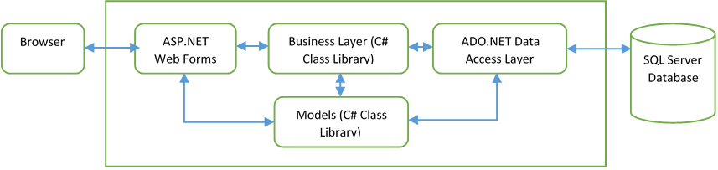

**3.2 Decomposition Description [Systems of PWMS-CRM]**

**3.2.1 Trainer Dashboard**

          The Trainer Dashboard is designed to keep track of all the trainees for the personal trainer, as well as keep track of contact information and physical specifications. This system has been designed with the Trainee class

**3.2.2 Workout Management**

            The Workout Management section is designed to keep track of reusable 5-Step Workout Plans tailored to the Trainees. Workouts will be available for assignment as soon as they are created.

**4. DATA DESIGN**

**4.1 Data Description**

Data will be structured into classes which are mapped to tables within the database.

**4.2 Data Dictionary**

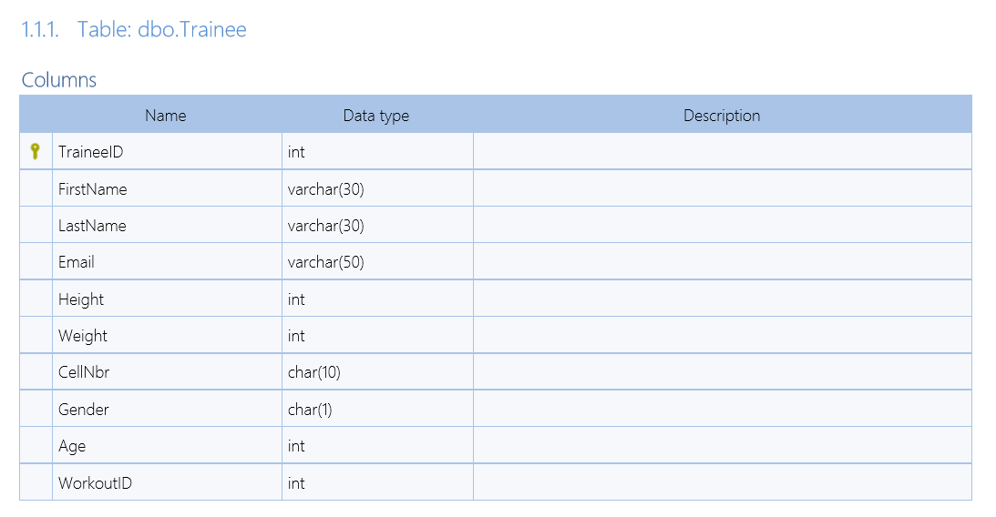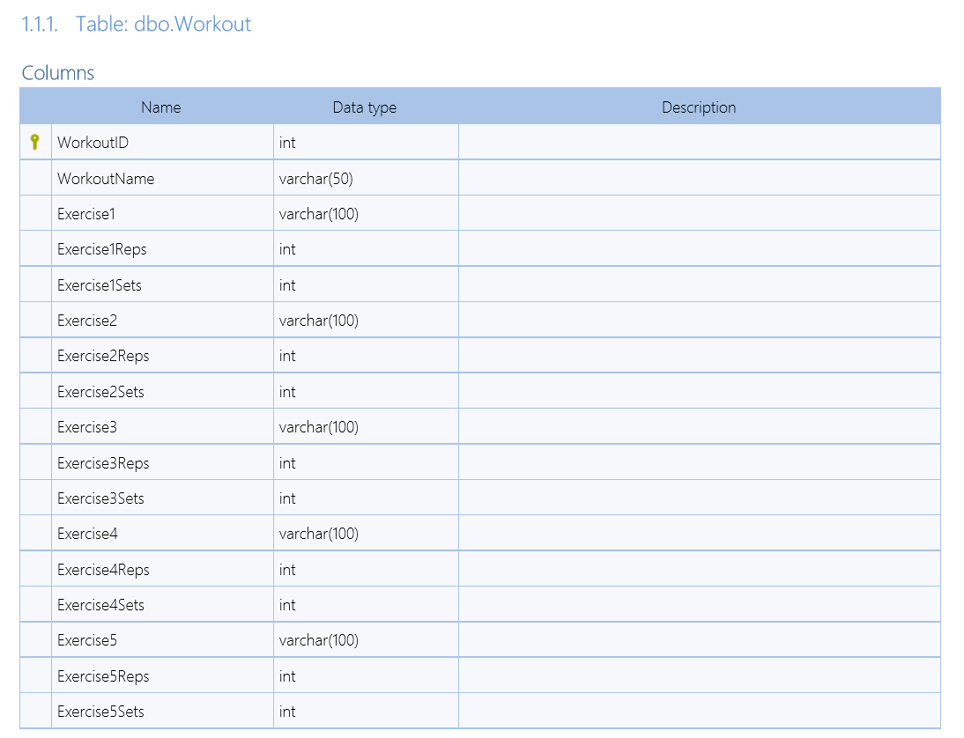

**4.3 Database Design Diagram**

**4.4 Class Diagram**

**4.5 Sequence Diagram**

