Investigating the Association of Periodontal Disease with Hospitalization or Death due to Coronary Heart Disease

Abstract
Background
Previous studies have found evidence of an association between periodontal disease and cardiovascular disease (CVD), and investigators have speculated that inflammation induced by periodontal disease may elevate the risk of coronary heart disease (CHD). In this study, we examined the independent link between periodontal disease and hospitalization or death due to CHD.
Methods
Using a large, observational, longitudinal study of over 11,000 United States residents, exclusion for missing data, a lack of follow-up, or a history of coronary heart disease at baseline created our study population of 6,747 participants. Baseline periodontal disease was assessed as a categorical variable (healthy, gingivitis, periodontal disease, or edentulous) and its association with incident hospitalization or death from CHD was analyzed using Cox proportional hazards models, sequentially adjusting for blocks of potential confounders.
Results
Median follow-up time was 19 years, with a maximum of 22 years. There was evidence of a strong unadjusted association between periodontal disease and CHD events, but this association was substantially attenuated towards the null with adjustment for potential confounders. In fully adjusted models, there was not evidence of a difference in the risk of CHD hospitalization or death between healthy participants and participants with gingivitis (estimated hazard ratio (HR): 1.06, confidence interval (CI): 0.90, 1.25), nor between healthy and edentulous participants (HR: 1.13, CI: 0.97, 1.32). There was borderline evidence (p=0.05) of an association of the periodontal disease classification, compared to healthy periodontal status, with hospitalization or death due to CHD (estimated 18% (CI: 0%, 39%) higher risk). This observed association was stronger in younger participants (< 45 years old).

Conclusions
There was borderline evidence of an independent association between periodontal disease and increased risk of CHD hospitalization or death. Due to significant limitations of this study, it is difficult to determine whether the observed association is due to the hypothesized inflammation mechanism or to residual confounding or induced bias. It would be of interest to perform additional sensitivity and consistency analyses to build on these analyses and discussion, and to further investigate a potential stronger association between periodontal and coronary heart disease within younger individuals.

Background:
Periodontal disease is an infection of the tissues that support the teeth. The degree of disease can be characterized by the Russell Index, which is based on measurements of bone loss around the teeth and gingival inflammation. The Russell Index can be condensed and used to classify an individual’s periodontal status into the following categories: healthy, gingivitis, or periodontal disease. Edentulous refers to the complete loss of teeth due to periodontal disease.
Previous studies have found evidence of an association between periodontal disease and cardiovascular disease (CVD). In addition, markers of inflammation, such as C-reactive protein (CRP), are associated with increased risk of coronary heart disease (CHD), which is the leading cause of death in the United States today. Investigators have hypothesized that inflammatory cytokines involved in the body’s defense against periodontal disease may have a damaging effect on blood vessels and the heart, elevating risk of CHD.
Records from a large, observational study of over 11,000 participants provide extensive baseline information on demographics, periodontal disease, and cardiovascular risk factors, as well as long-term follow-up for hospitalization and death due to CHD. In this study, we examined the independent link between periodontal disease and hospitalization or death due to CHD.

Materials and Methods:

Study population
Our study population comes from a large, observational, longitudinal survey study of 11,338 United States residents. Subjects were selected into the cohort between the years of 1960 and 1974 using a cluster-sampling design, but specific participant-level sampling information is not available for this study. From the cohort of 11,338 participants, 10 were excluded who did not have an ascertained baseline periodontal classification, 423 were excluded due to a lack of follow-up, and 851 were excluded due to a history of coronary heart disease at baseline. An additional 3,307 participants were excluded from primary models due to missing values for smoking, alcohol consumption, blood pressure, physical activity, education, or poverty index. Much of the missingness was due to missing values for smoking (n=1,749 missing values) and alcohol consumption (n=1,423 missing values). This created our study population of 6,747 participants. Subjects were assessed prospectively for CHD events.

Variables
Predictors of Interest
Periodontal status at baseline was categorized as healthy, gingivitis, periodontal disease, or edentulous. The classification into healthy, gingivitis, or periodontal disease was based on a condensation of the Russell Index. Edentulous refers to a subject missing all of his or her teeth due to periodontal disease. Periodontal status was assessed as a categorical variable for all analyses (via dummy variables), with healthy subjects as the reference group. The number of missing teeth due to periodontal disease was also used as a continuous predictor of interest, in sensitivity analyses.
Outcomes
Subjects were followed from the baseline examination (time = 0) prospectively for hospitalization or death due to coronary heart disease. The primary outcome in this study is the combined endpoint of hospitalization or death due to CHD. Death due to CHD will used as the outcome in secondary analyses. Both are censored outcomes assessed using the follow-up time (time since baseline) and a binary indicator of event or censoring. We decided to use hospitalization or death due to CHD as the primary outcome in order to capture more CHD events.
Covariates
All covariates refer to participant characteristics measured at baseline, with the exception of smoking (explained below). Demographic variables available were age, sex, and race (Caucasian, African-American, or Other). In addition, measurements on several known CVD risk factors were available. Smoking was assessed by pack years of smoking (categorized into 0, 1–15, 16–30, or >30) and through a binary indicator of current smoking status. Data on smoking were collected approximately 10 years after baseline; subjects were asked to recall their baseline smoking behavior. We categorized alcohol use into 0, 1-2, 3-5, or >5 drinks per day, due to the high skewness of the distribution of self-reported drinks per day, along with previous research suggesting that mild consumption (1-2 drinks per day) can provide a protective cardiovascular effect. Physical activity (very active, or not) and an indicator of a history of diabetes were assessed as binary variables. We assessed serum cholesterol, systolic and diastolic blood pressure, body mass index (BMI), and measures of socio-economic status (years of education and poverty index (% of poverty level income)) as continuous covariates. All of these known risk CVD risk factors were considered likely to be related to CHD death or hospitalization and thus included in fully adjusted models. It is also important to note that several of these baseline measures are also likely to be strongly associated to periodontal disease, and thus may be strong confounders. We also included a binary indicator of a history of nervous breakdown in adjusted models because there has been some evidence of a link between mental health and cardiovascular disease. Measurements were also available on height, weight, marriage, years of smoking, average numbers of packs smoked per day, missing teeth for unknown reasons, and extractions for other reasons. These variables were not considered related to the outcome of interest, or were already adjusted for via similar measures, so we did not include them in adjusted models.

Statistical Analyses
Baseline characteristics were tabulated overall and within groups defined by periodontal disease (categorized using the Russell Index). Crude follow-up statistics were reported (median, range, incident rates per 100 person-years of follow-up). Incidence of coronary heart disease events were described using Kaplan-Meier curves: Kaplan-Meier curves for cumulative risk of hospitalization or death due to CHD, and for cumulative risk of death due to CHD, were plotted within strata defined by periodontal status at baseline (categorized using the Russell Index).
The association between periodontal disease and CHD events was analyzed using Cox proportional hazards models. Sequential nested models were:
- unadjusted
- adjusting for demographics (age, gender, race)
- further adjusting for known strong CVD risk factors likely to also be strongly associated with periodontal disease (pack years of smoking, current smoking status, serum cholesterol, systolic blood pressure, diastolic blood pressure, BMI, history of diabetes)
- further adjusting for additional CVD risk factors (physical activity, alcohol use, poverty index, years of education, history of nervous breakdown)
Primary analyses used hospitalization or death due to CHD as a combined endpoint, while secondary analyses assessed death due to CHD as the endpoint. We performed a complete case analysis for this set of sequential models, using the subset of 6,747 subjects with complete data on all covariates.
We conducted subgroup analyses in order to explore whether the relationship between periodontal disease and CHD events was similar across groups defined by important confounders. Cox proportional hazards models were carried out within groups defined by gender, age (<45, 45-60, >60 years), and current smoking status (yes or no).
We also conducted one sensitivity analysis; Cox proportional hazards models using the number of missing teeth due to periodontal disease as a continuous predictor of interest were assessed. Several additional descriptive and inferential analyses would have been performed with additional time. These would include additional subgroup analyses, as well as further exploration of the most important confounders to ensure correct capture of the functional relationship with the outcome. In addition, we would explore the effects of missing data by comparing descriptives for baseline characteristics and outcomes within those missing important covariates (such as smoking – see discussion) to those with complete data. We also would have assessed the validity of the proportional hazards assumption by adding an interaction between time and periodontal status.
All Cox proportional hazards models use robust standard errors, and all reported estimation intervals are 95% confidence intervals. A critical level of 0.05 was used to determine statistical significance. All results were performed using R 2.7.2.

Results:

Baseline Characteristics
After exclusion of participants with missing data or a lack of follow-up, our study population (N=6,747) was comprised of 2,546 (38%) participants with a healthy periodontal classification, 1,591 (24%) with gingivitis, 1,174 (17%) with periodontal disease, and 1,436 (21%) edentulous participants. The mean age was 48 years, with a range from 25 to 74 years. 39% of participants were male and 15% were African-American. Comparing participants across the categories of periodontal classification, those with periodontal disease or complete loss of teeth due to the disease (edentulous) tended to be older, more likely to smoke, less educated, less wealthy, more likely to be diabetic, and had higher cholesterol, systolic and diastolic blood pressure, and BMI (Table 1).

Table 1. Baseline characteristics overall and by periodontal classification

Characteristic | Overall (n=6,747) | Healthy (n=2,546) | Gingivitis (n=1,591) | Periodontal disease (n=1,174) | Edentulous (n=1,436)
Age (years) | 48.4 (15.4) | 42.7 (13.9) | 43.6 (14.3) | 52.3 (14.1) | 60.7 (11.8)
Race
Caucasian | 5699 (84.5 %) | 2297 (90.2 %) | 1293 (81.3 %) | 863 (73.5 %) | 1246 (86.8 %)
African- American | 996 (14.8 %) | 235 ( 9.2 %) | 284 (17.9 %) | 296 (25.2 %) | 181 (12.6 %)
Other | 52 ( 0.8 %) | 14 ( 0.5 %) | 14 ( 0.9 %) | 15 ( 1.3 %) | 9 ( 0.6 %)
Male | 2595 (38.5 %) | 814 (32.0 %) | 639 (40.2 %) | 609 (51.9 %) | 533 (37.1 %)
Cholesterol (mg/dl) | 220.2 (48.9) | 212.6 (46.7) | 216.4 (47.2) | 222.6 (45.8) | 236.1 (52.9)
SBP (mm Hg) | 133.9 (24.0) | 127.8 (21.0) | 130.0 (22.6) | 139.3 (24.8) | 144.8 (25.2)
DBP (mm Hg) | 83.1 (12.8) | 80.7 (12.1) | 82.3 (12.3) | 86.2 (13.5) | 85.8 (13.0)
BMI (kg/m²) | 25.6 ( 5.0) | 24.8 ( 4.7) | 25.9 ( 5.2) | 26.2 ( 5.2) | 26.1 ( 5.1)
Poverty Index | 269.0 (175.9) | 313.7 (180.0) | 268.2 (172.5) | 237.6 (173.3) | 216.5 (152.8)
Years Education | 11.0 ( 3.8) | 12.5 ( 3.5) | 11.3 ( 3.6) | 9.8 ( 3.9) | 9.0 ( 3.4)
Pack years | 12.5 (21.5) | 9.0 (16.0) | 10.8 (18.5) | 16.6 (24.3) | 17.1 (28.2)
Current Smoker | 3324 (49.3 %) | 1190 (46.7 %) | 815 (51.2 %) | 675 (57.5 %) | 644 (44.8 %)
Alcohol
0 | 2323 (34.4 %) | 713 (28.0 %) | 462 (29.0 %) | 401 (34.2 %) | 747 (52.0 %)
1 - 2 | 4027 (59.7 %) | 1719 (67.5 %) | 1018 (64.0 %) | 669 (57.0 %) | 621 (43.2 %)
3 - 5 | 288 ( 4.3 %) | 87 ( 3.4 %) | 79 ( 5.0 %) | 76 ( 6.5 %) | 46 ( 3.2 %)
> 5 | 109 ( 1.6 %) | 27 ( 1.1 %) | 32 ( 2.0 %) | 28 ( 2.4 %) | 22 ( 1.5 %)
Diabetes | 279 ( 4.1 %) | 54 ( 2.1 %) | 43 ( 2.7 %) | 67 ( 5.7 %) | 115 ( 8.0 %)
History Nervous Breakdown | 195 ( 2.9 %) | 58 ( 2.3 %) | 39 ( 2.5 %) | 40 ( 3.4 %) | 58 ( 4.0 %)
Physical Activity | 3457 (51.2 %) | 1355 (53.2 %) | 815 (51.2 %) | 675 (57.5 %) | 644 (44.8 %)

Cell contents are mean (standard deviation) or count (percent)
SBP = systolic blood pressure, DBP = diastolic blood pressure, BMI = body mass index

Incident Coronary Heart Disease
Participants were followed from baseline for a median of 19 years, with a maximum follow-up of 22 years. The crude incident rate of hospitalization or death due to CHD was 1.3 events per 100 person years of follow-up. Crude incident rates were 0.7, 0.9, 1.8, and 2.6 hospitalizations or deaths from CHD for participants with a periodontal classification of healthy, gingivitis, periodontal disease, and edentulous, respectively. Kaplan-Meier plots stratified by periodontal classification as baseline illustrate that cumulative incidence over time of hospitalization or death due to CHD (Figure 1), and death to CHD (Figure 2), were lowest among healthy participants, and increased across the gingivitis, periodontal disease, and edentulous classifications. These plots are crude survival curves; they do not adjust for confounding variables.
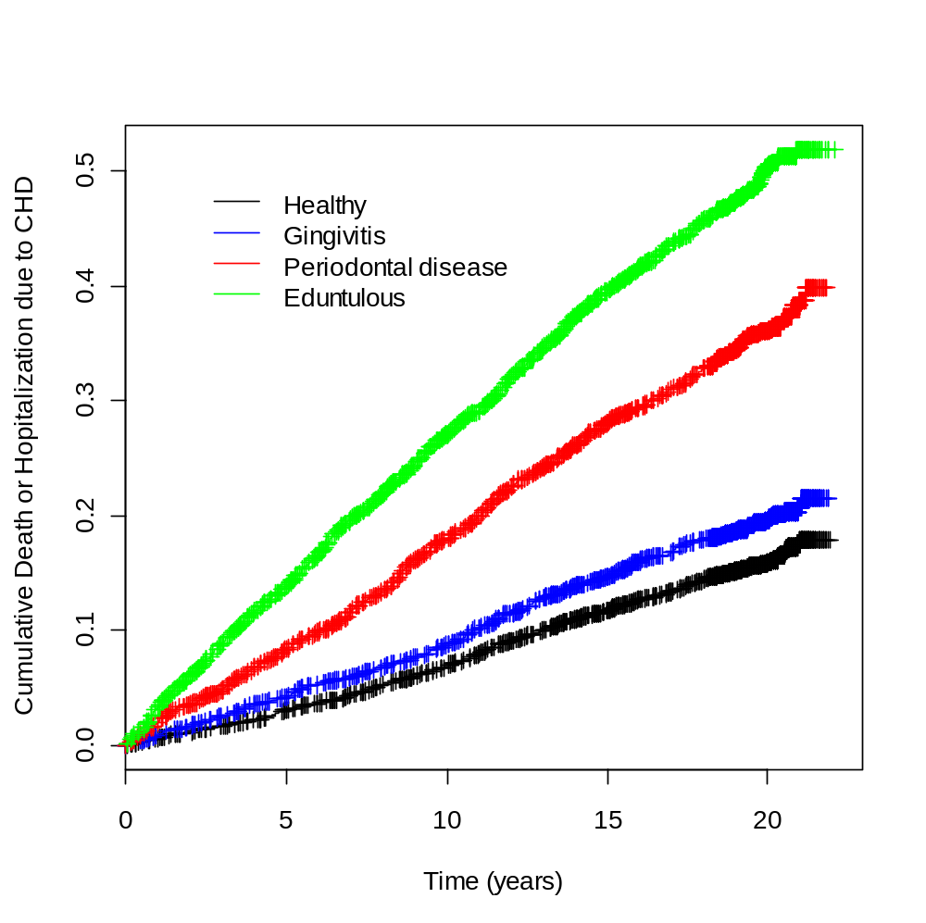

Figure 1. Kaplan Meier plots for cumulative hospitalization or death from coronary heart disease within groups defined by periodontal classification at baseline

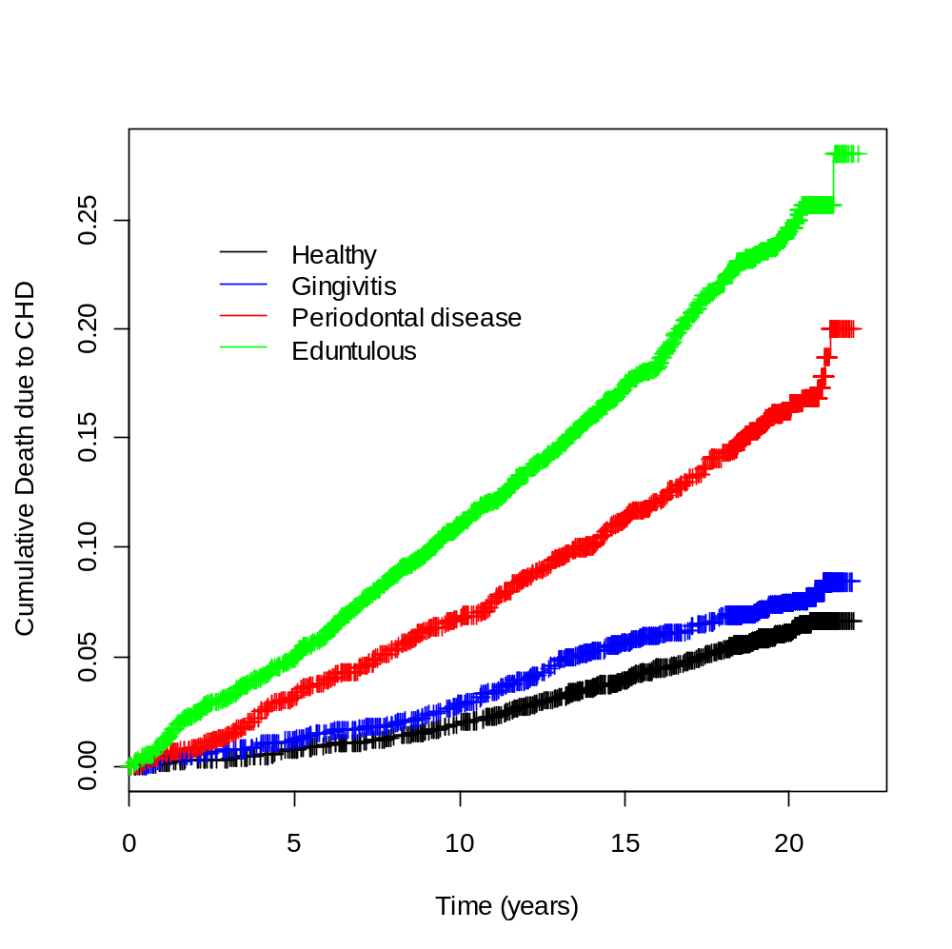
Figure 2. Kaplan Meier plots for cumulative death from coronary heart disease within groups defined by periodontal classification at baseline

Results of sequentially adjusted Cox proportional hazards models are displayed in Table 2 (hospitalization or death from CHD as combined endpoint) and Table 3 (death from CHD as endpoint). In unadjusted models, there was statistically significant evidence of a relationship between periodontal disease and coronary heart disease events. We estimate that, compared to healthy participants, those with gingivitis, periodontal disease, and complete tooth loss due to periodontal disease had 1.22 (1.04, 1.44), 2.48 (2.13, 2.90), and 3.82 (3.33, 4.39) times the unadjusted (instantaneous) risk of hospitalization or death due to CHD, respectively.
However, this association largely goes away with sequential adjustment for potential confounding variables. Sequential adjustment for demographic variables and known cardiovascular risk factors substantially attenuated estimated associations towards the null (Table 2). In fully adjusted models, we do not find statistical evidence of a difference in the risk of CHD hospitalization or death between healthy participants and participants with gingivitis (estimated hazard ratio (HR): 1.06, confidence interval (CI): 0.90, 1.25), nor between healthy and edentulous participants (HR: 1.13, CI: 0.97, 1.32). There was evidence (borderline statistical significance: p=0.05) of an association of the periodontal disease classification, compared to healthy periodontal status, with hospitalization or death due to CHD; we estimate that those with periodontal disease had 18% (0%, 39%) higher risk of hospitalization or death to CHD, in the fully adjusted model (Table 2).
Estimated hazard ratios comparing groups defined by periodontal classification with respect to death due to CHD were similar to those with the combined endpoint of hospitalization or death, although confidence intervals were wider with death as the endpoint. There was not evidence of an association between periodontal disease and risk of death from coronary heart disease (Table 3).
In a sensitivity analysis with the number of missing teeth due to periodontal disease as the (continuous) predictor of interest, there also was no evidence of an association; we estimate that each additional 5 missing teeth due to periodontal disease was associated with a hazard ratio for hospitalization or death due to CHD of 1.022 (0.995, 1.051).

Table 2. Estimated hazard ratios for association of periodontal disease at baseline with incident hospitalization or death due to coronary heart disease, using Cox proportional hazards regression

Model | Gingivitis | Periodontal disease | Edentulous
1 | 1.22 (1.04, 1.44) | 2.48 (2.13, 2.90) | 3.82 (3.33, 4.39)
2 | 1.13 (0.96, 1.34) | 1.35 (1.15, 1.59) | 1.41 (1.22, 1.64)
3 | 1.10 (0.94, 1.30) | 1.26 (1.07, 1.49) | 1.27 (1.09, 1.47)
4 | 1.06 (0.90, 1.25) | 1.18 (1.00, 1.39) | 1.13 (0.97, 1.32)

Cell contents are estimated hazard ratio (95% confidence interval), with healthy periodontal classification as reference group

Models:
- Unadjusted (crude)
- adjusted for demographics (age, gender, race)
- further adjusted for serum cholesterol, systolic blood pressure, diastolic blood pressure, BMI, history of diabetes, current smoking status, pack years of smoking
- further adjusted for physical activity, alcohol use, poverty index, history of nervous breakdown, years of education

Table 3. Estimated hazard ratios for association of periodontal disease at baseline with incident death due to coronary heart disease, using Cox proportional hazards regression

Model | Gingivitis | Periodontal disease | Edentulous
1 | 1.35 (1.01, 1.81) | 3.04 (2.33, 3.97) | 4.81 (3.78, 6.10)
2 | 1.21 (0.91, 1.62) | 1.40 (1.06, 1.86) | 1.39 (1.08, 1.80)
3 | 1.19 (0.89, 1.59) | 1.32 (1.00, 1.74) | 1.23 (0.95, 1.59)
4 | 1.16 (0.86, 1.55) | 1.25 (0.94, 1.65) | 1.13 (0.87, 1.46)

Cell contents are estimated hazard ratio (95% confidence interval), with healthy periodontal classification as reference group

Models:
- Unadjusted (crude)
- adjusted for demographics (age, gender, race)
- further adjusted for serum cholesterol, systolic blood pressure, diastolic blood pressure, BMI, history of diabetes, current smoking status, pack years of smoking
- further adjusted for physical activity, alcohol use, poverty index, history of nervous breakdown, years of education

Estimated associations between periodontal disease and hospitalization or death from CHD were similar within men and women, and within smokers and non-smokers, but not within age groups. Estimated hazard ratios and confidence intervals comparing healthy participants to participants with periodontal disease with respect to the risk of hospitalization or death from coronary heart disease are displayed in Figure 3. Of note, periodontal disease, in comparison to healthy periodontal classification, was more strongly associated with CHD events in younger participants (< 45 years) than middle-aged (45 – 60 years) and older (> 60 years) participants.

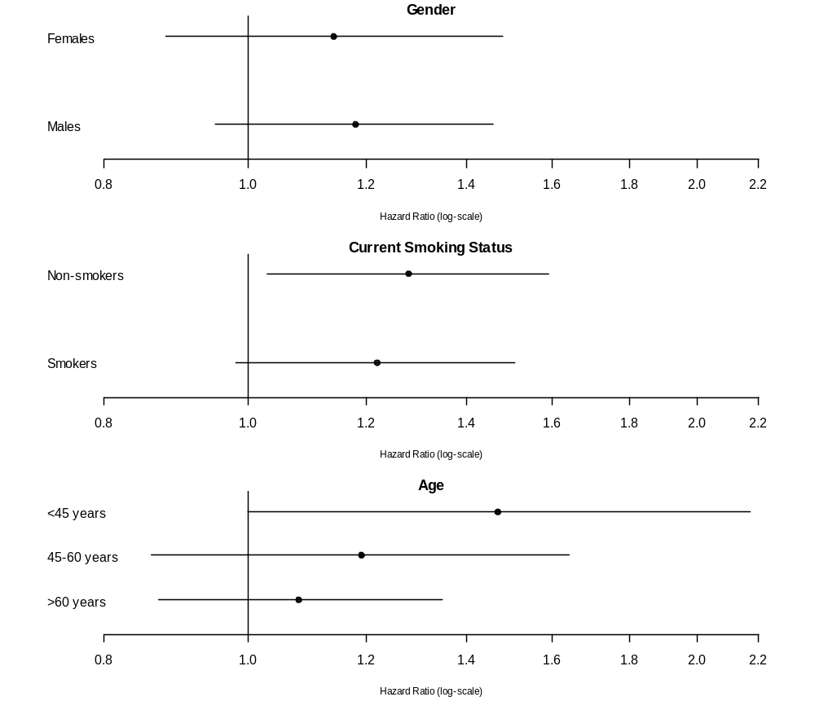

Figure 3. Estimated hazards ratios and 95% confidence intervals (shown by error bars) for hospitalization or death due to CHD, comparing those with periodontal disease to those with a healthy periodontal classification, within subgroups of interest (age, gender, and smoking groups)

Conclusions and Discussion:
In summary, there was evidence of a strong crude association between periodontal disease and coronary heart disease events, but this association was substantially attenuated towards the null with sequential adjustment for potential confounding variables. There was borderline evidence of an independent association between periodontal disease and hospitalization or death due to coronary heart disease; we estimate that those with periodontal disease, as compared to participants with healthy periodontal status, had 18% (0%, 39%) higher risk, in a fully adjusted model (p=0.05). There was not evidence of a difference in risk of CHD hospitalization or death comparing healthy participants to edentulous participants or to those with gingivitis. Estimates across periodontal classification categories were similar with CHD death as the endpoint, but confidence intervals were wider and there was not statistical evidence of an association with periodontal disease.
These results suggest a strong marginal association between periodontal disease and coronary heart disease events, but this observed association was largely due to confounding by other covariates related strongly to both periodontal and cardiovascular disease. These confounding variables include age, smoking, alcohol consumption, socio-economic status and markers of comorbidity, such as blood pressure, cholesterol, BMI, and diabetes. There was slight evidence of a persisting independent association between periodontal disease and CHD outcomes among participants with similar status on these confounding variables. The lack of an observed difference in CHD events among the healthy, gingivitis, and edentulous categories, although not proof of no association, could be supported by the hypothesized inflammation mechanism; it is likely that inflammation is not as severe in gingivitis as in periodontal disease, and that all inflammation has been removed with the complete loss of teeth in edentulous participants (although being edentulous also plausibly indicates a long history of periodontal disease and inflammation). It is also important to note that subgroup analyses suggest that periodontal disease may be more strongly associated with increased risk of coronary heart disease in younger participants (< 45 years). This generates the hypothesis that the speculated inflammation mechanism between periodontal disease and coronary heart disease may be more pronounced in younger individuals, but there are several significant limitations of this study that may weaken causal inference.
Important limitations of our study include the following. The study is observational, so residual confounding could exist due to imperfect adjustment for measured confounders and/or due to important unmeasured variables. Thus, conclusions were stated regarding associations rather than causal inference. It is important to note that the scientific question at hand can really only be addressed via an observational study such as this. However, in order to speculate such a causal relationship, we would seek estimated effects that are both strongly statistically significant and very important clinically, and neither conclusion is supported by these data. In addition, there is substantial missing data in important potential confounders. With further time, we would have compared subjects with and without missing covariates with respect to other measured variables, the predictor of interest, and CHD outcomes. Of note, smoking has substantial missing data, which could very plausibly bias our results, due to its assessment 10 years after baseline. Participants missing smoking were much more likely to have early hospitalization and mortality from CHD, and this leads to worry that bias could be induced by the existence of a different association between periodontal disease and cardiovascular events in these participants than among subjects with complete information on all measured variables. There also could be miss-classification of the outcome, which could induce bias. In addition, although the subjects were selected using a cluster-sampling design, participant-level sampling information is not available for this study. Correlation due to cluster could lead to incorrect estimation of standard errors and thus invalid inference. Finally, some participants were lost to follow-up, and informative censoring could bias results.
Strengths of the study include the large sample size and long-term follow-up. In summary, we find borderline evidence of increased risk of CHD hospitalization or death in participants with periodontal disease, as compared to healthy subjects, in a fully adjusted model. Due to significant limitations of this study, it is difficult to determine whether the persisting association is due to the hypothesized inflammation mechanism or to residual confounding or induced bias. It is also important to note that the study does not rule out a clinically relevant independent association between periodontal disease and coronary heart disease. It would be of interest to perform additional sensitivity and consistency analyses to build on these analyses and discussion, and to further investigate a potential stronger association between periodontal and coronary heart disease within younger individuals.

