Register GitHub:

1. Go to <https://github.com/join>

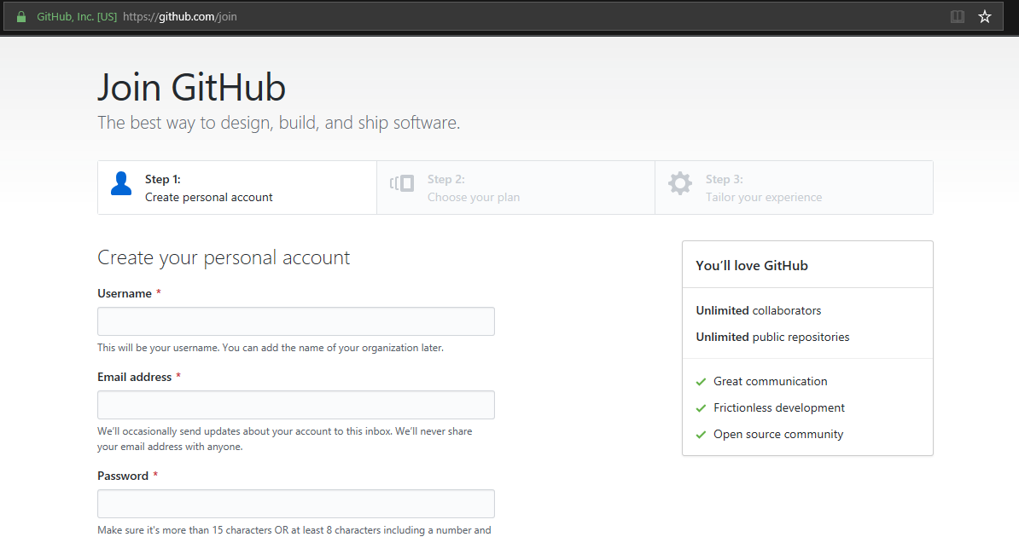

1. User name Should be: First Initial and then Last Name
   1. Example : Laxman Wadkar
   2. User Name : lwadkar
2. Email Address:
3. Password:
4. Verify Account:

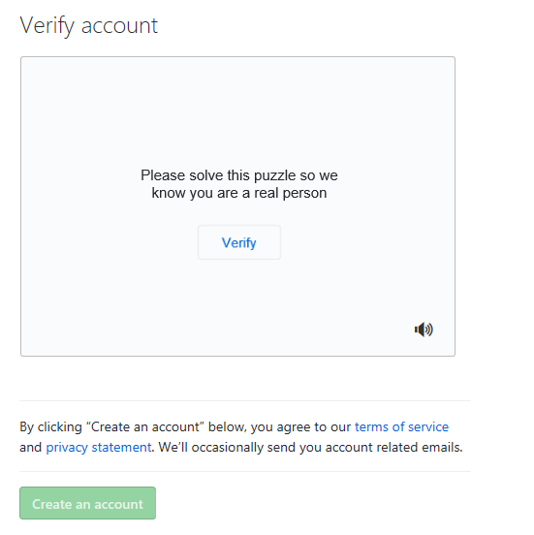

1. Set Plan : Set Free Plan

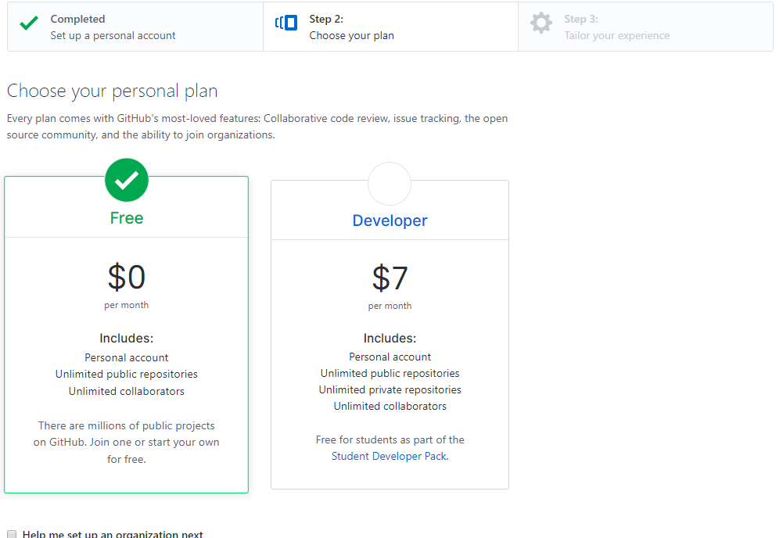

1. Setup Organization:

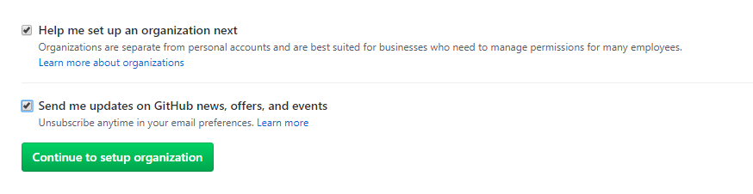

1. Tailored Experience:

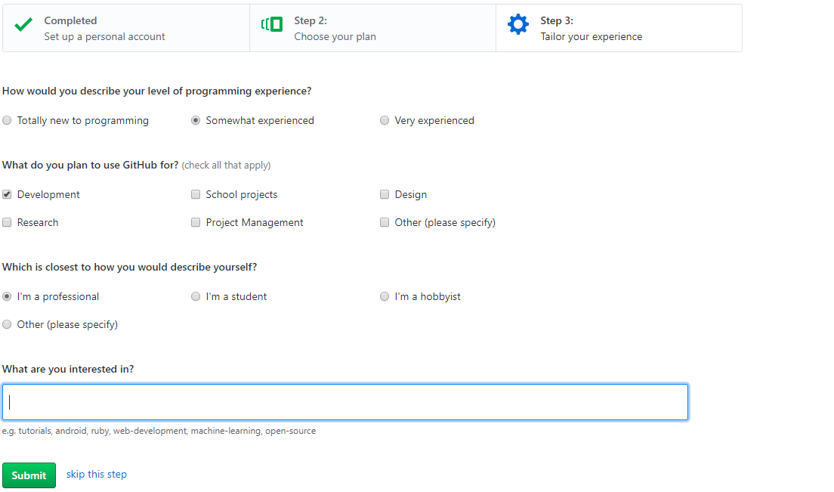

1. Verify Email Address
2. Created new Repository : https://github.com/lwadkar/chatbot