Modeling and Uncertainty Quantification of Cases Related to Exercise I-1 and Exercise I-2 of the IAEA CRP on HTGR UAM

**Abstract**

Exercise I-1 and I-2 include fuel pebble model and core unit model which resembles 0.61 packing fraction. Featuring double heterogeneity, the fuel pebble can be either explicitly or implicitly modeled. Implicit model includes homogenizing the fuel region techniques, namely SCALE DOUBLEHET model and RPT model. Explicit method considers modeling the TRISO fuel particle inside the fuel region, with cutting the boundary or not. Fuel unit can be modeled as hexagonal prism or fake enlarged pebble with cutting.

**1. Introduction**

**2. Computer codes and models**

2.1 SCALE

The criticality calculations of single fuel pebble and pebble cluster were performed with both SCALE/KENO-VI and Serpent 2, while the uncertainty of multiplication factor was only quantified by SCALE/TSUNAMI-3D.

The KENO-VI is a three-dimensional Monte Carlo transport program and works as a functional module in the SCALE system. KENO-VI can operate in multigroup or continuous energy mode, run as standalone code, or integrated in computational sequences such as TSUNAMI-3D, which facilitates the application of sensitivity and uncertainty analysis theory to criticality safety analysis. In multigroup mode, TSUNAMI-3D performs forward and adjoint Monte Carlo neutron transport calculation and calculates eigenvalue sensitivity coefficients. In continuous mode, sensitivity coefficients are computed in a single forward Monte Carlo neutron transport calculation for either eigenvalue or generalized reaction rate ratio responses. In both MG and CE mode, KENO-VI module is used for transport solver.

The officially SCALE 6.2.2 release with mpi compilation was used in this study. ENDF/B-VII.1 library is provided in this code. Considering the underestimation of graphite radioactive capture cross section in ENDF/B VII.0 library, which is well discussed in previous study, only ENDF/B VII.1 library is discussed in this study. It should be noted that the library influence on eigenvalue of single fuel pebble is about 200 pcm with 7 g heavy metal per ball configuration and will be enlarged if more graphite emerged in the calculation system.

2.2 Serpent

Serpent 2 is a three-dimensional continuous energy Monte Carlo transport calculation code, developed and maintained in VTT Technical Research Centre of Finland since 2004. It is facilitated with the capability to simulate random particle or pebble distribution for HTGR calculations. The coordinates of the particles are written in a separate file using format that can be directly read into explicit HTGR geometry model during criticality calculations. The double heterogeneous structure of HTGR fuel system is thus considered without assumption.

2.3 computer models

IAEA CRP EXERCISES

3. study on the modeling approach

The fuel pebble is

3.1 SCALE/KENO-VI implicit models

DOUBLEHET model

The DOUBLEHET cell date was selected to account for the double heterogeneous effect of pebble during the self-shielding calculation in multi-group mode.

DOUBLEHET homogenizing strategy:

RPT model-radius choice

3.2 Explicit model with a particle lattice

A naturally come-out particle arrangement is an infinite square lattice with some fuel particles being intersected by the enclosing sphere. The theoretical lattice pitch was determined by retaining the amount of heavy metal in the fuel region, namely, 7 g per fuel ball, with a homogenously filling assumption. Considering the influence of lattice elements at the enclosing boundary being cut unevenly, the lattice pitch is slightly reduced by 0.029% to make the heavy metal amount correct in this model.

In the second lattice model, the particles were arranged in such a square lattice where no fuel particle was cut by the enclosing fuel region surface. Though average particle packing fraction is reserved, the local packing fraction was slightly increased and some spots with only graphite emerged at the boundary. As a result, the eigenvalue was found to be a few hundred pcm lower when compared with the previous model.

Comparing model 1 and model 2, a relative difference of the amount of heavy metal per ball caused by round-off error was observed to be 0.002%.

|  |  |  |  |
| --- | --- | --- | --- |
| model | Kinf | Code comp | Model comp |
| Keno-vi cut | 1.42310+-0.00015 | 20+-17 |  |
| Serpent cut | 1.42290+-0.00008 |  | 317+-11 |
| Keno-vi nocut | 1.42773+-0.00013 | 7+-15 |  |
| Serpent nocut | 1.42766+-0.00008 |  | 159+-11 |
| Serpent nocut dbrc | 1.42760+-0.00008 |  |  |
| Serpent random_0 | 1.42607+-0.00008 | 15+-11 | Ref |
| Serpent random_1 | 1.42622+-0.00008 |  |  |
| Keno-vi dh | 1.42555+-0.00012 |  | 52+-14 |

Identical lattice models were made with Serpent 2 for code-to-code verification.

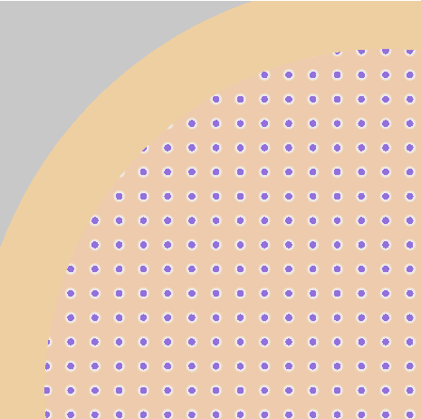 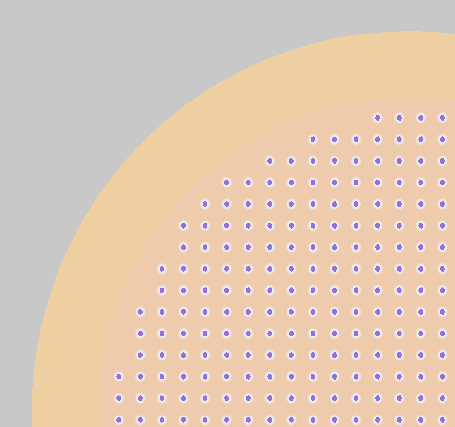

3.3 Explicit model with a random particle distribution

Serpent has the capability to produce random distribution based on particle dimension and packing fraction or filling number and the result coordinates were written in a separate file. When a criticality calculation is carried out, serpent reads the particle coordinates from the file and the randomness is taken into consideration without approximation.

4. Core unit modeling approach

A unit model of

/cm/shared/apps/ncsu/MCNP/MCNP_DATA/xdata/endf71x/U/92235.710nc

/cm/shared/apps/ncsu/SERPENT/xsdata/endfb71/sss_endfb71u.xsdata

4.1 hexagonal prism

4.2 square close lattice packing with cutting edge

|  |  |
| --- | --- |
| model | Kinf |
| Keno-vi hcp_cut | 1.42327+-0.00014 |
| Serpent hcp_cut |  |
| Serpent hcp_cut_dbrc |  |
| Keno-vi hcp_nocut |  |
| Serpent hcp_nocut |  |
| Serpent hcp_nocut_dbrc |  |
| Serpent hcp_random |  |
| Serpent hcp_random_dbrc |  |
|  |  |
| Keno-vi bcc_cut | 1.42317+-0.00014 |
| Serpent bcc_cut |  |
| Serpent bcc_cut_dbrc |  |
| Keno-vi bcc_nocut |  |
| Serpent bcc_nocut |  |
| Serpent bcc_nocut_dbrc |  |
| Serpent bcc_random |  |
| Serpent bcc_random_dbrc |  |
|  |  |
| Keno-vi cub_cut | 1.42338+-0.00013 |
| Serpent cub_cut |  |
| Serpent cub_cut_dbrc |  |
| Keno-vi cub_nocut |  |
| Serpent cub_nocut |  |
| Serpent cub_nocut_dbrc |  |
| Serpent cub_random |  |
| Serpent cub_random_dbrc |  |

5. Uncertainty quantification results and analysis

Uncertainty Quantification by SCALE/TSUNAMI-3D only, validated by comparing with Direct Perturbation method.

The direct perturbation method:

[scale manual]

The accuracy of the energy-integrated region-integrated sensitivity coefficients can be confirmed through the use of central difference direct perturbation sensitivity calculations. The sensitivity of keff to the number density is equivalent to the sensitivity of keff to the total cross section integrated over energy. (why total sensitivity coefficients test is adequate for all other sensitivity coefficients?) For each sensitivity coefficient examined by direct perturbation, the keff of the system is computed first with the nominal values of the input quantities, then with a selected nominal input increased or decreased by a certain percentage.



Where  and  represent the increased and decreased values, respectively, of the input quantity  and  and represent the corresponding values of keff. Statistical uncertainties in the computed values of keff are propagated to uncertainties in direct perturbation sensitivity coefficients by standard error propagation techniques as



The principle of perturbation selection is considered as large enough to induce a statistically significant (10) change in the eigenvalue but not large enough to induce second-order effects in the perturbed eigenvalue. In this study, the keff perturbation should target a 0.5% change (0.005); therefore, the change in the number density is calculated as . If the DP sensitivity does not agree with the TSUNAMI-3D sensitivity, the perturbation will be changed for further validation.

6. Summary and Conclusion

Fuel pebble including an infinite particle lattice with some particles being intersected by the enclosing sphere (surface).

Fuel pebble including an lattice where fuel particles and graphite particles, which is same as the matrix material, are placed as to avoid fuel particles cutting by the spherical surface and thus the lattice is slightly closer.

Acknowledgements

This work was supported by the China Nature and Science Funding contract and IAEA CRP contract.

References