Name
Class
Date

2-7
Solving Proportions
Enrichment

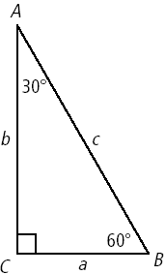
When dealing with right triangles, certain ratios are formed called trigonometric ratios. They are formed by examining various sides in relation to the angles. A commonly used triangle is the 30°-60°-90° triangle shown at the right. The hypotenuse is the side opposite the 90° angle. The other two sides are called sides opposite or adjacent to respective angles in the triangle.
Side a is opposite to angle A and adjacent to angle B. Side b is opposite to angle b and adjacent to angle A.

All 30°-60°-90° triangles are proportional, so the relationships shown in the triangle at the left can be used to determine missing lengths of any other 30°-60°-90° triangle provided you are given one side.
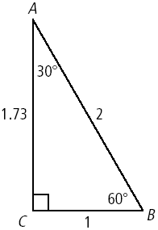

Use the relationships shown and proportions to determine the length of the other two sides.

1. | 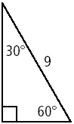 | 2. | 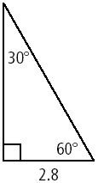
3. | 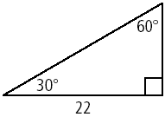 | 4. | 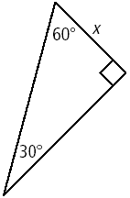
Prentice Hall Algebra 1 • Teaching Resources
Copyright © by Pearson Education, Inc., or its affiliates. All Rights Reserved.
68

