Name
Class
Date

2-7
Solving Proportions

Practice Form G

Solve each proportion using the Multiplication Property of Equality.
1. 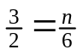 2. 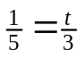 3. 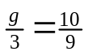
4. 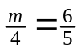 5. 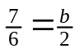 6. 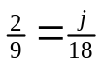
7. 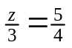 8. 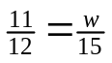 9. 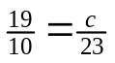
Solve each proportion using the Cross Products Property.
10. 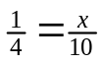 11. 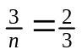 12. 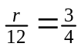
13. 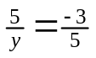 14. 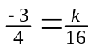 15. 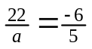
16. 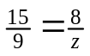 17. 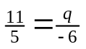 18. 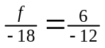
- The windows on a building are proportional to the size of the building. The height of each window is 18 in., and the width is 11 in. If the height of the building is 108 ft, what is the width of the building?
- Eric is planning to bake approximately 305 cookies. If 3 pounds of cookie dough make 96 cookies, how many pounds of cookie dough should he make?
- On a map, the distance between Sheila’s house and Shardae’s house is 6.75 inches. According to the scale, 1.5 inches represents 5 miles. How far apart are the houses?
Prentice Hall Gold Algebra 1 • Teaching Resources
Copyright © by Pearson Education, Inc., or its affiliates. All Rights Reserved.
63

Name
Class
Date

2-7
Solving Proportions

Practice (continued) Form G

Solve each proportion using any method.
22. 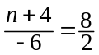 23. 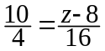
24. 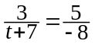 25. 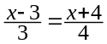
26. 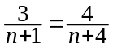 27. 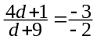
- Sixty-two students, out of 100 surveyed, chose pizza as their favorite lunch item. If the school has 1250 students, how many students would likely say that pizza is their favorite if the survey is a fair representation of the student body?
- The senior class is taking a trip to an amusement park. They received a special deal where for every 3 tickets they purchased they received one free ticket. 3 tickets cost $53.25. The total purchase of tickets cost $1384.50. How many tickets did they receive?
Solve each proportion.
30. 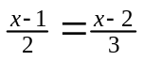 31. 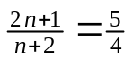 32. 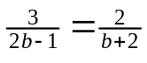
33. Open-Ended Give one example of a proportion. Describe the means and the extremes of the proportion. Explain how you know it is a proportion. Give one non-example of a proportion. Explain how you know it is not a proportion.
Prentice Hall Gold Algebra 1 • Teaching Resources
Copyright © by Pearson Education, Inc., or its affiliates. All Rights Reserved.
64

