Name
Class
Date

2-7
Solving Proportions
Reteaching

A proportion is an equation that states that two ratios are equal. If a quantity in a proportion is unknown, you can solve a proportion to find the unknown quantity as shown below.

What is the solution of
There are two methods for solving proportions—using the Multiplication Property of Equality and the Cross Products Property.
1) The Multiplication Property of Equality says that you can multiply both sides of an equation by the same number without changing the value.

 | To isolate x, multiply each side by 14.
 | Simplify.
10.5=x | Divide 42 by 4.
2) The Cross Products Property says that you can multiply diagonally across the proportion and these products are equal.
(4)(x) = (3)(14) | Multiply diagonally across the proportion.
4x = 42 | Multiply.
 | To isolate x, divide each side by 4.
x = 10.5 | Simplify.
Real world situations can be modeled using proportions.
A bakery can make 6 dozen donuts every 21 minutes. How many donuts can the bakery make in 2 hours?
A proportion can be used to answer this question. It is key for you to set up the proportion with matching units in both numerators and both denominators.
For this problem, you know that 2 hours is 120 minutes and 6 dozen is 72 donuts.

Correct:
Incorrect:

Prentice Hall Algebra 1 • Teaching Resources
Copyright © by Pearson Education, Inc., or its affiliates. All Rights Reserved.
69

Name
Class
Date

2-7

Reteaching (continued)
Solving Proportions

This proportion can be solved using the Multiplication Property of Equality or the Cross Products Property.
Solve this proportion using the cross products.
21x = (72) (120) | Cross Products Property
21x = 8640 | Multiply.
 | Divide each side by 21.
x = 411.43 | Simplify.
Since you cannot make 0.43 donuts, the correct answer is 411 donuts.
Exercises
Solve each proportion using the Multiplication Property of Equality.

1. | 2. | 3.
4. | 5. | 6.
Solve each proportion using the Cross Products Property.

7.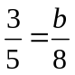 | 8.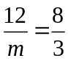 | 9.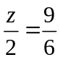
10.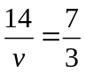 | 11.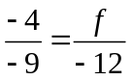 | 12.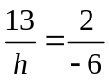
13. A cookie recipe calls for a half cup of chocolate chips per 3 dozen cookies. How many cups of chocolate chips should be used for 10 dozen cookies?
Solve each proportion using any method.

14. 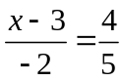 | 15.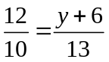 | 16.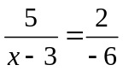
Prentice Hall Algebra 1 • Teaching Resources
Copyright © by Pearson Education, Inc., or its affiliates. All Rights Reserved.
70

