Name
Class
Date

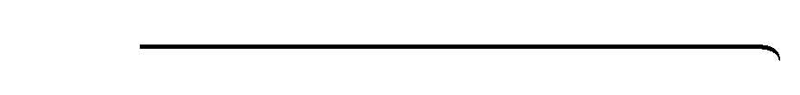
Puzzle: Constitution Math
2-8
Find the indicated lengths in the figures below. Then place each answer in its appropriate place at the bottom of the page. If your answers are correct, you will
find the answer to the question below from the four numbers in the circles.

Proportions and Similar Figures
Data question: In what year was the United States Constitution signed?
A. ∆ABC is similar to ∆XYZ. B. Rectangle KLMN is similar to rectangle PQRS.
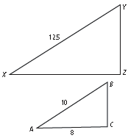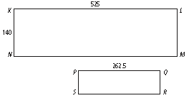

XZ = PS =

C. ∆RST is similar to ∆BCD. D. Trapezoid DEFG is similar to trapezoid WXYZ.
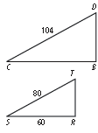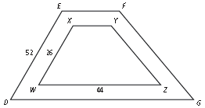

BC =

DG =

Answer A Answer B Answer C Answer D
Prentice Hall Algebra 1 • Activities, Games, and Puzzles
Copyright © by Pearson Education, Inc., or its affiliates. All Rights Reserved.
21

