Name
Class
Date

2-8
Proportions and Similar Figures
Enrichment

You are an executive who has been given the privilege of designing your floor of the office building. Below is the outline of the floor plan for your floor. There are a few things shown that cannot be moved because they affect the other floors of the building.
The plan is drawn to a scale 1 in. : 18 ft and each unit on the grid represents 0.3 in.
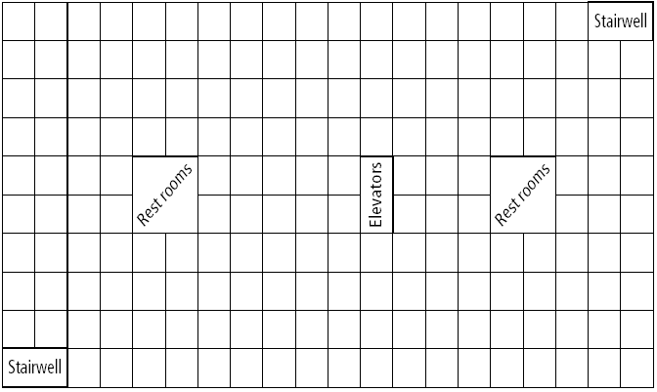
- What are the actual dimensions of the entire office building?
- What is the actual size of the restrooms? elevators? stairwells?
- You design the following on your floor: 2 break rooms, 2 copier rooms, 10 executive offices that are at least 18 ft by 12 ft, and enough cubicles (minimum size of 6 ft by 6 ft) for 50 employees. Draw each of the rooms to scale on the grid shown above. Label your drawings.
- What are the actual dimensions of each of the rooms you designed?
- The break room has ceramic tile covering the floor. How many square yards of tile is there in the break room?
- Describe two ways to compute the actual area of any room on the floor plan.
Prentice Hall Algebra 1 • Teaching Resources
Copyright © by Pearson Education, Inc., or its affiliates. All Rights Reserved.
78

