Name
Class
Date

2-8
Proportions and Similar Figures
Practice
Form K

The figures in each pair are similar. Identify the corresponding sides and angles.

1. ABCD ~ EFGH
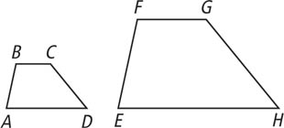
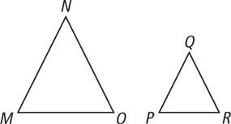
2. ΔMNO ~ ΔPQR

The figures in each pair are similar. Find the missing length.
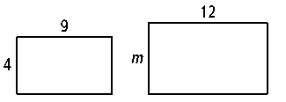
3.

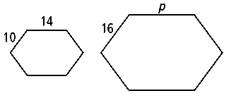
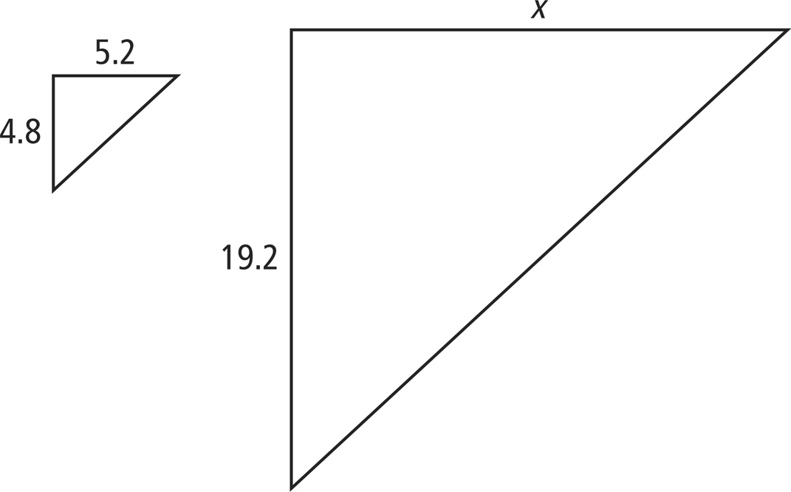
4.
5.

Prentice Hall Foundations Algebra 1 • Teaching Resources
Copyright © by Pearson Education, Inc., or its affiliates. All Rights Reserved.
75

Name
Class
Date

2-8
Proportions and Similar Figures
Practice (continued)
Form K

The scale of a map is 0.25 cm : 15 km. Find the actual distance corresponding to each map distance.

6. 0.75 cm | 7. 2 cm
8. 3.5 cm | 9. 5.25 cm
- For a celebration a town is going to pass out miniature replicas of the town’s bell. The replicas are 9 in. tall. If the scale of the replica is 1 in. : 0.5 ft, how tall is the actual bell?
- An architect created a scale model of what a college campus will look like
once construction is finished. The scale for the model is 2 in. : 25 ft. The tallest building in the model is 10 in. tall. How tall is the actual building?
- A model of a golf course says that hole #9 is 175 yards long. If the scale of the model is 2 in. : 20 yards, how many inches are there between the tee and the hole on the model?
- Open-Ended Give an example of similar figures in your school.
- Reasoning You are given two similar triangles. You know that one pair
of corresponding sides is equal. What do you know about the other sides? Explain.
Prentice Hall Foundations Algebra 1 • Teaching Resources
Copyright © by Pearson Education, Inc., or its affiliates. All Rights Reserved.
76

