Name
Class
Date

2-8
Proportions and Similar Figures
Reteaching

In similar figures, the measures of corresponding angles are equal, and the ratios of corresponding side lengths are equal. It is important to be able to identify the corresponding parts in similar figures.
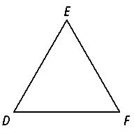
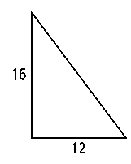
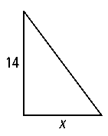
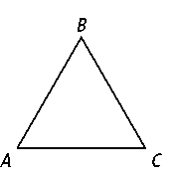
Since ∠A ≅ ∠D, ∠B ≅ ∠E, and ∠C ≅ ∠F,
. This fact can help you
to find missing lengths.

What is the missing length in the similar figures?
First, determine which sides correspond. The side with length 14 corresponds to the side with length 16. The side with length x corresponds to the side with length 12. These can be set into a proportion.

 | Write a proportion using corresponding lengths.
(16) x = (14) (12) | Cross Products Property
16x = 168 | Multiply.
x = 10.5 | Divide each side by 16 and simplify.
Exercises
The figures in each pair are similar. Identify the corresponding sides and angles.

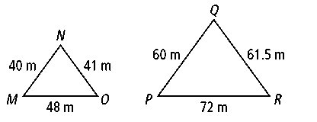
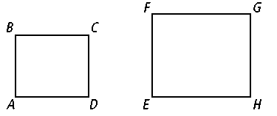
1.
2.
Prentice Hall Algebra 1 • Teaching Resources

Copyright © by Pearson Education, Inc., or its affiliates. All Rights Reserved.
79

Name
Class
Date

2-8
Proportions and Similar Figures
Exercises
Reteaching (continued)

The figures in each pair are similar. Find the missing length.

3.
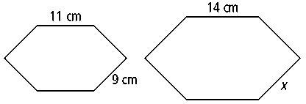
4.
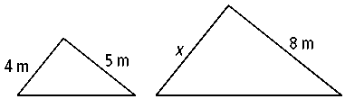
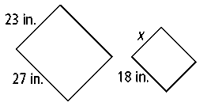

5.
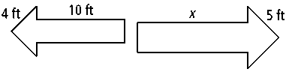
6.

A map shows the distance between two towns is 3.5 inches where the scale on the map is 0.25 in. : 5 mi. What is the actual distance between the towns?
Map scale:
If you let x be the actual distance between the towns, you can set up and solve a proportion to answer the question.
0.25 = 17.5
x = 70
The towns are 70 miles apart.
Exercises
The scale of a map is 1.5 in. : 50 mi. Find the actual distance corresponding to each map distance.

7. 10 in.
8. 4.25 in.
9. 6.75 in.

10. The blueprints of an octagonal shaped hot tub are drawn with a 1 in. : 5 ft
scale. In the drawing the sides are 3.5 inches long. What is the perimeter of the hot tub?
Prentice Hall Algebra 1 • Teaching Resources
Copyright © by Pearson Education, Inc., or its affiliates. All Rights Reserved.
80

