Name
Class
Date

2-8
Proportions and Similar Figures
Additional Vocabulary Support

Concept List

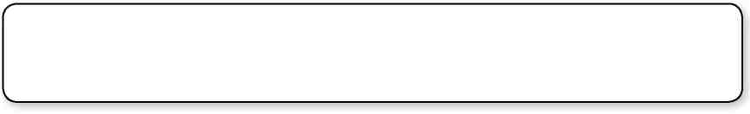
Cross Products Property is congruent to is similar to
length proportion ratio
scale scale model similar figures
Choose the concept from the list above that best represents the item in each box.

1. 24x = 10(18) | 2. ~ | 3.
4. 1 cm : 12 m | 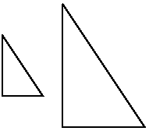  5. | 6.
7. ≅ | 8. | 9.  
Prentice Hall Algebra 1 • Teaching Resources
Copyright © by Pearson Education, Inc., or its affiliates. All Rights Reserved.
71

