Name
Class
Date


Game: Greater Than or Less Than?
2-9

Percents
1. Is 20% of 200 greater than or less than 100?

Twenty-four percent problems are listed below. Players take turns challenging each other by choosing a question that must be answered using mental math. A problem can only be selected once. Two racetracks are provided at the bottom of the page. Players fill in a block for each correct answer. Players must agree on the correct answer. The first player to complete the course wins! If neither player completes the course, then the player who advances the farthest wins.
3. Is 2% of 1000 greater than or less than 30?
5. Is 80% of 20 greater than or less than 10?
7. Is 90% of 120 greater than or less than 110?
9. Is 150% of 2 greater than or less than 4?
11. Is 70% of 70 greater than or less than 50?
13. Is 43% of 33 greater than or less than 11?
15. Is 20% of 18 greater than or less than 8?
17. Is 1% of 180 greater than or less than 2?
19. Is 30% of 180 greater than or less than 100?
21. Is 10% of 800 greater than or less than 70?
23. Is 67% of 15 greater than or less than 10?
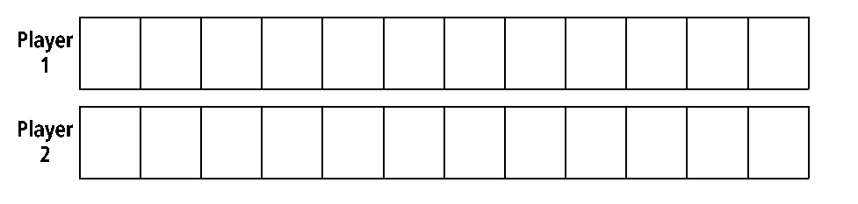
2. Is 25% of 80 greater than or less than10?
4. Is 75% of 8 greater than or less than 5?
6. Is 30% of 70 greater than or less than 15?
8. Is 5% of 40 greater than or less than 3?
10. Is 18% of 18 greater than or less than 9?
12. Is 25% of 15 greater than or less than 7?
14. Is 55% of 80 greater than or less than 40?
16. Is 60% of 45 greater than or less than 22?
18. Is 72% of 80 greater than or less than 60?
20. Is 95% of 70 greater than or less than 35?
22. Is 66% of 6 greater than or less than 4?
24. Is 25% of 800 greater than or less than 100?

Prentice Hall Algebra 1 • Activities, Games, and Puzzles
Copyright © by Pearson Education, Inc., or its affiliates. All Rights Reserved.
22

