Name
Class
Date

2-9

Enrichment
Percents

Compound Interest and Annual Percentage Yield
When money is invested in some types of accounts, such as savings accounts or certificates of deposit, the interest is compounded. This means that interest is paid at intervals, such as monthly, quarterly, or yearly. The interest is added to the account, and interest is then earned on the interest that has already been paid. For every $100 invested in an account paying 6% interest, compounded twice per year, the interest earned is $6.09. This represents a rate of 6.09%, because of the compounding.
The name for the effective percent earned on an account where the interest is compounded is annual percentage yield (APY). It tells what percent of an original investment you will earn in a year.
The equation that expresses this percent is APY = 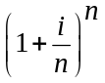 – 1, where i is the
advertised interest rate (written as a decimal) and n is the number of compounding periods per year. The result is the percent, written as a decimal. Using the example above, with i = 0.06 and n = 2:
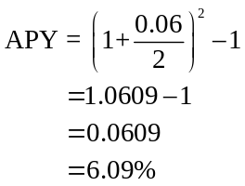
For Exercises 1–4, determine the annual percentage yield (APY).
- 8% interest rate, 2 compounding periods per year
- 8% interest rate, 4 compounding periods per year
- 8% interest rate, 6 compounding periods per year
- 8% interest rate, 12 compounding periods per year
- What do you notice about the APY as the number of compounding periods increases?
- What is the relationship between the interest rate and the APY when the number of compounding periods per year is 1? What does this mean?
Prentice Hall Algebra 1 • Teaching Resources
Copyright © by Pearson Education, Inc., or its affiliates. All Rights Reserved.
88

