Name
Class
Date

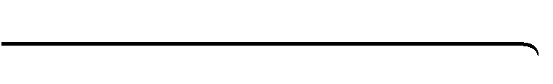
Think About a Plan
2-9
Percents
Finance A savings account earns simple interest at a rate of 6% per year. Last year the account earned $10.86 in interest. What was the balance in the account at the beginning of last year?

Understanding the Problem

1. | What is the formula for finding simple interest?
2. | What values are given in terms of the formula you wrote in Step 1?
Planning the Solution

3. | Substitute the given values into the formula for simple interest.
Getting an Answer

4. | Solve for the unknown value.
5. | Is your answer reasonable? Explain.
6. | What does your solution mean?
Prentice Hall Algebra 1 • Teaching Resources
Copyright © by Pearson Education, Inc., or its affiliates. All Rights Reserved.
82

