Name
Class
Date

2-9
Percents

Additional Vocabulary Support

Use the list below to complete the diagram.

12 = p% · 36 |  | l = 45(0.04)6
 | l = prt | a = p% · b

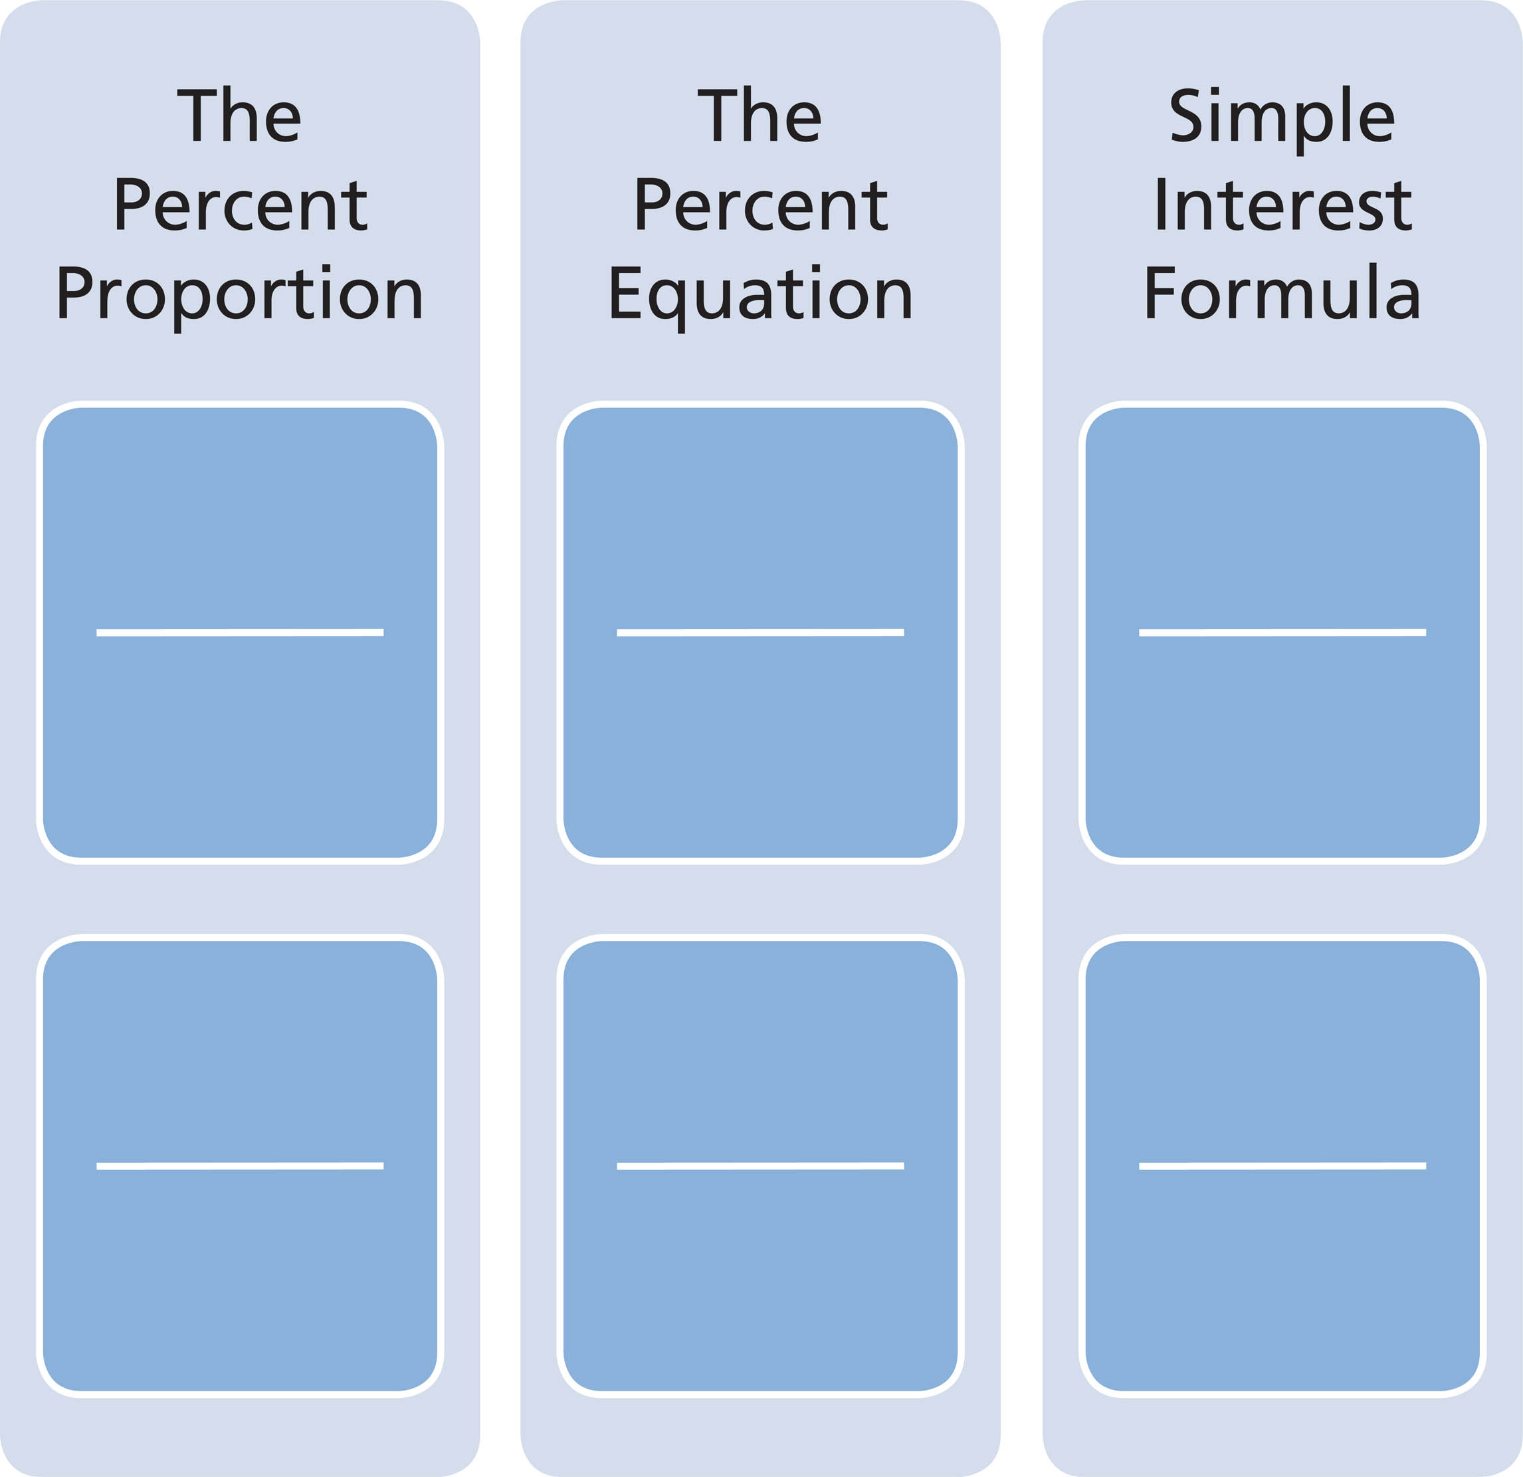
Prentice Hall Algebra 1 • Teaching Resources

Copyright © by Pearson Education, Inc., or its affiliates. All Rights Reserved.
81

