Class
Name
Date

Chapter 2 Quiz 2
Lessons 2-6 through 2-10
Form G

Do you know HOW?
Convert the given amount to the given unit.
1. 6 min; seconds 2. 112 dollars; cents 3. 3.5 lb; ounces
Solve each proportion. Explain your reasoning.
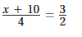
4.
5.
In the diagram, ΔABC ~ ΔPQR. Find each side length.
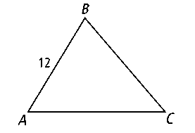
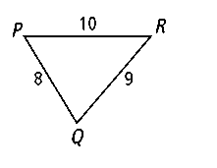
6. BC 7. CA
8. What percent of 60 is 12?
9. What is 30% of 70?

10. Your car gets 30 mpg on the highway. If gas costs $4.20 per gallon, how much does it cost to drive your car per mile?
11. A gardener has a 15 ft² garden. If she increases to a 24 ft² garden, by what percentage does she increase the area of the garden?
Do you UNDERSTAND?
12. How are ratios and proportions the same? How are they different?

13. Error Analysis The length of an object is exactly 20 cm. A student says that a measurement of 19 cm represents a percent error of 95%, while a measurement of 21 cm represents a percent error of 105%. Explain what the student did wrong. What are the correct percent errors?

Prentice Hall Algebra 1 • Teaching Resources
Copyright © by Pearson Education, Inc., or its affiliates. All Rights Reserved.
102

