Name
Class
Date

Chapter 2 Quiz 2
Lessons 2-6 through 2-10
Form K

Do you know HOW?
Convert the given amount to the given unit.
1. 8 ft; in. 2. 2.5 miles; ft
Solve each proportion. Use the Multiplication Property of Equality or the Cross Product Property. Explain your choice.
3. 4. 5.
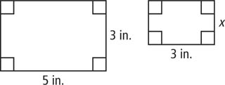
- The figures at the right are similar.
Find the missing length.
- What percent of 50 is 30?
Tell whether each change is an increase or decrease. Then find the percent change.
8. Original amount: $25  New amount: $35 | 9. Original amount: $54 New amount: $47

Define a variable and write an equation for each situation. Then solve.
10. The scale of a map is 1 in. : 75 km. Determine the distance between two towns
that are 5.6 in. apart on the map.
11. In 2005, a car sold new for $12,500. In 2008, value of the car was $8750. Find
the percent decrease.
Do you UNDERSTAND?
12. Open-Ended Write a problem that can be solved using proportions. Write
the proportion and solve the problem.
13. Writing How can unit analysis help you solve a conversion problem?
Prentice Hall Algebra 1 • Teaching Resources
Copyright © by Pearson Education, Inc., or its affiliates. All Rights Reserved.
106

