
TEACHER INSTRUCTIONS

2-1

Game: Algebra 1-Step
Solving One-Step Equations

The caller will need the following questions and answers in order to run the game.
1. 2. 80x = –640 –8 3. a + 5 = 9
Answer: 50 Answer: –8 Answer: 4
4. b – 7 = –19 5. 5d = 35 6. –4x = –24
Answer: –12 Answer: 7 Answer: 6
7. 8. 30x = 90 9.
Answer: –4 Answer: 3 Answer: –36
10. 8 + n =13 11. 10 = g + 17 12. 10r = –60
Answer: 5 Answer: –7 Answer: –6
13. 5t = 10 14. 15. y + 18 = 28
Answer: 2 Answer: –9 Answer: 10
16. y – 17 = –28 17. –15x = 90 18. 100k = 100
Answer: –11 Answer: –6 Answer: 1
19. 20. 3p = –9 21. 8 + w = 20
Answer: –1 Answer: –3 Answer: 12
22. u + 12 = 23 23. –10x = 100 24. j + 19 = 28
Answer: 11 Answer: –10 Answer: 9
25. 5g = 40 26. 8x = 104 27. 2x = –10
Answer: 8 Answer: 13 Answer: –5
28. x + 156 = 154 29. 30. 9 + b = 18
Answer: –2 Answer: –50 Answer: 9
31. 32. s – 19 = 24 33. –2x = 28
Answer: –4 Answer: 43 Answer: –14
34. a + 5 = –10 35. 27 = y + 20 36. –11r = –33
Answer: –15 Answer: 7 Answer: 3
Prentice Hall Algebra 1 • Activities, Games, and Puzzles
Copyright © by Pearson Education, Inc., or its affiliates. All Rights Reserved.
12

Name
Class
Date

Game: Algebra 1-Step
Solving One-Step Equations
2-1
This is a game for three or more players. Your teacher will provide you with a blank scoring card.

- Players use the scoring card to place the integers from –12 to 12 in the twenty-four squares in any arrangement they choose. A sample is shown. Each integer is used once; do not use 0.
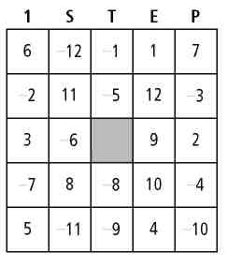
- A student or the teacher can serve as the game’s caller.
- The caller randomly announces one of the exercise numbers to the left of an equation below. Players solve the equation called. If the solution is one of the numbers on his or her scoring card, then the player marks an X in the appropriate box. The equation is then crossed out.
- The first player to have Xs in all boxes in any row, column, or diagonal wins the game. The caller checks to be sure scoring card is indeed correct.
1. 2. 80x = –640 3. a + 5 = 9
4. b – 7 = –19 5. 5d = 35 6. –4x = –24
7. 8. 30x = 90 9.
10. 8 + n = 13 11. 10 = g + 17 12. 10r = –60
13. 5t = 10 14. 15. y + 18 = 28
16. y – 17 = –28 17. –15x = 90 18. 100k = 100
19. 20. 3p = –9 21. 8 + w = 20
22. u + 12 = 23 23. –10x = 100 24. j + 19 = 28
25. 5g = 40 26. 8x = 104 27. 2x = –10
28. x + 156 = 154 29. 30. 9 + b =18
31. 32. s – 19 = 24 33. –2x = 28
34. a + 5 = –10 35. 27 = y + 20 36. –11r = –33
Prentice Hall Algebra 1 • Activities, Games, and Puzzles
Copyright © by Pearson Education, Inc., or its affiliates. All Rights Reserved.
13

Name

Class
Date
2-1

Game: Algebra 1-Step
Solving One-Step Equations
p

Scoring Card
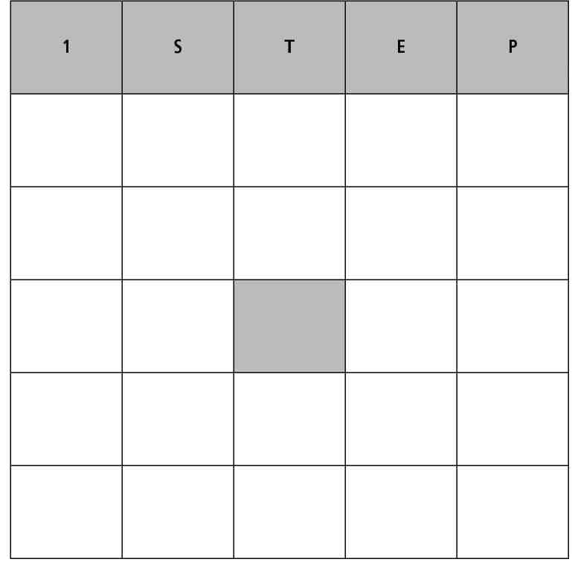
Prentice Hall Algebra 1 • Activities, Games, and Puzzles
Copyright © by Pearson Education, Inc., or its affiliates. All Rights Reserved.
14

