Name
Class
Date

2-1
Solving One-Step Equations
Practice
Form K

Solve each equation using addition or subtraction. Check your answer.
1. 6 = p – 8 2. z + 5 = 4
3. m – 4 = 12 4. –10 = h – 4
5. n + 14 = –5 6. 2 = a + 7
Solve each equation using multiplication or division. Check your answer.
7. 4t = –32 8. –25 = –5x
9. –3.2k = 16 10. 2.8r = 16.8
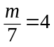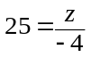11. 12.
Solve each equation. Check your answer.
13. 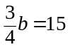 14. 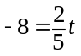
15. 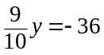 16.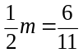
Prentice Hall Foundations Algebra 1 • Teaching Resources
Copyright © by Pearson Education, Inc., or its affiliates. All Rights Reserved.
5

Name
Date
Class

Practice (continued)
2-1

Solving One-Step Equations
Form K

Define a variable and write an equation for each situation. Then solve.
- Bradley has a goal to work 28 hours each week at the pizza shop. So far he has worked 12 hours. How many more hours does he need to work to meet his goal?
- Sheree is 4 times as old as Benjamin. If Sheree is 72 years old, how old is Benjamin?
Solve each equation. Check your answer.
19. –8h = 26 20.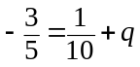
21. 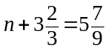 22. –9w = 6.3
23. 5.8 = –4.5 + z 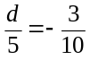24.
25. A youth club is taking a field trip to a community farm. 27 members attended the trip. The total cost for the club was $148.50.
a. Write and solve an equation to determine the cost for each person.
b. The farm brought in $1512.50 that day including what they received from
the youth club. Write and solve an equation to find the number of people
that visited the community farm that day.
Prentice Hall Foundations Algebra 1 • Teaching Resources
Copyright © by Pearson Education, Inc., or its affiliates. All Rights Reserved.
6

