`Name
Date
Class


Think About a Plan
2-1
Solving One-Step Equations
Volleyball In volleyball, players serve the ball to the opposing team. If the opposing team fails to hit the ball, the service is called an ace. A player’s ace average is the number of aces served divided by the number of games played. A certain player has an ace average of 0.3 and has played in 70 games this season. How many aces has the player served?

Understanding the Problem

1. | What values are you given?
Planning the Solution

2. Write an expression, using words, to represent the relationship between ace average, number of aces, and the number of games played.
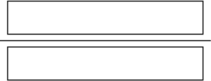
Ace Average =
3. Use the expression to write an equation, where A = number of aces.

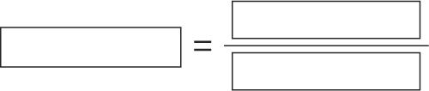

Getting an Answer

4. | Solve the equation you wrote in Step 3.
5. | Explain what this solution represents.
6. | Is your answer reasonable? Explain.
Prentice Hall Algebra 1 • Teaching Resources
Copyright © by Pearson Education, Inc., or its affiliates. All Rights Reserved.
2

