Name
Class
Date

2-1
Solving One-Step Equations
Additional Vocabulary Support

Two numbers with a sum equal to zero
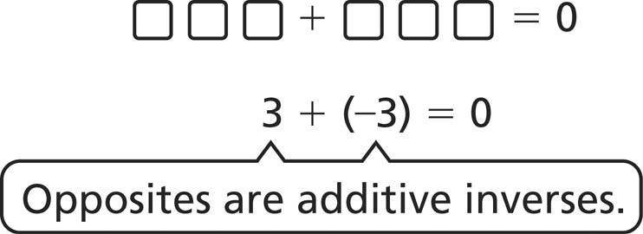
Sample 12 and –12 are additive inverses.
Solve.

1. | –32 + 32 =
2. | Circle the additive inverse of 6. | –6 |  |  | 6
3. | Circle the additive inverse of –18. | –18 |  |  | 18
4. | Circle the opposite of 91. | –91 |  |  | 91
5. | Cross out the pairs of numbers that are NOT additive inverses.
27 and –27 4 and –4 10 and 12 and 15 and 11

Two numbers with a product equal to zero
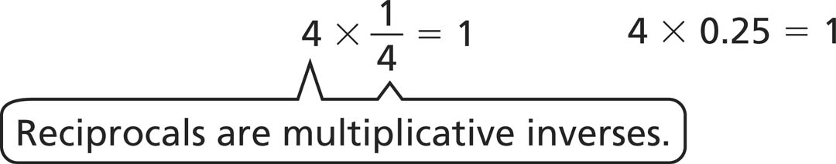
Sample 4 and are multiplicative inverses.
Solve.
6. 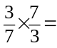
7. Cross out the pairs of numbers that are NOT multiplicative inverses.

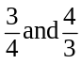 | 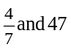 | 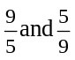 | 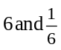 | 0.1 and 10

8. | Circle the multiplicative inverse of 6. | –6 | 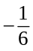 |  | 6
9. | Circle the reciprocal of –18. | –18 | 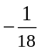 | 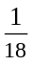 | 188
Prentice Hall Algebra 1 • Teaching Resources
Copyright © by Pearson Education, Inc., or its affiliates. All Rights Reserved.
1

