Name

Class
Date
2-2

Game: Equation Challenge
Solving Two-Step Equations

This is a game for three or more players. A student or the teacher can serve as the
host.
The host calls out a combination from the table at the left below and a
combination from the table at the right below. For example, the call “A3 T2” gives
the following equation.
4x + 5 = 6
Each player writes the equation, solves it, and records the solution using the score
sheet below.
At the end of Round 6, the host polls the players to agree upon the correct
solutions for each round. A correct solution earns 3 points, while an incorrect
solution earns no points.
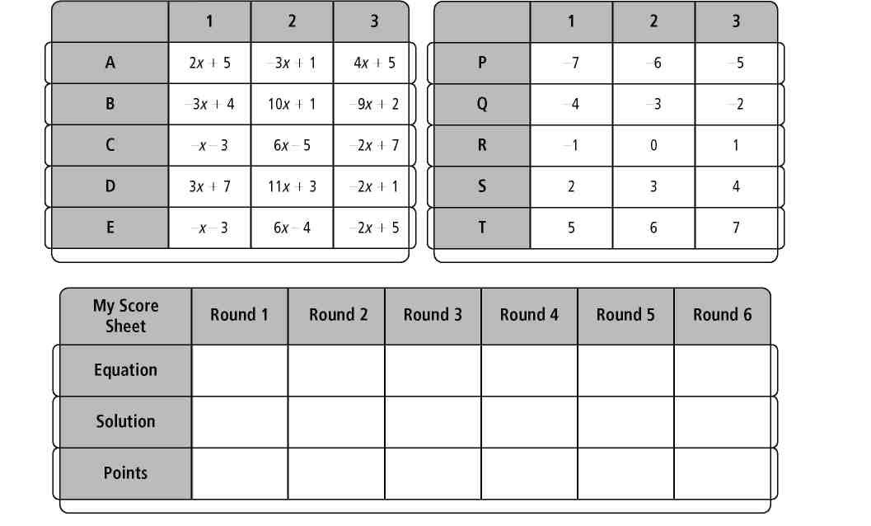
My total: 
Wait—the game is not over! You can boost your score by correctly solving
10⁶x + 10⁵ = 10⁶. T e correct solution is worth 10 points.
Prentice Hall Algebra 1 • Activities, Games, and Puzzles
Copyright © by Pearson Education, Inc., or its affiliates. All Rights Reserved.
15

