Name
Class
Date

2-2
Solving Two-Step Equations

Practice Form G

Solve each equation. Check your answer.
1. | 6 + 3b = –18 | 2. | –3 + 5x = 12
3. | 7n + 12 = –23 | 4. | 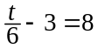
5. | 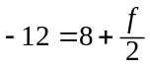 | 6. | 13 = 8 – 5d
7. | 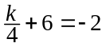 | 8. | –22 = –8 + 7y
9. | 16 – 3p = 34 | 10. | 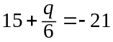
11. | 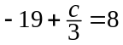 | 12. | –18 – 11r = 26
13. | 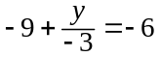 | 14. | 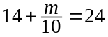
Define a variable and write an equation for each situation. Then solve.
- Chip earns a base salary of $500 per month as a salesman. In addition to the salary, he earns $90 per product that he sells. If his goal is to earn $5000 per month, how many products does he need to sell?
- A pizza shop charges $9 for a large cheese pizza. Additional toppings cost $1.25 per topping. Heather paid $15.25 for her large pizza. How many toppings did she order?
Prentice Hall Gold Algebra 1 • Teaching Resources
Copyright © by Pearson Education, Inc., or its affiliates. All Rights Reserved.
13

Name
Class
Date

2-2
Solving Two-Step Equations

Practice (continued) Form G

Solve each equation. Check your answer.

17. | 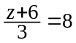 | 18. | 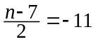
19. | 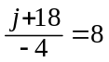 | 20. | 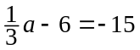
21. | 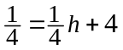 | 22. | 6.42 – 10d = 2.5
- The selling price of a television in a retail store is $66 less than 3 times the wholesale price. If the selling price of a television is $899, write and solve an equation to find the wholesale price of the television.
- The fare for a taxicab is $5 per trip plus $0.50 per mile. The fare for the trip from the airport to the convention center was $11.50. Write and solve an equation to find how many miles the trip is from the airport to the convention center.
- An online movie club offers a membership for $5 per month. Members can rent movies for $1.50 per rental. A member was billed $15.50 one month. Write and solve an equation to find how many movies the member rented.
- Writing Describe, using words, how to solve the equation 6 – 4x = 18. List any properties utilized in the solution.
- a. Solve 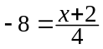
b. Write the right side of the equation in part (a) as the sum of two fractions.
Solve the equation.
c. Did you find the equation in part (a) or the rewritten equation easier to
solve? Why?
Prentice Hall Gold Algebra 1 • Teaching Resources
Copyright © by Pearson Education, Inc., or its affiliates. All Rights Reserved.
14

