Name
Class
Date

2-2
Solving Two-Step Equations
Practice
Form K

Solve each equation. Check your answer.
1. 4x + 5 = 13 2. –8 + 3h = 1
3. 2j – 13 = 25 4. 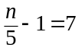
5. – 5 = – 8+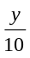 6. 7 = –6m + 7
7. 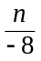 – 5 = – 2 8. –14 = –6 + 4w
9. 15 – 3t = –12 10. 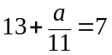
Define a variable and write an equation for each situation. Then solve.
- A fair charges $7.25 for admission and $5.50 for a ride pass. Ten friends visited the fair. Not all of the friends purchased ride passes. If their total cost was $105.50, how many friends purchased ride passes?
- A cafeteria sells entrées and additional items. An entrée costs $4.75, and each additional item costs $1.25. A customer pays $9.75 for one entree and some additional items. How many additional items were ordered?
Prentice Hall Foundations Algebra 1 • Teaching Resources
Copyright © by Pearson Education, Inc., or its affiliates. All Rights Reserved.
15

Name
Class
Date

2-2
Solving Two-Step Equations
Practice (continued)
Form K

Solve each equation. Check your answer.
13. 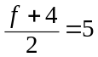 14. 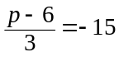
15. 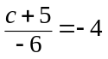 16. 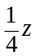 + 9 = – 1
17. 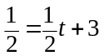 18. 4.52 – 5h = 2.8
- Jasmine is 23 years old. Jasmine is 3 years less than half of George’s age. Write and solve an equation to find George’s age.
- An appliance repair person charges $55 per trip plus $15 per hour for her
labor. The cost of fixing a stove was $92.50. Write and solve an equation to find how many hours it took to repair the stove.
- Shelly has a cell phone plan that costs $9.99 per month plus $0.05 per minute. Her total bill for the month is $25.59. Write and solve an equation to find how many minutes she used for the month.
- Writing Describe using words how to solve the equation 3 – 5n = –22. Describe the properties utilized in the solution.
Prentice Hall Foundations Algebra 1 • Teaching Resources
Copyright © by Pearson Education, Inc., or its affiliates. All Rights Reserved.
16

