Name
Class
Date

Think About a Plan
2-2
Solving Two-Step Equations
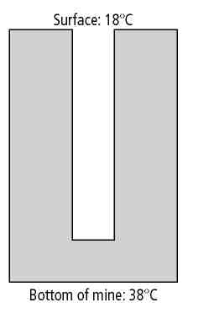
Earth Science The temperature beneath Earth’s surface increases by 10°C per kilometer. The surface temperature and the temperature at the bottom of a mine are shown. How many kilometers below Earth’s surface is the bottom of the mine?

Understanding the Problem

1. | What happens to the temperature as the distance below Earth’s surface increases?

2. | What do you need to determine?
3. | What is the change in temperature from Earth’s surface to the bottom of the mine?
Planning the Solution

4. | Write an expression for how much the temperature increases x kilometers below the surface.
5. | Write an equation that relates the change in temperature, from 18°C at Earth’s surface to 38°C at the bottom of the mine, to the expression for how much the temperature increases x kilometers below the surface.
Getting an Answer
6. Solve the equation.

7. | Is your answer reasonable? Explain.
Prentice Hall Algebra 1 • Teaching Resources
Copyright © by Pearson Education, Inc., or its affiliates. All Rights Reserved.
12

