Name
Class
Date

Activity: Actors and Equations
2-3

Solving Multi-Step Equations
This is an activity for the entire class. Beforehand, the students and/or teacher will need to make cards showing the following:


The sketch below shows actors (students) lined up in a row. Some actors are holding cards, and some are not. Together, they model the equation 2(x + 1) = 4.

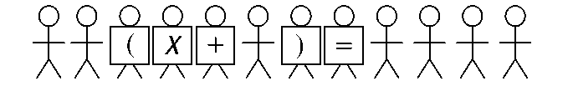
Students from the audience must choose operations to perform to solve the equation. In doing so, actors may be directed to leave the stage, come onto the stage, or move to another position on the stage. After instructions are given and stage movements take place, a small group of actors will be left to reveal the solution.

- Actors: Line up in a row to illustrate 2(x + 1) = 4. You may need feedback from the audience in order to do so.
- Audience: Solve the equation by giving instructions to the actors. Be sure to use the Distributive Property.
Write the solution to the equation here: 
Now let’s try a different approach.
- Actors: Line up in a row to illustrate 2(x + 1) = 4.
- Audience: Solve the equation by giving instructions to the actors. Instead of applying the Distributive Property, use a different method to solve.
Write the solution to the equation here:
Summarize what you learned about solving two-step equations in the space below.
Prentice Hall Algebra 1 • Activities, Games, and Puzzles
Copyright © by Pearson Education, Inc., or its affiliates. All Rights Reserved.
16

