Name
Class
Date

2-3
Solving Multi-Step Equations
Practice
Form K

Solve each equation. Check your answer.
1. 20 + g + g = 14 2. 7 + 4x – 9 = –6
3. –12 = –5 – 6n + 11 4. t + 10 – 4t = –11
5. 8 = 8p + 13 – 3p 6. 4y – 16 + 8y = –4
Write an equation to model each situation. Then solve the equation.
- A plumber finished three jobs on Tuesday. The first two only cost the owner the $45 trip fee because they took very little time to complete. For the third job, the plumber charged the trip fee plus 6 times his hourly rate. If the plumber received a total of $303 for the day, what is the hourly rate?
- Three times a number plus 12 minus 5 times the same number is 22. What is the number?
Solve each equation. Check your answer.
9. 4(–2d – 3) = 12 10. 5(5t – 2) = –35
11. –2(a + 6) = –22 12. 60 = 6(6 – 2n)
13. –14 = –4(9x – 1) 14. –(5z + 12) = 18
Prentice Hall Foundations Algebra 1 • Teaching Resources
Copyright © by Pearson Education, Inc., or its affiliates. All Rights Reserved.
25

Name
Class
Date

2-3
Solving Multi-Step Equations
Practice (continued)
Form K

15. Eli took the fleet of 8 vans for oil changes. All of the vans needed windshield
wipers which cost $24 per van. The total bill was $432. Write an equation to
find out what each oil change cost. Solve the equation.
Solve each equation. Choose the method you prefer. Check your answer.
16. 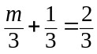 17. 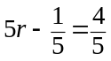
18. 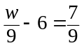 19. 1.75t – 4.5 = 7.75
20. 6z + 0.36 = 24.72 21. 7.85 – 2.15c = 20.75
- Writing Describe the first step you would take in solving 12 = 7 – 3x + 5x. Explain.
- Writing Describe how you would solve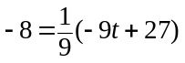.
Solve each equation. Round to the nearest hundredth if necessary.
24. 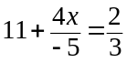 25. 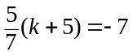
26. Reasoning Can you solve the equation 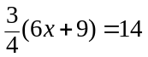by using the Division
Property of Equality? Explain.
Prentice Hall Foundations Algebra 1 • Teaching Resources
Copyright © by Pearson Education, Inc., or its affiliates. All Rights Reserved.
26

