Name

2-5

Activity: Advertising Formulas
Literal Equations and Formulas
Class
Date

You will need poster paper and markers or colored pencils for this activity. You may work by yourself or in small groups.

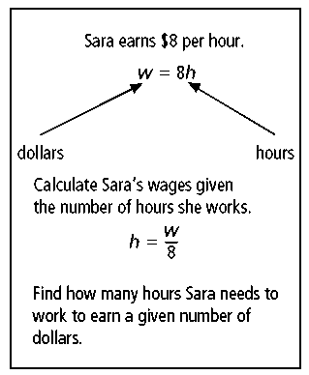
We may not think about it, but there are literal equations and formulas all around us. For example, the sample poster shown at the right involves hourly wages. Notice that the formula at the top is solved for w, while the formula at the bottom has been rewritten and solved for h.
Your job is to make a similar poster that
- gives a simple formula,
- describes how the formula can be used in real
life, and
- shows how a new formula can be rewritten from the original one.
Here are some ideas to help you get started.
Food Prices: a formula to calculate cost based on unit price
Age: a formula to determine your age y years in the future

Cycling: a formula to determine how far a cyclist can bike at a given speed
Gardening: a formula to determine the area of a garden in the corner of a backyard
Field Trips: a formula to determine how many buses are needed to transport a certain number of students given a seating capacity
Numbers: a formula to determine the nth positive multiple of 7
Sports: a formula for points scored by touchdowns and field goals
Describe the plan for your poster in the space below. Then, go ahead and make your poster. Your teacher may ask you to share it with the rest of the class, and then display it afterwards.

Prentice Hall Algebra 1 • Activities, Games, and Puzzles
Copyright © by Pearson Education, Inc., or its affiliates. All Rights Reserved.
18

