Name
Date
Class

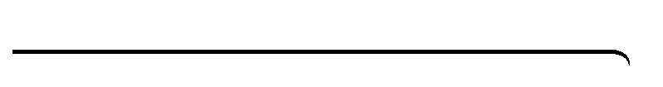
Think About a Plan
2-5
Literal Equations and Formulas
Density The density of an object is calculated using the formula , where m

is the object’s mass and V is its volume. Gold has a density of 19.3 g/cm³. What is the volume of an amount of gold that has a mass of 96.5 g?
KNOW

1. | What is the formula you are given for the density of an object?
2. | What values are you given in the problem?
NEED

3. | What measurement are you asked to determine?
4. | Solve for the variable V. Show your work.
PLAN

5. | Write your new formula. Substitute the values you are given into the formula.
6. | What is the volume of 96.5 g of gold?
7. | In what units is your answer? Do these units make sense? Explain.
Prentice Hall Algebra 1 • Teaching Resources
Copyright © by Pearson Education, Inc., or its affiliates. All Rights Reserved.
42

