Name
Class
Date

2-5
Literal Equations and Formulas
Additional Vocabulary Support

There are two sets of cards below that show how to solve 12c + 2d = 48g for d. The set on the left explains the thinking. The set on the right shows the steps. Write the thinking and the steps in the correct order.

Think Cards
Write Cards

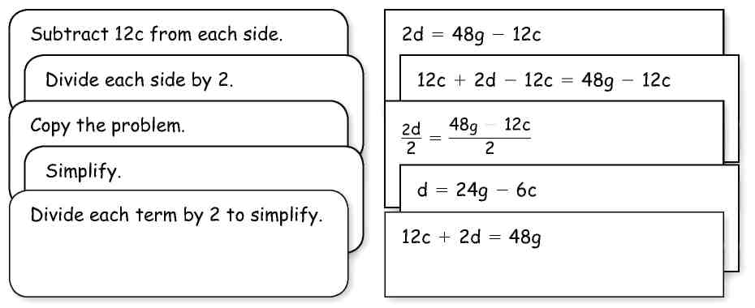

Think

Write

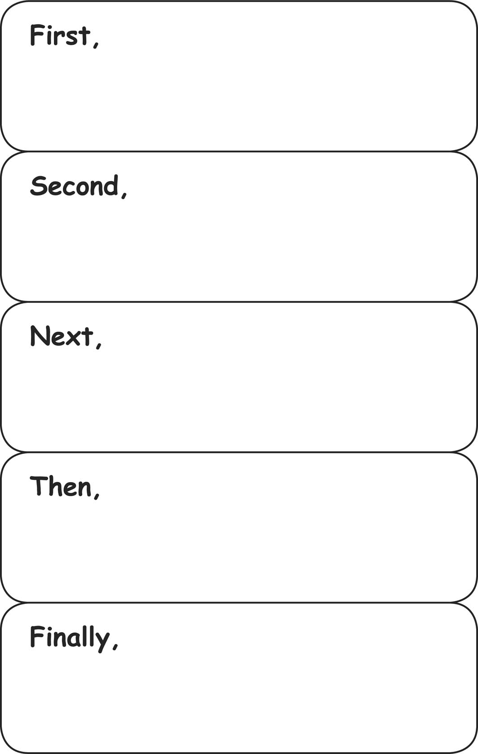
Step 1
Step 2
Step 3
Step 4
Step 5

Prentice Hall Algebra 1 • Teaching Resources
Copyright © by Pearson Education, Inc., or its affiliates. All Rights Reserved.
41

