Name
Class
Date


Activity: Everyday Ratios and Rates
2-6
This activity should be done in small groups. Each
group needs a newspaper. If your newspaper has several sections, you may want to give each group member a separate section to work with.

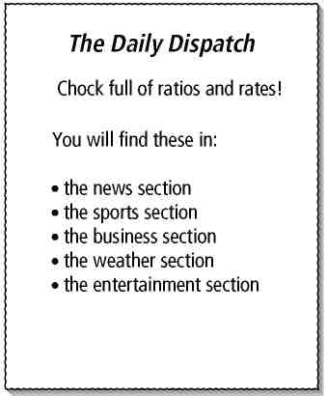
Ratios, Rates, and Conversions
Read through your newspaper and try to find as many ratios and rates as you can. Read carefully, as a rate or ratio may not appear in the mathematical form you are used to seeing in your textbook. Try and identify more ratios and rates than the other groups in your class!
Here are some places where you are likely to find examples of ratios and rates.
- bank advertisements
- car-buying advertisements
- the sports section
- the financial section
- the weather section

To complete the activity, compare your group’s findings with those of the other groups. Explain why your information qualifies as a ratio or rate.
If time permits, have your group answer the following questions.
- Lisa and her family plan to travel to Italy. Find the current exchange rate for American dollars to Euros (€). How many Euros will they receive for $500?
- At the end of the trip, Lisa’s family wants to exchange 200 Euros for American dollars. Find the current exchange rate for Euros to American dollars. How much will they receive for 200 Euros?
Prentice Hall Algebra 1 • Activities, Games, and Puzzles
Copyright © by Pearson Education, Inc., or its affiliates. All Rights Reserved.
19

