Name
Class
Date


Game: Climb the Ladder
2-7
Play Climb the Ladder against a classmate. Decide who will be Player 1 and who
will be Player 2.

Solving Proportions
In this game, players take turns choosing a proportion from the list below and challenging their opponents to solve it. Once a proportion is chosen, it should
be crossed out. The game continues until someone climbs to the top, all the proportions have been used, or time runs out.
Use the ladders to keep score. The solution to the selected equation tells the player
how many rungs to climb, or how many rungs to go down. A positive solution
means “go up,” while a negative solution means “go down.” Note: The rungs are
2 units apart. If a player’s score goes below 0, then that play puts the player at 0
and he or she has to begin to climb again.
The player who reaches the top first wins. If time runs out, the player closest to the
top wins. Choose your equations wisely in order to limit the number of rungs your opponent can climb!

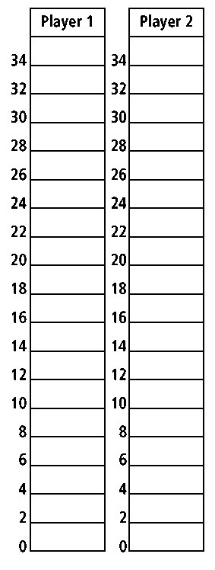
1. 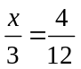 2. 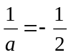 3. 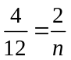
4. 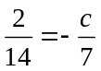 5. 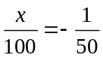 6. 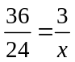
7. 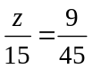 8. 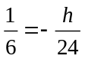 9. 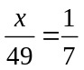
10. 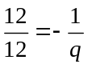 11. 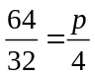 12. 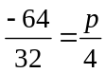
13. 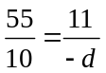 14. 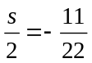 15. 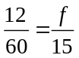
16. 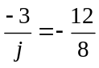 17. 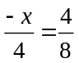 18. 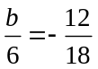
19. 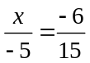 20.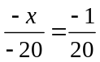 21. 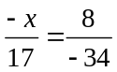
22. 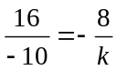 23. 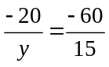 24. 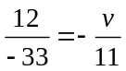

Prentice Hall Algebra 1 • Activities, Games, and Puzzles
Copyright © by Pearson Education, Inc., or its affiliates. All Rights Reserved.
20

