Name
Class
Date

1-1

Practice Form G
Variables and Expressions

Write an algebraic expression for each word phrase.

1. 10 less than x | 2. 5 more than d
3. 7 minus f | 4. the sum of 11 and k
5. x multiplied by 6 | 6. a number t divided by 3
7. one fourth of a number n | 8. the product of 2.5 and a number t
9. the quotient of 15 and y | 10. a number q tripled
11. 3 plus the product of 2 and h | 12. 3 less than the quotient of 20 and x
Write a word phrase for each algebraic expression.
13. n + 6 | 14. 5 − c | 15. 11.5 + y
16. 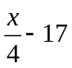 | 17. 3x + 10 | 18. 10x + 7z

Write a rule in words and as an algebraic expression to model the relationship in each table.
19. The local video store charges a monthly membership fee of $5 and $2.25 per video.
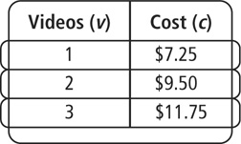
Prentice Hall Gold Algebra 1 • Teaching Resources
Copyright © by Pearson Education, Inc., or its affiliates. All Rights Reserved.
3

Name
Class
Date

1-1

Practice (continued) Form G
Variables and Expressions

20. Dorothy gets paid to walk her neighbor’s dog. For every week that she walks the dog, she earns $10.

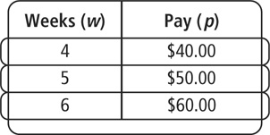
Write an algebraic expression for each word phrase.

- 8 minus the quotient of 15 and y
- a number q tripled plus z doubled
- the product of 8 and z plus the product of 6.5 and y
- the quotient of 5 plus d and 12 minus w
- Error Analysis A student writes 5y · 3 to model the relationship the sum of 5y and 3. Explain the error.
- Error Analysis A student writes the difference between 15 and the product of 5 and y to describe the expression 5y − 15. Explain the error.
- Jake is trying to mail a package to his grandmother. He already has s stamps
on the package. The postal worker tells him that he’s going to have to double the number of stamps on the package and then add 3 more. Write an algebraic expression that represents the number of stamps that Jake will have to put on the package.

Prentice Hall Gold Algebra 1 • Teaching Resources
Copyright © by Pearson Education, Inc., or its affiliates. All Rights Reserved
4

