Name
Class
Date

1-1

Practice Form K
Variables and Expressions

Write an algebraic expression for each word phrase.

1. 11 more than y | 2. 5 less than n
3. the sum of 15 and w | 4. 22 minus k
5. a number b divided by 8 | 6. q multiplied by 2
7. the product of 3.3 and a number x | 8. one third of a number m
Write a word phrase for each algebraic expression.

9. 8 − a | 10. v + 9
11.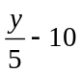 | 12. 1.9 + n
13. 5h + 3k | 14. 2x + 1
Write a rule in words and as an algebraic expression to model the relationship.
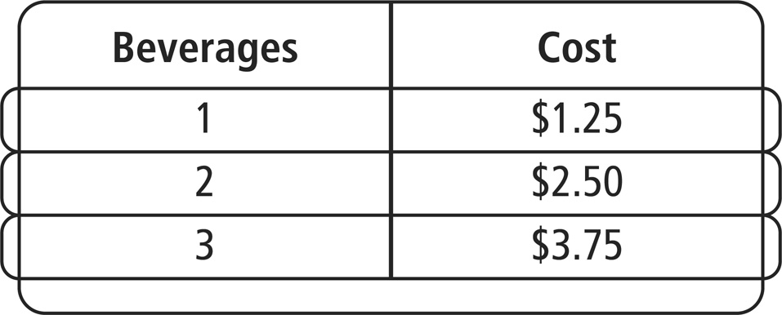
15. The cost of beverages in a vending machine is shown.

Prentice Hall Foundations Algebra 1 • Teaching Resources
Copyright © by Pearson Education, Inc., or its affiliates. All Rights Reserved.
5

Name
Class
Date

1-1

Practice (continued) Form K
Variables and Expressions

16. Jordan gets paid to mow his neighbor’s lawn. For every week that he mows the lawn, he earns $20. Write a rule as an algebraic expression to model the relationship.
Write an algebraic expression for each word phrase.
- 14 minus the quotient of 25 and p
- a number w tripled plus t quadrupled
- the product of 13 and m plus the product of 2.7 and n
- the product of 2 times a and 5 times b
- Error Analysis A student writes the sum of 7 times a number n plus 5 to describe the expression 7(n + 5). Explain the error.
- Sarah is going to pay for an item using gift cards. The clerk tells her that she will need 2 gift cards and an additional $3 to pay for the item. Write an algebraic expression to model the situation using the variable g for the number of gift cards to pay her total bill, t.
Prentice Hall Foundations Algebra 1 • Teaching Resources
Copyright © by Pearson Education, Inc., or its affiliates. All Rights Reserved.
6

