Name
Class
Date

1-1
Variables and Expressions
Reteaching

You can represent mathematical phrases and real-world relationships using symbols and operations. This is called an algebraic expression. | For example, the phrase 3 plus a number n can be expressed using symbols and operations as 3 + n.

What is the phrase 5 minus a number d as an algebraic expression?
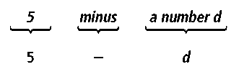
The phrase 5 minus a number d, rewritten as an algebraic expression, is 5 — d.

The left side of the table below gives some common phrases used to express mathematical relationships, and the right side of the table gives the related symbol.

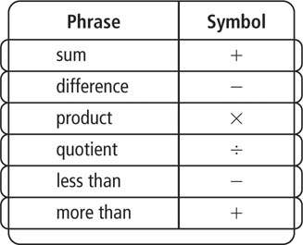
Exercises

Write an algebraic expression for each word phrase.

1. 5 plus a number d | 2. the product of 5 and g
3. 11 fewer than a number f | 4. 17 less than h
5. the quotient of 20 and t | 6. the sum of 12 and 4
Write a word phrase for each algebraic expression.

7. h + 6 | 8. m – 5 | 9. q × 10
10. | 11. h + m | 12. 5n
Prentice Hall Algebra 1 • Teaching Resources
Copyright © by Pearson Education, Inc., or its affiliates. All Rights Reserved.
9

Name
Class
Date

1-1
Variables and Expressions
Reteaching (continued)

Multiple operations can be combined into a single phrase.

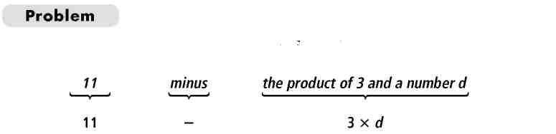
What is the phrase 11 minus the product of 3 and d as an algebraic expression?
The phrase 11 minus the product of 3 and a number d, rewritten as an algebraic expression, is 11 – 3d.

Exercises
Write an algebraic expression for each phrase.
- 12 less than the quotient of 12 and a number z
- 5 greater than the product of 3 and a number q
- the quotient of 5 + h and n + 3
- the difference of 17 and
Write an algebraic expression or equation to model the relationship expressed in each situation below.
- Jane is building a model boat. Every inch on her model is equivalent to 3.5 feet on the real boat her model is based on. What would be the mathematical rule to express the relationship between the length of the model, m, and the length of the boat, b?
- Lyn is putting away savings for his college education. Every time Lyn puts money in his fund, his parents put in $2. What is the expression for the amount going into Lyn’s fund if Lyn puts in L dollars?
Prentice Hall Algebra 1 • Teaching Resources
Copyright © by Pearson Education, Inc., or its affiliates. All Rights Reserved.
10

