Name
Class
Date


Think About a Plan
1-1
Variables and Expressions
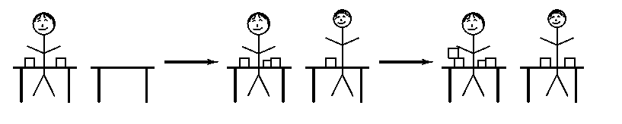
Volunteering Serena and Tyler are wrapping gift boxes at the same pace. Serena starts first, as shown in the diagram. Write an algebraic expression that represents the number of boxes Tyler will have wrapped when Serena has wrapped x boxes.

Think
1. Since Serena started first she will always have more boxes than Tyler. How many boxes did Serena wrap before Tyler started?
Plan
2. Examine the situation. What phrase in the situation could be rewritten as an algebraic symbol? What is the associated symbol?
Solve
3. When Serena has wrapped x boxes, how many boxes has Tyler wrapped?
4. Could this situation be expressed in another manner? Explain and give an example to prove your point.
Prentice Hall Algebra 1 • Teaching Resources
Copyright © by Pearson Education, Inc., or its affiliates. All Rights Reserved.
2

