Name
Class
Date

1-1
Variables and Expressions
Additional Vocabulary Support

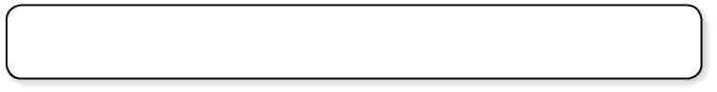
difference divided by less more than
product quotient sum times
Use the list to write two words or word phrases that represent each operation.

1. | Addition
2. | Subtraction
3. | Multiplication
4. | Division
For Exercises 5–12, draw a line from each phrase in Column A to a matching algebraic expression in Column B. The first one is done for you.

 | Column A | Column B
5. | 9 times a number p | 15q
6. | 34 less than a number d
7. | 12 more than a number n | t + 7
8. | the quotient of a number k and 6 | d – 34
9. | a number v divided by 4 | s – 18
10. | the sum of t and 7 | n + 12
11. | the product of q and 15 | 9p
12. | 18 fewer than s
Prentice Hall Algebra 1 • Teaching Resources
Copyright © by Pearson Education, Inc., or its affiliates. All Rights Reserved.
1

