Name
Class
Date


Puzzle: Calc-Words
1-2
Order of Operations and Evaluating Expressions
Instead of entering a letter in each box of this crossword puzzle, write a digit! Draw the digit in each box so it looks like you typed it using your calculator.


To check your answers, turn this page upside down. If each horizontal or vertical group of numbers forms a word, then your answers are correct!

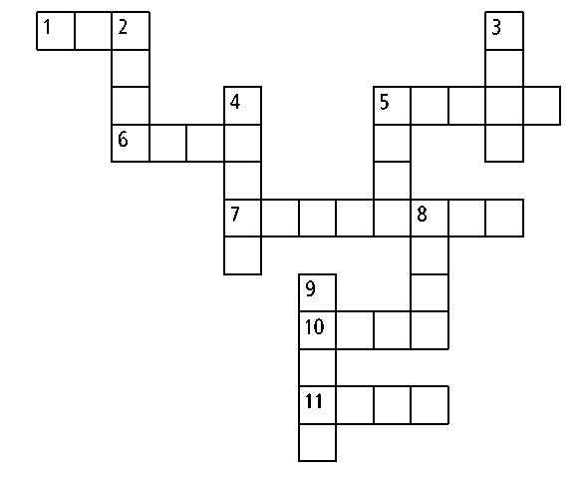

ACROSS

1. Find the value of x³ + 2y³ for x = 7 and y = 1.
5. Simplify 524 + 55 · 627.
6. What is the value of
2x³ + 4x² + 4x + 8 when x = 15?
7. Simplify 1583 + 7986 · 9685.
10. Find the value of
12 ÷ 2 + 4 + 78·91.
11. What is the simplified form of
2⁴ · 3(9 · 8 + 1)?
DOWN
2. Evaluate 2x⁴ + 2x³ + x² when x = 7.
3. Find the value of x² + 2xy + 3y² for x = 70 and y = 4.
4. What is the simplified form of 351 + 524 · 72?
5. Evaluate 5(x⁵ + y²) when x = 3 and y = 20.
8. What is the value of
11x² – 6x + 1 when x = 29?
9. Find the value of x² + 3x + 0.2345 when
x = 0.17. (Include the leading zero and
ignore the decimal point.)

Prentice Hall Algebra 1 • Activities, Games, and Puzzles
Copyright © by Pearson Education, Inc., or its affiliates. All Rights Reserved.
2

