Name
Class
Date

1-2

Practice Form K
Order of Operations and Evaluating Expressions

Simplify each expression.

1. | 9² | 2. | 8³
3. |  | 4. | (4 + 3)²
5. | 8 + 5(7) | 6.
7. | 11(3) − 3² | 8.
9. | (3(4))³ | 10. | 3⁴ −2⁴ ÷ 2²
Evaluate each expression for x = 3 and y = 2.

11. | x + 7 | 12. | 8 − y
13. |  | 14. | 5(y)³ − 6
15. | −6(x)² + y³ − 8 | 16.
Prentice Hall Foundations Algebra 1 • Teaching Resources
Copyright © by Pearson Education, Inc., or its affiliates. All Rights Reserved.
15

Name
Class
Date

1-2

Practice (continued) Form K
Order of Operations and Evaluating Expressions

17. George is driving at an average speed of 62 miles per hour. Write an expression that would give his distance traveled for h hours. Make a table that records his distance for
3, 5.5, 7, and 8.5 hours.
Simplify each expression.

18. | 5[(4 + 8) − 3³] | 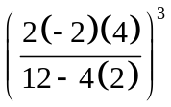19. | 2[(7 − 10)² + 5]²
20. | [(32 ÷ 4)³ − 500]³ | 21.
22. The cost to rent a car is $30 per day. Write an expression for the cost of renting a car for d days. Make a table to find how much it will cost to rent a car for 3, 5, 7, and 10 days.
Evaluate each expression for the given values of the variables.

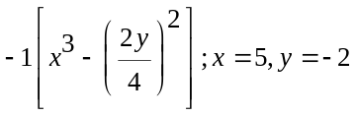23. | 2(m + 1) − n³; m = −2, n = 3 | 24. | −3[(a − 3)² + b]²; a = 4, b = 6
25. |  | 26. | t[v² − (23 − v²) + 3]; t = −2, v = 2
27. Reasoning Show that the expressions 3m²n² and 5m³ + 13m²n are equal when m = 2 and n = 5.
Prentice Hall Foundations Algebra 1 • Teaching Resources
Copyright © by Pearson Education, Inc., or its affiliates. All Rights Reserved.
16

