Name
Class
Date

1-3

Real Numbers and the Number Line
Activity: Inequality Ski Trail

In this activity, you will ski down the trail shown below. You can work with a partner and then discuss your results as a class when everyone has finished.
Begin by filling in the 18 boxes with the 18 numbers below. You can place the
numbers anywhere you want. Use each number once. After filling in the numbers, determine the path to take by identifying the symbol (<, =, >) that correctly
relates the two numbers. Place the correct symbol in the circle. If the symbol is <,
take the left path down the trail. If the symbol is =, take the middle path. If the
symbol is >, take the right path.
After you have completed the trail, find the time it took you to ski down. The times
(in seconds) are shown next to each of the paths. Compare your time with your
partner’s and other classmates.

–0.4 | 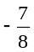 | 0.32 | 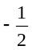 | 0.75 | 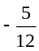 | 0.09 | –0.1
–0.9 |  | –0.5 |  | 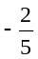 | 0.2 | 0.6 | 0.625
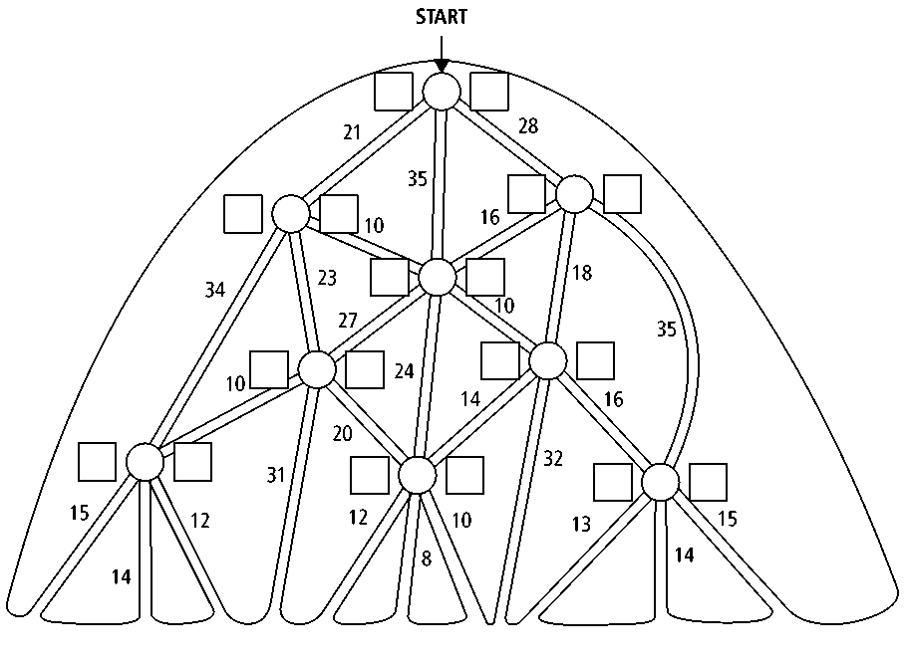
Prentice Hall Algebra 1 • Activities, Games, and Puzzles
Copyright © by Pearson Education, Inc., or its affiliates. All Rights Reserved.
3

