Name
Class
Date

1-4

Properties of Real Numbers
Game: You’ve Got My Property

This is a game for two players. The top table lists 24 equations, and the bottom
table lists eight properties three different times. The object of the game is to match
each equation with the property it describes.
Decide which player goes first. Player 1 starts by matching any equation with its
property. After each match, use a pencil to cross out both the equation and the
property. A player can match as many as three equations with their properties
in a single turn. Players check each other’s matches after each one is given. An
incorrect answer results in the other player taking over, and the equation and
property are still in play. The winner of the game is the player who crosses off the
last match. The strategy is to match just enough equations and properties so that
you will be able to select the last one!
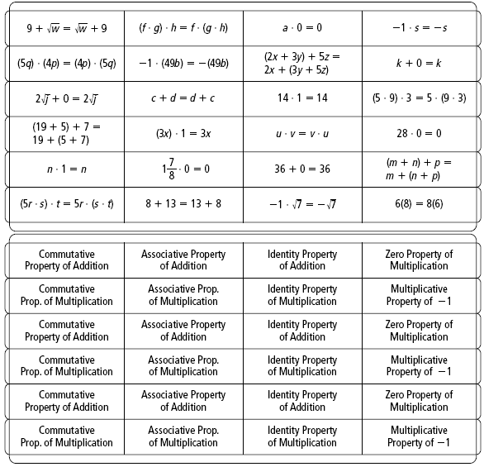
Prentice Hall Algebra 1 • Activities, Games, and Puzzles
Copyright © by Pearson Education, Inc., or its affiliates. All Rights Reserved.
4

