Class
Date
Name
1-5

Puzzle: That’s Sum Puzzle!
Adding and Subtracting Real Numbers

Puzzle 1
Use the numbers {19, 25, 34, 47, 78, 94} to fill in the blank squares in the table below. Each number can only be used once. Arrange the numbers so that the sum
of the numbers in the first row is 295, and the sum of the numbers in the second
row is 120. T e differences down each column must equal 28, 36, 42, and 69, from
left to right.

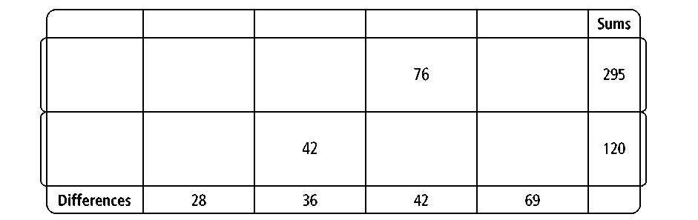
Puzzle 2

Use the fractions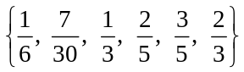 to fill in the blank squares in the table below. Each fraction can be used only once. Arrange the fractions so that the sum
of the fractions in the first row is 2, and the sum of the fractions in the second row
is 1. In addition, the differences down each column must equal 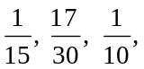 and 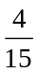, from left to right.
Prentice Hall Algebra 1 • Activities, Games, and Puzzles
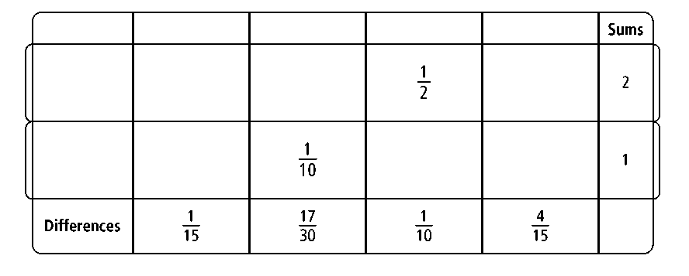
Copyright © by Pearson Education, Inc., or its affiliates. All Rights Reserved.
5

