Name
Class
Date

1-5
Adding and Subtracting Real Numbers
Enrichment

A number square is a square where the numbers in any row, column, or diagonal have the same sum. Notice that in the square at the right, the sum of each row, each column, and each diagonal is 15.
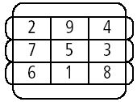
Complete each number square.

1. | 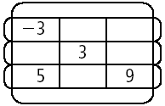 | 2. | 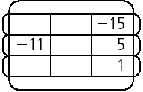
3. | 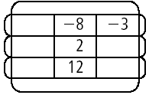 | 4. | 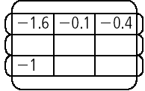
5. | 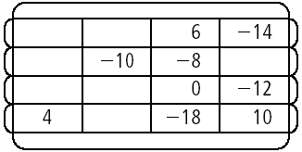 | 6. | 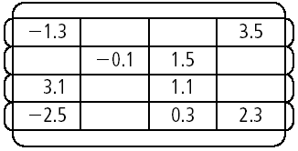

Prentice Hall Algebra 1 • Teaching Resources
Copyright © by Pearson Education, Inc., or its affiliates. All Rights Reserved.
48

