TEACHER INSTRUCTIONS


TEACHER INSTRUCTIONS


Activity: A Class Divided
1-6
Multiplying and Dividing Real Numbers
Cut out the squares from the top grid and give the squares to half the class. Then
cut out the squares from the bottom grid and give the squares to the other half of
the class. If you do not pass out all of the squares from the top grid, be sure to only
pass out the corresponding squares from the bottom grid. For example, if you pass
out the top two rows from the top grid, be sure to pass out the top two rows from
the bottom grid.
This activity should take no more than 10 to 15 minutes. Stress to students
beforehand that they are only allowed to read aloud the expression on their
classmates’ square.
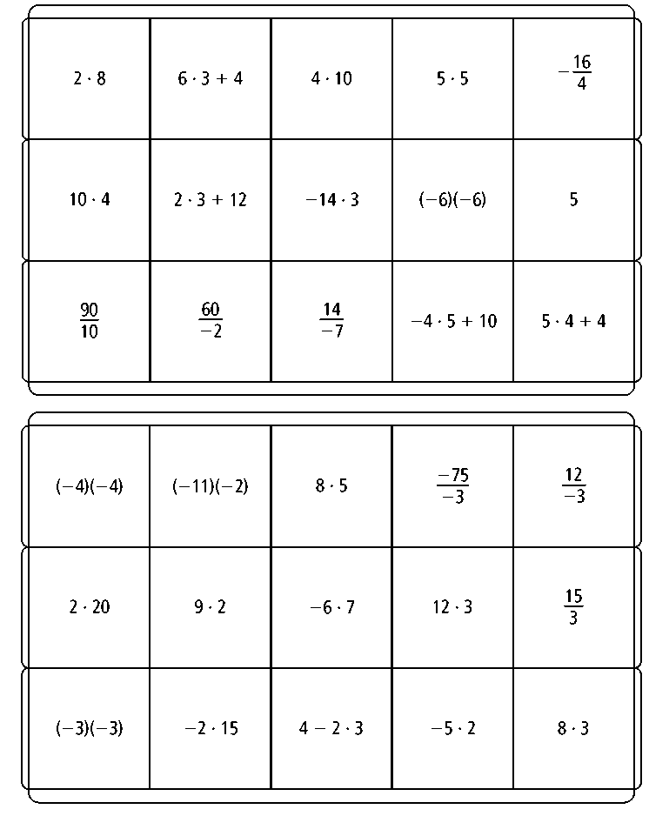
Prentice Hall Algebra 1 • Activities, Games, and Puzzles
Copyright © by Pearson Education, Inc., or its affiliates. All Rights Reserved.
6

Name
Class
Date

1-6

Activity: A Class Divided
Multiplying and Dividing Real Numbers

Your teacher will give you a square with expressions involving multiplication and division. Each expression has a matching equivalent expression. Use mental math
to evaluate the expression on your square. Then walk around the class to find the classmate who has the square with the equivalent expression. For example, if your
square shows the expression 6 · 4 + 11, then your expression equals 35 and you
will need to find the classmate whose expression also equals 35.
- When you approach a classmate, you are only allowed to read aloud the expression on the classmate’s square, and the classmate is only allowed to
read aloud the expression on your square. You cannot say anything more.
- When you find the matching square, you and your classmate should return
both squares to your teacher to see if you are indeed correct.
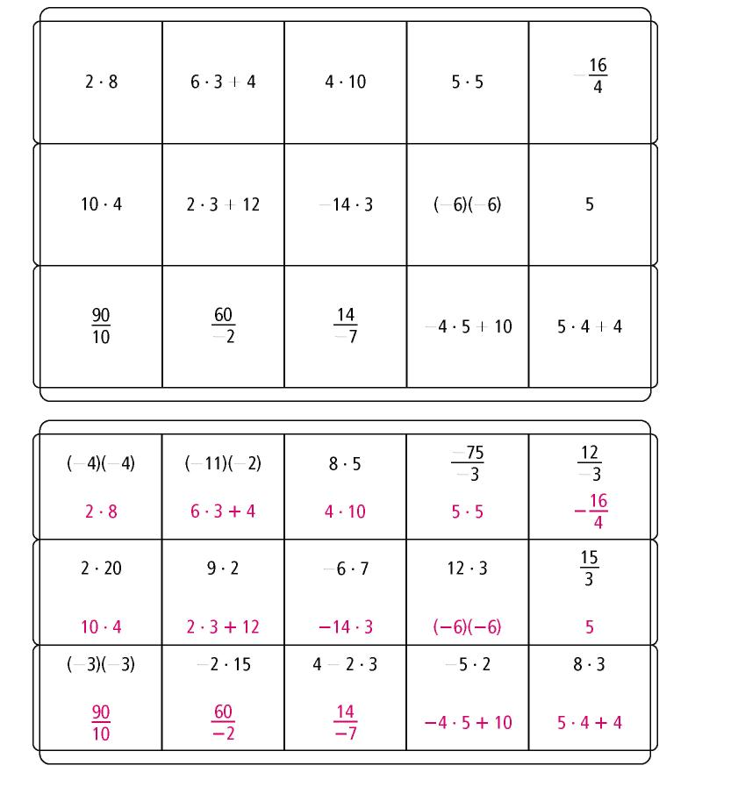
Prentice Hall Algebra 1 • Activities, Games, and Puzzles
Copyright © by Pearson Education, Inc., or its affiliates. All Rights Reserved.
7

